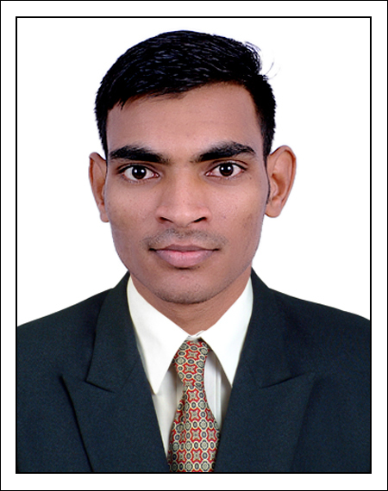Devendra Kumar Gond

**ADDRESS:** Village: - Mathiya Bhokariya, Post: - Dhrampur Parvat, Dist:-Kushinagar, Pin:-274302, State:-Uttar Pradesh

**MOBILE:** +91-**8957942741, 8320262641**

**EMAILADDRESS: [devendracipet0@gmail.com](mailto:plastwold.avinash@gmail.com)**

**CARREROBJECTIVE**:

To employ the best of my skill sand knowledge inateam based environment adding to the growth of the organization as well as myself in the field of plastic processing, QC & maintenance.

# ACADEMICDETAILS:

|  |  |  |  |  |  |
| --- | --- | --- | --- | --- | --- |
| **Sr.**  **No.** | **Course** | **NameofInstitution** | **Board/University** | **Year ofpassing** | **CGPA/%** |
| 1. | Diploma(PlasticTechnology) | CIPET-Ahmedabad | CIPET-Chennai | 2020 | 75 |
| 2. | th  10 | MICD Dumahi Dhrampur parvat Dist-Kushinagar | Uttar Pradesh | 2017 | 80 |

# WORK EXPERIENCE:

**Job Designation: Production Engineer**

# Current Organization: Chemco Plastic Industries Pvt.Ltd.

Engaged in manufacturing of PET Preform through ASB DPH 70 ISBM (From 17 May,2020 to till date)

* + Knowledge of mouldloading and unloading, water connection &startup/shutdown process.

# TECHNICAL SKILLS:

**PLASTIC PROCESSING LABORATORY**

## Knowledge of Process and Basic Handling of:

Injection Moulding,

Extrusion Process ( Wire Coating- Extruder, Crosshead die, Screw Types, Heating System ),Single&Twin ScrewExtruder

# PLASTIC TESTING LABORATORY

## Knowledge of plastic testing equipment & have skill to perform operation of:

Universal Testing,MeltFlowIndexTest,

Carbon Black content Test,DensityTest.

# ACADEMIC PROJECT DETAILS:

Extrusion Blow Moulding 6 manth

# DEVELOPMENT ACTIVITIES:

* Visitedat PLASTINDIAEXHIBITION 2018-Gandhinagar,Gujrat.

# AREA OF INTERESTS:

* Production
* Qualitycontrol
* Research&Development

# STRENGTH

* Flexibility and Adaptability to work in any environment
* Result oriented and hardworking
* Good observation and communication
* Fast decision making
* Self-motivated
* Good manpower handling

# PERSONAL INFORMATION:

Date of Birth : 01/07/2002

Gender : Male

Marital status : Single

Hobbies : Travelling & Cricket

Language : English, Hindi

Father’s Name : Mr.Anil Gond Mother’s Name : Mrs.Sunita Father’s Occupation : Farmar Mother’s Occupation : Home maker Nationality : Indian

# DECLARATION:

I here by declare that the information furnished above is true to the best of my knowledge and belief.

DATE:

PLACE:SILVSSA,GUJARAT

## DEVENDRA KUMAR GOND