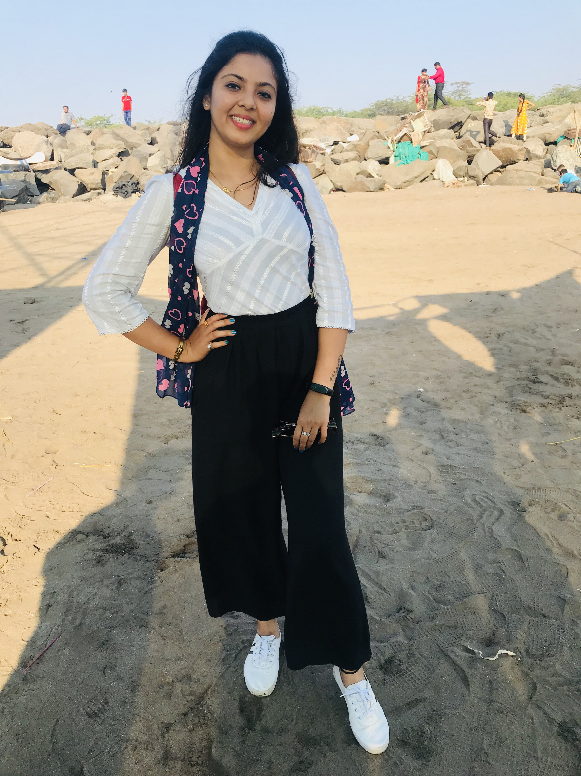**DRUSHTI PATEL**

**Degree : B.Sc (Chemistry)**

9537165636 ; 6359660026

[pateldrushti1996@gmail.com](mailto:xxxxxxxxxxxxxxx@gmail.com) 📌Ahmadabad, Gujarat

# CERTIFIED IN MEDICAL CODING

**Prowess Pharma Knowledge Centre LLP**

🗓️ 06 January **2019 to (pursuing)** 📌Ahmadabad

* Brief about Medical coding & CPC certification exam.
* Overview ofCPT® , ICD-10-CM/Diagnosis& HCPCS level II codingguidelines.
* Anatomy & Terminology of all Human body system (Integumentary, Musculoskeletal, Cardiovascular, Hemic & lymphatic, Digestive, Urinary, Male & female reproductive, Nervous & Special sensory)
* Overview of Evaluation/Management services.
* Surgery codes (10,000-60,000 Series).
* Overview of Anesthesia, Radiology, Laboratory/Pathology & Medicine.
* Gain the knowledge of ICD-10-CM/Diagnosis codes
* Brief about Compliance & Regulatory.

**LIFE OBJECTIVE**

To secure a challenging position that utilizes my years of experience, while allowing me the opportunity to grow professionally. I offer strong interpersonal skills to develop global customer solutions with thought leadership and integrity, excellent interpersonal, oral and written communication and presentation skills, functioning well both independently and collaboratively with an outgoing personality. My goal is to become a valued asset.

**A DAY OF MY LIFE**

**Industrial visits/ EXPO:**

# ACRONE PHARMACEUTICALS

* AMUL INDUSTRIES ANAND.
* MONTAGE LABORATORIES Pvt. Ltd.

**STRENGTHS**

* Leadership.
* Adaptability to any condition.
* Can work independently and in group.
* Work for perfection and betterment.
* Good communication.
* Hardworking personality.
* Corporative nature.
* Have management skill.
* Also a Motivational Skill.

**HOBBY**

Photography

Traveling

Music

**LANGUAGES**

**English**

**Hindi**

**Gujarati**

# AREA OF INTEREST:

* Medical Coding & Billing Industry
* Healthcare industry
* Hospitals & Doctor’s Office
* Insurance agencies

**Computer Knowledge**

* M.S OFFICE
* Internet
* Remote
* Team viewer

# SEMINARS\CONFERENCES:

* Skill development program.
* Global Warming Program.

# EDUCATION

Bachelor of Education - Running

Bachelor of Science (Chemistry)

YEAR: 2016

\_-- 2019

**University :** Gujarat University

-----------------------------------------------------

10th class – 94.33%

12th Class – 55.08%

Gujarat Secondary Education Board

**Experience :**

6 Months in Tuition Classes

6 Months in Aqkode Healthcare Solution ( Client Service Executive- Billing )

6 months in Revesolv LLC ( client services and executive- Billing)

**DECLARATION:**

I hereby declare that the information furnished above is correct to the best of my knowledge.

THANKS AND REGARDS

Drushti Patel