**CURRICULUM VITAE**

**Harish Chander**

126 Shivani enclave part 2

Kakrola New Delhi-110078

Email Id- harishtejan12@gmail.com

Mob No. **+91 9540618688**

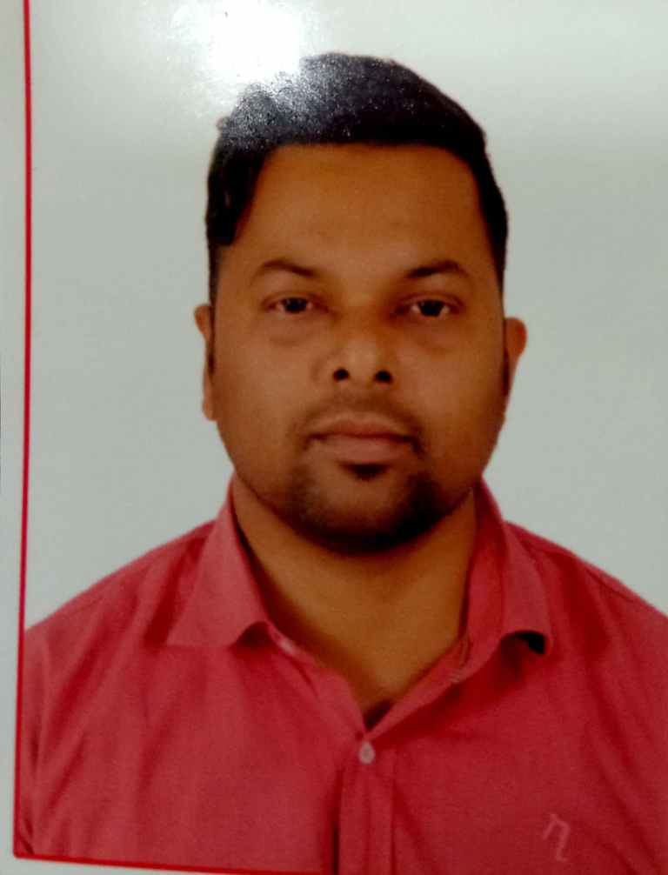

# **Objective:**

To Work in a challenging and dynamic environment to keep adding value to myself and simultaneously contribute to the growth and success of the organization, I represent.

**Educational Qualification: (Civil Engineering)**

|  |  |  |  |  |
| --- | --- | --- | --- | --- |
| **Examination** | **School/College** | **Board/University** | **Year of passing** | **Percentage** |
| Diploma(Civil) | Chotu Ram Rarural Institute of Technology | Board of Technical Education ,Delhi | JUNE’ 2009 | 58.55% |

#### **Professional Credentials:**

|  |  |  |  |
| --- | --- | --- | --- |
| **Designation** | **Name & Address of Employer** | **From** | **To** |
| Site Engineer | Rites Ltd. | MAY’2014 | Till Now |
| Site Engineer | IITL-NIMBUS Group. | JUNE’2011 | MAY’2014 |
| Site Engineer | Gammon India Ltd. | JUNE ’ 2009 | JUNE’ 2011 |

#### **Employment Records:**

**1. Rites. Ltd.**

* Period : MAY’2014 to Till Date
* Project Name : Western Dedicated Freight Corridor (Railway)
* Project Cost : 7700 Cr.
* Client : Dedicated Freight Corridor Corporation of India.
* Designation : Site Engineer (Project Management Consultant)
* Employer : DFCCIL (Under Ministry of Railways)
* Supervision of Major, Minor & Important Bridges, viaduct and Road under bridges (RUB), Pedestal sub way (PS), Foot over bridges (FOB) & Pipe Culverts.
* Mac Drain Installation at RUB, Geogrid Installation in Earth work.
* Supervision of Pre-Stressing & Post-Tensioning of Girders & Slabs.
* Preparation of bridge progress charts for monitoring progres.
* Supervision of Piling work including Boring & Flushing, Cage lowering, Casing, Sample Collection & Testing etc.
* Detailed quantity calculation for planning & execution of work.
* Supervision of Formation work including Embankment, Subgrade & Blanketing including Level Checking & FDD testing by Core cutter Method, Sand Replacement, Nuclear Density Gauge Method.
* Supervision of High Embankment bank protection including Toe walls, Retaining walls, ERS, Side Drain(Geocell and RCC), and Slope Turfing & CC Block Pitching.
* Preparation of layer charts & strip charts for progress & quality monitoring.
* Monitoring and interacting with contractor site engineers to complete the tasks as per Schedule.
* Detailed quantity calculations and identifying the variation of items and identification of extra items and initiating for getting approvals with department and giving feedback to contractor’s site engineers related to all constructional works.
* Supervision of P-Way work including Ballast Measurement, Ballast Gradation, Sleeper Spacing etc.
* Co-ordination with Client and Contractors regarding constructional activities.
* Preparation of documents for Monthly Billings & Measurement Recording in Measurement Books for billing.
* Setting out plans of the bridges, Road under bridges (RUBs), Railway Station Yards, and Return & Wing Walls for bridges & RUBs.
* Conducting the field & lab test like SPT, FDD, Grading, Soil Sampling & Cube Testing, LAV, and Permeability etc.
* Supervision of STATION/IMSD/Service/SDBD/Key man Quarter/Residential Buildings work
* Large concreting via Slipform method for Major & Important Bridges
* OHE Foundation

**2. IITL-NIMBUS Group.**

Period : JUNE’11 to MAY’14

Project Name : The Golden Palm

Project Cost : 58 Cr.

Designation : Sr. Site Engineer

* Supervision of Structure and finishing work.
* Supervise Piling work , raft foundation ,column ,brickwork , plaster and waterproofing and all finishing work till handover.
* Sampling & testing of material for quality assurance.
* Monitoring and interacting with contractor site engineers to complete the tasks as per Schedule.
* Detailed quantity calculations and identifying the variation of items and identification of extra items and initiating for getting approvals with department and giving feedback to contractor’s site engineers related to all constructional works.
* Co-ordination with Contractors regarding constructional activities.
* Preparation of documents for Monthly Billings & Stage Payment Certificates.
* Conducting the field & lab test like GTI, Plate load test, Grading & Cube Testing etc, LAV.
* Preparation of documents for Monthly Billings & Measurement Recording in Measurement Books for billing.

**3. Gammon India Ltd.**

Period : JUNE’2009 to JUNE’ 2011

Project Name : **1.3 km Viaduct** **bridge** over rail (ROB & RUB) Durgapuri , Delhi

Project Cost : 110 Cr.

Client : DTDC

Designation : Site Engineer

* Supervision of Pilling, Plate load Test, Pile cap, Pier, Pier cap Girder and Deck slab Erection.
* Supervision of Formation and Roadwork including Level Checking & FDD testing by Core cutter Method, Sand Replacement, bituminous aggregate laying in time limit.
* Preparation of layer chart for quality & progress monitoring.
* Sampling & testing of material for quality assurance.
* Supervision of Piling work including Boring & Flushing, Cage lowering, Casing, Sample Collection & Testing etc.
* Monitoring and interacting with Client site engineers to complete the tasks as per Schedule.
* Detailed quantity calculations, identifying the variation of items and identification of extra items, and initiating for getting approvals with department.
* Co-ordination with Client regarding constructional activities.
* Preparation of documents for Monthly Billings & Stage Payment Certificates.
* Conducting the field & lab test like FDD, Grading, and Soil Sampling & Cube Testing etc, LAV.
* Calculating cement & steel requirement and forwarding the same to the company time to time
* Maintaining Daily Machinery Utilization Report.

**Software Skills:**

* Microsoft office (Word, Excel, Power Point)

**Strength:**

* Expertise in planning, executing, monitoring large scale projects.
* Sound knowledge of construction, supervision, quality control and project management.
* Excellent written and communication skills.
* Well acquainted with specifications of IRC, IS, RDSO & MORTH.

**PROFILE SUMMARY**

**Civil engineer structure and Earthwork ,Heavy structure of civil , IMB/MJB/MIB Bridges, steel Bridge , RUB, PS, Slip Form, pile foundation, precast Bridges, PSC Girders, Post-tension Girder, ERS structure, STATION/IMSD/Service/SDBD Building work, Drain(Geocell and RCC), Mac Drain Installation at RUB, Geogrid Installation in Earthwork Ballast testing P-way Railway etc.......**

#### **Personal Profile:**

**Father’s Name** : Mr. Karan Pal Singh

**Mother’s Name** : Late. Santosh Devi

**Date of birth** : 13-08-1986

**Languages Known** :English and Hindi

**Marital Status** : Married

#### **Declaration:**

I hereby declare that all information given above is true to the best of my knowledge.

**Date:**

**Place : Delhi (Harish Chander)**