RESUME

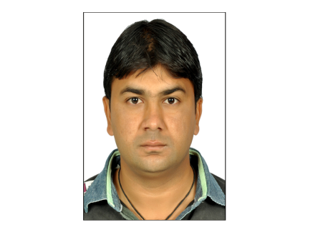 HARUN A.MALEK

**MALEK VAS,**

**AT:JETHLAJ, TA:KALOL,**

**DIST:GANDHINAGAR**

**MOBILE-: 9824733875**

**CAREER OBJECTIVE** :

## To pursue a challenging career in the field of Textile, Garment , Pharma, Plastics industry, Where I can prove my caliber and there by contributing to the growth of the organization and self.

## ACADEMIC QUALIFICATION_ :

* Senior Secondary : Passed in science stream from Guj. Board in 1998
* Higher Secondary : Passed in science stream from Guj. Board in 2000
* IT & E.COM: : Passed in IT & E.COM from GSCVT. BOARD

in S.K.PATEL INSTITUTE IN 2002

* Graduation : B.A.(English) From Samarpan Arts & com.

College in Gandhinagar, Sector-8, 2007 (Guj.university)

* Ielts : Passed Ielts exam From Aus.Univercity in 2009
* Ielts : Passed Ielts exam From Cambridge.Univercity in 2015

**PROFESSIONAL QUALIFICATION :**

* Knowledge of Computer, M.S. Office
* Internet
* **ERP,** NOW System, SAP,Orapse, BONRIX

**WORKING EXPERIENCE:**

* Worked with Aan pharma Ltd as a S**tore Incharge & Store Officer** since 14 June 2002 to 2 Dec. 2004.
* Working with Arvind Mill Ltd. At. Santej as a  **Store officer / Dispatch Officer**

from 2nd March 2005 to 20th July 2017.

* Working with Finecare Corporation Pvt.Ltd. as a S**tore Manager**  from 26Th July2017, to 20Th Apr. 2019.
* Working with Dubond Product India Pvt.Ltd. as a **Dispatch Executive**  from 26Th Apr 2019 to till Date.

**JOB PROFILE DETAILS :**

* Create Sales invoice & Dispatch material as per instruction…
* Every day do proper coordination for next day dispatch work with sales order department & marketing
* Every day follow up transporter for transportation
* Bring the different rate for transporter
* To fulfill complete process of every new material like INWARD,OUTWARD GRN & MRN & Bill passing.
* Regularly maintain courier inward register
* Create all material indents which are use in department …
* Release a PR(purchase Requisation) after check the book stock, If stock is available in book then inform to department & cancel the requisition.
* Check quantity & quality for all type of receipts & inform to user of department by mail.
* Responsibility of total receive material like Raw, packing, chemical, Oil & Lubricants and all type of spare parts.
* Arrange a Inhouse Repairing work with reference of our rate contract which is final by our Hod.
* Monthly stock report & non moving report send to HOD.
* Reject material send to party with debit note.
* Issue materials in departments with ref. of reservation slip.
* Arrange a vehicle for internal & External transfer activity with smoothly production.
* Pass transporter’s freight bills and send to account department.
* Arrange a repairing gate pass which material send to party (Outside of our company premises).
* Create waste material’s invoice & send the payment to our account department..
* Bring the different vendor's quatation, after rate approval send the order of vendor..

# STRENGTH :

* Self Confidence
* Capacity & willingness to work hard.
* Adaptability to any working environment.
* Optimistic in my career.
* Work Accuracy..

## PERSONAL DETAILS :

Name **: Malek Harunbhai Akbarbhai** Date of Birth **:** 19th September, 1982  
 Father Name **:** Mr. Akbarbhai B. Malek  
 Present Address **:** At.Jethlaj, Ta.Kalol, Dist.Gandhinagar, Malek Vas.   
 Language Known **:**  English, Hindi, Gujarati  
 Marital Status **:** Married   
 Nationality **:** Indian  
 Personal Interests **:** Playing Cricket, singing, drawing

**Date : 09.06.2021  
 Place : Jethlaj (Kalol)**

**Your’s trully**

**( HARUN A. MALEK)**