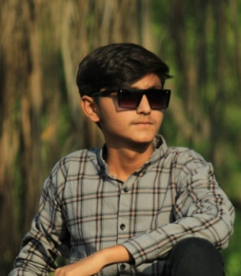Dharaiya Hit Rajeshbahi

Lathi Road,Near Sunflower School

Amreli-365601 Dist-Amreli.

Gujrat

[Email-dharaiyahit0@gmail.com](mailto:Email-dharaiyahit0@gmail.com)

Mo.9104624691

**Career Objective:**

Seeking Position that can provide a steady growth and learning opportunity to practice my profession and practical experience extensively.

**Education:**

|  |  |  |  |
| --- | --- | --- | --- |
| Degree | University | Year | Percentage |
| SSC | GSEB Gandhinagar | 2020 | 55.65 |
| HSC | GSEB Gandhinagar | 2022 | 50.40 |

**Personal Profile**

Name :-Dharaiya Hit Rajeshbhai

Death Of Birth :-20/03/2005

Gender :-Male

Marital Status :-Unmarried

Religion :-Hindu

Nationality :-Indian

Language :-Gujrati; Hindi

Hobbies :- Cricket

**Basic Knowledge**

Data Entry

Tally

**Declaration**

I here by declare that all furnished information is true to the best of my knowledge. I take full responsibility for the accuracy of the information and if given an opportunity I promise to give the best abilities to the Organization.

Dharaiya Hit R.