**RESUME**

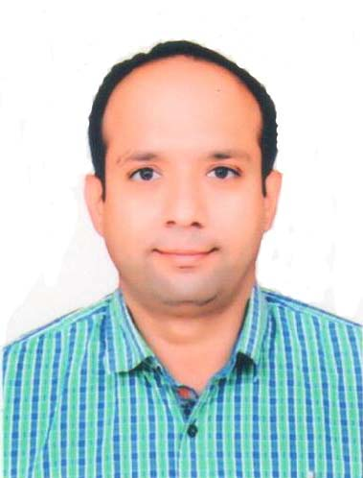

**CAREER OBJECTIVES**

To work in an organization where my technical skills, leadership qualities and experience can be optimally utilized for the growth of the Company in lieu of Stores/Warehouse/Office Management, Banking Sector, Administrative Department or Fire Asst Supervisor.

**PROFESSIONAL / OTHER QUALIFICATION**

* Diploma in Warehousing (Rani Durgavati Vishwavidhyalaya) University of Jabalpur.
* Proficiency Certificate for Physical Training and Drill (Indian Army)
* Security Training Certificate (Indian Army)
* Technical Training Certificate (Indian Army)

**EDUCATIONAL QUALIFICATION**

* 12th passed from Gujarat Secondary Education Board, Gandhinagar.
* Bachelor of Arts (English) passed from Gujarat University, Ahmedabad.
* Equivalent Graduation from Indian Army (Ministry of Defence)

**ARMY EDUCATION QUALIFICATION**

* SKsT Class - I
* MR Class - II

**KEY PERFORMANCE AREAS**

* Expert in handling various types of stores Auto Mobiles Spares & Parts, Ration, Ammunition, Clothing, Signals, Fuel Oil & Lubricant (FOL), Kote, Hyg & Chemical, Expendables, Tools & Special Maintenance Tools and Accommodations.
* Good skill in handling accountability of row materials, storage & packing materials
* Quality for timely accounting of physical stocks verification
* Good knowledge of demanding procedure as per three pad system, maintaining inventory of store items more than 1,20,000 type, Local Purchase, Chain & Logistic management, Care & Preservation.
* Quarter Master Branch Head Clerk.
* Security Asst Officer/ Security Officer.
* All Security & Manpower Management.
* Administration of all types of Management.

**-2-**

**JOB EXPERIENCE**

* 16 years 10 months experience as Store Keepers Technical in Corps of Electronics and Mechanical Engineers.
* Served in various Indian Army establishments and get opportunity to handling of different type of Stores/Warehouse.
* I performed the duties of Junior Commissioned Officer.

**PERSONAL MANAGEMENT**

**HRM/ HRD**

Oversee smooth implementation of security policies for manpower planning, recruitment, selection, induction and development of new employees in the organization. Being team leader with more than 100 persons under command for various objectives and at various forms.

**CORE COMPETENCIES**

* Expert in Store Keepers Technical field in any type of stores accounts.
* Expert in providing security to any organization within frameworks for maximum efficiency and benefit to the parent organization by maximizing levels of professional competence.
* Ensuring smooth operations at all time and maintaining proper decorum & discipline for full readiness by implementing & modifying the polices & procedures.
* Experts in any types of Physical Training and Drill.

**PERSONAL PROFILE**

Name : Tivari Jitendrakumar S

Date of Birth : 12 Nov 1983

Gender : Male

Marital Status : Married

Language Known : Hindi, Gujarati, English

Nationality : Indian

Organization : Indian Army

Date of Enrollment : 28 Sep 2001

Date of Retirement / Release : 31 Jul 2018

Total Service : 16 Years 10 Months

**MOBILE** : 7016371329 / 9409604778

**E-MAIL ID** : [jst1464@gmail.com](mailto:jst1464@gmail.com)

**DECLARATION :** Ideclare that all the above mentioned details are true to the best of my knowledge and belief.

D:\PERSONAL DETAILS\SIG.jpg

Place : Ahmedabad (Tivari Jitendrakumar S)