**KUSHAL B GAJJAR** 

**Mobile: +91 – 9558809083, 079 – 25468916**

**E-Mail: kushalgajjar14@gmail.com**

Aspiring for challenging assignments in **Logistics Warehouse operations/ Materials Management/**

**Procurement**  with an organisation of high repute

Industry Preference: Manufacturing

**PROFILE SUMMARY**

* B.E. in Mechanical Engineering with more than 13 years of experience in:

~ Inventory Control ~ Logistics Warehouse Operations ~ Supplier packaging

~ Cost Reduction & Budgeting ~ Vendor Development ~ Documentation

~ Purchase/ Procurement ~ Materials Management ~ Team Management

* Gained experience in coordinating with the suppliers (vendors) and enhancing their process operations, thereby achieving the required quality level in the supplies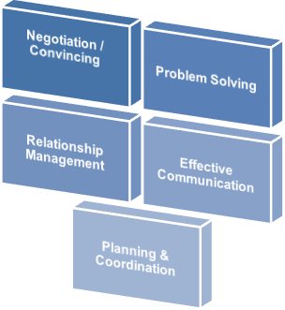
* Proven abilities in managing the logistics operations and planning daily work with thorough knowledge of the procedures involved in ordering, receiving, storing and delivering stocks
* Adept in sustaining the existing network & managing the supply chain for ensuring timely delivery of materials
* Established credibility in spearheading procurement plans / strategies and vendor identification / development with focus on strengthening effectiveness
* Deft at ensuring material availability at right quantity and at right time, meeting quality & cost requirements and coordinating in new product development process
* Effective communicator with honed negotiation & relationship management skills
* Excellent presentation skills

**CORE COMPETENCIES**



* Overseeing activities involving working out requirements and ensuring cost finalization for all kinds of materials 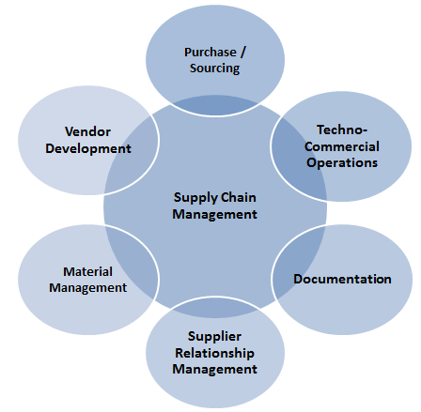
* Interfacing with cross-functional departments for drafting procurement and warehousing plans of raw materials
* Procuring material on day-to-day basis as per purchase indent requirement and following up with supplier for material procurement
* Managing inventory levels for ensuring ready availability to meet procurement & dispatch targets
* Coordinating with other depts. for material requirement & procurement and ensuring continuous supply at optimum costs
* Identifying and developing alternate vendor source for localization and achieving cost effective purchases of raw materials with reduction in delivery time & improvement in quality
* Lead in physical stock taking project

**ORGANISATIONAL EXPERIENCE**

**Since Nov’07: Bosch Rexroth India Ltd., Ahmedabad as Engineer and promoted in 2017 to Manager (Logistics)**

**Role:**

* Carried out techno-commercial scrutiny of purchase requisitions, procurement of hydraulic power-pack components and sheet metal & heavy fabrication
* Overseeing machining parts, estimation of drawing based parts and procurement of bought-outs (hydraulic power-pack accessories like valves, heat exchangers, pipes, fittings, motors & switches)
* Accountable for negotiating with vendors for drawing based Power Unit parts like oil tanks, valve tables, accumulator stands, frames, etc.
* Adhering to QAP requirements in fabrication items
* Coordinating with finance for payments & C-forms
* Handling responsibility of warehouse management ‎& ‎operational support
* Managing down payment request to finance
* Managing Continuous Improvement Project (CIP)-goods material movement from production, ‎‎inward area & purchase quality with the help of value stream mapping and swim lane diagram
* Administering Physical Operations Department with 30 workers (blue collar) and 5 white collar staff
* Conducting interview for Apprentice/Trainee Engineers in Logistics Inbound Department at Bosch Rexroth India Ltd.

**Projects Handled:**

* **Fabrication Improvement Project**: Educated vendor for welder qualification, product liability, process improvement, critical dimension, etc.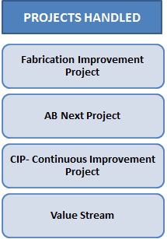
* **AB Next Project**- Coordinated with cross-functional teams to analyse and reduce hydraulic power-pack cost
* **CIP- Continuous Improvement Project**- Performed process optimization by identifying and eliminating non value-added activities and reducing time in current activities. Defined items, safety stocks, MOQ, bin size, rack design, equipment and complete material & information flow from production to supplier.
* **Value Stream**: Worked in Power Units and valves value streams
* FMEA Failure Mode & Effects Analysis (Material Shifting, Storage and supply to production)
* Time Window for material receipt
* External and internal milk run
* Visualization project (Fifo boards, process confirmations)
* Supermarket implementation with barcode and kanban card
* Perishable and preservation project
* Implementation of Supplier returnable packaging
* Physical stock taking and cycle counting
* Updating work instructions for material flow in warehouse
* Skill upgradation by providing trainings on Logistics Quality principles
* Supplier returnable packaging concept
* Reduction in plastic utilization
* Material directly kept in returnable KLTs which was previously warped in plastic bags
* Assurance of correct part with correct quantity as mix up is prevented also feasible to count

- Defined KLT for corresponding material also Material quantity per KLT is fixed (row x column = total qty)

* Dent/Damage due to transit and rust is reduced

- Jumping and touching of parts is avoided

* Proper identification with tag to maintain FIFO
* Ident number, Quantity, Vendor details, Invoice date
* Returnable packaging reduce packaging cost

- In addition to saving of packing material also Non value added activity like unpacking/repacking is reduced

**Accomplishments:**

* Bagged Man of the Match Award in company tournament & served as the Captain for the same
* Played a key role as Project Lead for successful implementation of Kanban System for over 400 items already established Kanban in hydraulic power-pack, cylinder, block and valve assembly 2 Bin System of B & C class items as a with barcode scanning facility
* Pivotal role in identifying new vendors like Ashhtec Engineering, Basic Engineering, Lancer Fabtech Pvt. Ltd. for fabrication drawing based items and developed 1.2 mm thickness sheet-metal cabinets along with other fabrication items like valve tables, cabinets & frames and achieved 10-15% cost reduction
* Served as Project Lead and managed Stock Management Project, with the help of ABC XYZ analysis identified all B & C class items and oversaw consideration MOQ, plant delivery time, daily consumption & vendor managed inventory for 400 plus items.
* Efficiently introduced digital scanning facility & developed procedure with PDCA and process confirmation
* Team leader in physical stock taking process and achieved inventory variance reduction stupendously to 1.7 % of total inventory.
* Leading team of 5 white collar and 30 blue collar in warehouse operations responsible for powerpack, manifold block, cylinder and valve manufacturing value streams.
* Generating purchase requisitions of consumable items related to production as well as developing bins/pallets for valve component items and active member in warehouse space optimization project.
* Implementation of supermarket in component value stream.
* 5S coordinator of warehouse
* Quality table representative from Logistics department.
* Implementation of FIFO board for casting.
* Perishable and preservation concept development for rubber and machining parts respectively.
* Supplier packaging and milk-run concept to minimize material damage and mix up issues.
* Catering daily production requirement of assembly lines and machine shop by work prioritization and distribution.
* Monitoring GRN making and shifting material target in same day.

**Apr’07-Nov’07: Midco Ltd., Ahmedabad as Materials Officer**

**Role:**

* Carried out effective planning and purchase of petrol pump components such as sheet-metal parts with powder coating
* Delivered support in the development of new vendors by explaining existing procedures, quality & design requirements

**Accomplishment:**

* Received Certificate of Excellence for manufacturing highest no. of nozzles, i.e., 2034 nozzles per month

**Oct’05-Feb’06: ABM Steels, Ahmedabad as Sales Officer**

**Role:**

* Coordinated with foreign customers such as Elaborate Clyde Bergemann (USA) and Johnston Sweeper (UK)
* Carried-out purchase planning for on-time order completion

**APPRENTICESHIP**

**February’06-April’07: Bosch Rexroth India Ltd., Ahmedabad Location as Apprentice**

**Role:**

* Handled the procurement of hydraulic power-pack components
* Carried-out estimation of drawing based parts and documentation

**TRAININGS**

* Attended training on Industrial Hydraulics encompassing:
* Cylinders & Selection Parameters in Hydraulic Power-pack Circuit
* Hydraulic Valves
* Coolers
* Pumps
* Electric Motors
* Filters

**EDUCATION**

index

2005 Bachelor of Engineering (Mechanical Engineering) from G. H. Patel College of Engineering & Technology, V. V. Nagar, Gujarat, Sardar Patel University in 2005

**TECHNICAL SKILLS**

Software: SAP, Microsoft Office & AutoCAD

Machines: Welding, Shearing, Bending & Hydraulic Press

**EXTRAMURAL ENGAGEMENTS & OTHER ACCOLADE**

* Adjudged as the runner-up in Inter Class Cricket Tournament at GCET College, Vallabh Vidyanagar, Gujarat
* Served as the Captain of Best High School Cricket Team
* **Memorize up-to 100 digits of PIE (3.1415….)**
* **Able to memorize deck of cards**

**PERSONAL DETAILS**

Date of Birth: 14th February, 1984

Permanent Address: 29, Bharatkutir, Punit Park, Maninagar, Ahmedabad-380008

Languages known: English, Hindi & Gujarati