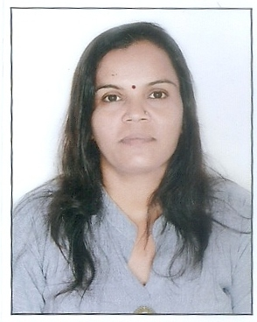

**CURRICULUM VITAE**

***KAILASHBEN PARESHBHAI CHAUHAN***

411/2350, Vivekanand Nagar,

Gujarat Housing Board,

Chandkheda, Ahmadabad -382424(Gujarat)

E-mail: [kailashparesh@gmail.com](mailto:kailashparesh@gmail.com)

: +91-**7046398498** / 7984126219

**Objective**

A treatment coordinator “closes,” or assists the doctor in closing, the doctor's recommended treatment plans. This position **assumes responsibility of the entire patient base and works toward having all patients complete their treatment plans**

**Academic Qualification**

* S.S.C. Completed from Gujarat Board in March-1997 with 65.86%
* H.S.C. Completed From Gujarat Board in March 1999 with 57.33%
* Bachelor in Arts Completed from Sardar Patel University Anand in April -2018 with pass class.
* Master in social worker completed from HNGU Patan in year 2021 with first class.
* Master of arts in Sociology pursuing from Singhania University in year 2021

**Computer Knowledge** : CCC certificate from Smearing Information Technology Pvt. Ltd with B Grade

**Personal Profile**

**Husband`s name** : Pareshbhai Chauhan

**Gender** : Female

**Date of Birth :** 18th Sep. 1981

**Marital Statuses :** Married

**Nationality :** Indian

**Hobbies** : Listening Music, Hard working

**Language Known** : Gujarati, Hindi& English

**Working Experience :**

* Have worked with **MAX LIFE INSURANCE** as a Agent Advisor from 2008 to 2013.
* Have worked with **PRAGATI VIDHALAYas**a Ass. Teacher from 2012 to 2013.
* Have worked with PULKIT VIDHALAYas a Ass. Teacher from 2013 to 2018.
* Have worked with **JEET PROJECTS** as a HUB AGENT from 2018 to 2019.
* Have worked with **JEET PROJECTS** as a Treatment Coordinator from 2019 to 31st March 2021.
* Currently working with Alert India as a Treatment Coordinator from 01st April 2021 to Till Date.

I Certify that the above information given by me is true the best of my Knowledge and experience.

If given an opportunity in your organization I shall discharge my duties to the best of my ability and honesty. I hope you will accept my application and give me a chance to prove my ability.

**(Kailashben P Chauhan)**