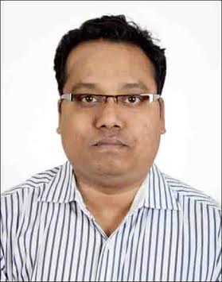

**KUMAR RITWITZ ASHWAL**

**Contact@:** 09727755282

**E-Mail@:** [ritwitz.m@gmail.com](mailto:ritwitz.m@gmail.com)

# CAREER OBJECTIVE

**A Result oriented professional with a demonstrated record of achievement in conceiving & implementing ideas that fuel market place presence and drive revenue**

# PROFILE SUMMARY

**Over 16 years** of experience in **Sales & Marketing, Retail Operations, New Business Development, Appointment of new Channel Partners, Product Placement &Management Channel Management ,and Sales operations Customer Relationship Management**. Hands-on experience in directing marketing activities across channel of distribution and handling communication for brands which includes all below the line (BTL) activities including outdoor publicity, event & promotions, product launch & retail visibility. Proficiency in conducting market research, developing retail strategies and liaising with corporate team for providing market intelligence feedback & suggestions with a view to maximize operational efficiency.

Skilled in preparation of technical reports and commercial reports .Competency in cementing healthy relationship with the clients for generating business as well as defining service standards and guidelines that serves as benchmark for excellent service delivery. Experience in guiding and training the channel partners in achieving business objectives, Achievement oriented professional with excellent people management skills and an ability to manage change with ease.

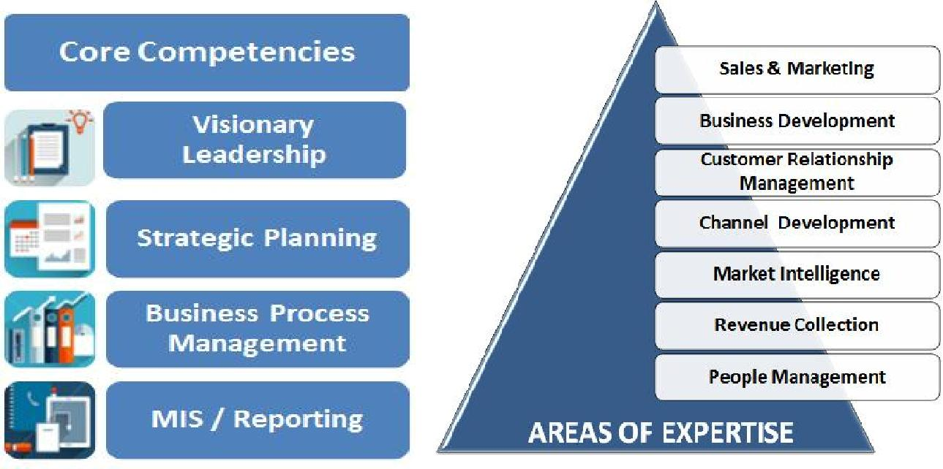

# CORE COMPETENCIES

* Developing and appointing financially strong / reliable business partners to expand product reach in the market
* Analyzing weak areas at the dealerships & taking counter measures to improve the satisfaction
* Carrying out periodic monitoring of the performance of dealers & distributors regarding sales and collections
* Formulating tactical plans for enhancing product visibility & brand building through medium such as product displays, road shows & other creative promotional campaigns
* Hired the best Person of the Industry as Managers and In- shop Promoters and trained them.
* Mentoring high-performing marketing team for ensuring optimum performance to deliver quality services.
* Mentoring the process as per the companies Guidelines.

# ORGANISATIONAL EXPERIENCE

**Nov’15- : Indus Towers Ltd. Ahmedabad as Manager, Site Acquisition.**

**Key Result Areas:**

* Supervised the Managed a Team of 10 officer for Telecom Tower sites of Ahmadabad and North Gujarat as well as entire Gujarat as Zonal Lead
* Conceptualizing strategies for long term business Direction to ensure Maximum Profitability in line with organization objectives, like rental control and Maximum Tenure and also care of owner satisfaction.

**Dec’10- May’15:** **Videocon Telecommunication Ltd., Ahmedabad as Deputy Manager, Sales**

**Key Result Areas:**

* Supervised the overall business operations of Ahmadabad and North Gujarat as Zonal Sales Manager into sim paired Mobile Handsets on Supervising the 12 CSM(On role), and after winding up the business by Videocon Mobile Services Supervised Ahmedabad as sales Manager of Ahmadabad into sim card business I looked after one distributor into Ahmadabad Territory with full accountability for profitability in commercial aspects
* Conceptualizing strategies for long term business directions to ensure maximum profitability in line with organizational objectives

 

**Main Highlights:**

* Efficiently introduced new products & services as ZSM at SIM paired mobile handsets which resulted in high visibility of the brands into the Market by looked after 25 distributor of Ahmadabad and North Gujarat
* Holds the merit of being selected as the 3rd Best Sales Manager at telecom in Gujarat Circle, A contest held at Videocon Premier league during 2011-2012
* Adjudged as Best Performer for the Dec’12

**May’10 - Dec’10:** **MVL Telecom Ltd., Gujarat as State Head**

**Key Result Areas**

* Successfully Launched into Gujarat Market
* Appointed 5 Super Distributor at District Level looked after by a team of 4 Assistant Managers (on company payroll) reporting me, one each in Ahmedabad, Surat& Navsari, Baroda, Bhavnagar
* Administered a channel of 5 Super Distributors of mobile Handset.
* Controlled the sales and marketing of entire Gujarat.
* Within the two month of his starting, this company do the business of 1Cr., into Gujarat Territory, Highest among all western region.

**Main Highlights:**

* holds the merit of attaining the highest revenue collection for the company across the entire western region
* Gujarat become the First state by the Company who within a span of one month of his launch able to do highest number of Primary and secondary sales.

**May’09 - Mar’10:** **Universal Digital Connect Ltd. (A subsidiary of Videocon Mobile) , Gujarat as Branch Head - Bhavnagar & North Gujarat**

**Key Result Areas**

* As an Branch Head of Mobile Handset Business ,led the complete business operations with accountability for profitability in commercial forecasting of monthly/ annual sales targets & executing them in given time frame by organizational planning
* Accountable for establishing new DSA (Direct Sales Associates) and DRA (Direct Retail Associate)
* Help the Company to establish the handset Business into Gujarat By appointing Distributor of Baroda, Ahmedabad, Bhavnagar, North Gujarat, and Rajkot.

**Main Highlights:**

* Diligently ensured achievement of quantity as well as quality sales and provided effective after sales services
* Successfully led the appointment of two RDS into **Maharashtra Vidarbha Region, one in Nagpur and other at Akola District** and initiated billing for Videocon Mobile as a special assignment from Sep’09 to Nov’09
* Accomplished planned sales volumes and market share for Videocon mobiles in assigned circle
* Actively involved in developing new markets in North Gujarat with the support of 3 Direct Sales Associates and 400 Retail Associates

# ORGANISATIONAL EXPERIENCE Contd.

|  |  |
| --- | --- |
| **Oct’06 - Apr’09:** | **Spice Mobiles Ltd., Gujarat as State Head** |
| **Feb’06 - Oct’06:** | **Kidstuff Promos and Event Pvt. Ltd., Delhi - NCR (Motorola India Pvt.** |
|  | **Ltd.) as Moto Agent (Business Development Officer)** |
| **Jun’04 - Jan’06:** | **Infomedia India Limited, Delhi as Sales Executive** |
| **Feb’00 - Mar’02:** | **Kailash International Pvt. Ltd., Patna, Bihar as Sales Executive** |
| **Jan’93 - Feb’96:** | **Maurya International Pvt. Ltd., Patna, Bihar as Sales Executive** |
| TRAINING ATTENDED | |
| **Aug’03 – Aug’03:** | **The Primus Company, Delhi as Trainee** |
| Project Title: | Assessment of Levi’s and Dockers Accessories in West Delhi Market |
| Scope: | The project focused on mapping of prospective retail outlets and creating |
|  | awareness among the retailers about Levis Accessories. |
| **Apr’03 - Jun’03:** | **Britannia Industries Limited, Delhi as Summer Trainee** |
| Project Title: | Strategy to Improve the Market Share of Cheese Cubes and Spread in South |
|  | Delhi Region |
| Scope: | The project aimed at assessing the market share of Britannia Cheese Cubes and Cheese |
|  | Spread in this area and then giving out what the customer was looking for in Britannia in |
|  | terms of competitor. |

# IT SKILLS

* Well versed with MS Office, Windows 07 and Internet Applications

# EDUCATIONAL QUALIFICATION



* **Post Graduate Diploma in Business Management (Marketing)** from Institute of Productivity & Management, Meerut (UP) in2004
* **B.Com.(Accountancy)** from College of Commerce, Patna, Magadh University(Regular) in 1999



# ACADEMIC PROJECTS

* Successfully completed projects on:

o **Consumer Preferences on House Loans** offered by various Banks in Pallavpuram Area, Meerut **Buying Preferences of Consumers for Detergents** in Pallavpuram Area, Meerut

# PERSONAL DETAILS

|  |  |  |
| --- | --- | --- |
| Date of Birth | : | 1st March 1977 |
| Address | : | B-202, ICB Flora, Behind Vodafone Tower, S.G. Highway, Near Gota Circle, New Ranip, |
| Place of Birth | : | Ahmedabad, Gujarat-382481  Patna, Bihar |
| Languages Known | : | English and Hindi |
| Location Preference | : | No Preferences |