## **RESUME**

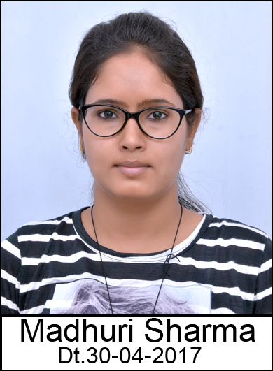

**Full Name**: - Madhuri Sharma

**Mobile No.**: - (+91) 9979539281, 9157609240

**Email id**: - madhurisharma26294[@gmail.com](mailto:sssadarshsss@gmail.com)

**Career Objective**

To secure a challenging position in a growth oriented, esteemed organization that will utilize my knowledge, ability, technical skills to the maximum and to learn and improve my skills for the better.

**Personality Traits**

Leadership, Adaptivity, Regular, Punctual, Smart Working , Optimistic.

**Academic Qualification**

|  |  |  |  |  |
| --- | --- | --- | --- | --- |
| Degree | Name of the Board/University | Year of Passing | Marks Obtained(% or CGPA) | Remarks |
| 10th (SSC) | CBSE | 2010 | 8.0 |  |
| 12th (HSC) | CBSE | 2012 | 73.4% |  |
| B.Sc.(Hons) Horticulture | SDAU | 2017 | 8.02 | First Class With Distinction.  With Fellowship |

**Computer Competency**: - Studied in SSC and in B.Sc. (Hons) Horticulture (course BSC 1.1 in 1st Semester of credit (1+1)), Ms-Office ,internet surfing .

**Academic Experience**

* Training in Rural Agricultural Work Experience (RAWE) for 5 months in 8th Semester under B.Sc. (Hons) Horticulture programme.
* Training in Experimental Learning Programme (ELP) for 5 months in 7th Semester under B.Sc. (Hons) Horticulture programme.

**Languages known**

|  |  |  |  |  |
| --- | --- | --- | --- | --- |
| **Languages** | **Read** | **Write** | **Speak** | **Understand** |
| Hindi | Yes | Yes | Yes | Yes |
| English | Yes | Yes | Yes | Yes |
| Gujarati | Yes | No | Yes | Yes |

**Extracurricular Activities**

* Served as NSS Volunteer in B.Sc. (Hons) Horticulture.
* Participated in intercollegiate Badminton Tournament and secured 1st Position and also selected for IU (inter-university) player during 2016-17.
* Participated in intercollegiate Badminton Tournament and secured 1st Position during 2015-16.
* Participated in various quiz competitions at HSC & SSC level.
* Participated in leadership training seminar by rotary club Deesa ( RYLA-2015).
* Participated in all India environment awareness competition and secured 64%.
* Completed the training course “aquifer management through participatory approach and local ground water issues Dantiwada, Banaskantha, Gujarat” (20th to 21st February 2014).

**Permanent Address**

House No.22 Neelam park society, Radhanpur road, Mehsana, Gujarat pin code -384002

**Personal Details**

* Date of Birth: - 26/02/1994
* Nationality: - Indian
* Gender: - Female
* Marital Status: - unmarried

**Hobbies**

Playing Badminton, Gardening, Cooking, Interacting with new people.

**References**

|  |  |
| --- | --- |
| Dr. Sanjay P. Pandya | Technical Officer to vice chancellor at SDAU Agriculture university, Dantiwada(Gujarat)  Mo-9408418675 |
| Ms. Laxmi Rani Dubey | Assistant Professor& Placement Cell Incharge, College of Horticulture,SDAU, Jadugan, Gujarat-382710. Mo. 9624252284 |

**Declaration**

I hereby declare that the above information is true and correct to the best of my knowledge and belief.

Place: - (signature)

Date: - MADHURI SHARMA