RESUME

**Ms. Manorama Rath**

**VR-67, Unit-6, BBSR-751001**

**Mob: 09040023390/ 9439867574**

**Email: manoramaratha@gmail.com**



**Objective:**

To acquire a growth oriented position which helps in building a purposeful career and contributing towards fulfillment of organizational and individual goals, while consistently enriching both.

**Professional Qualification**:  
Post Graduate Diploma in Banking (PGDB) from IFBI (NIIT, Bhubaneswar ) in 2012.

**Educational Qualification**:

* Master of Business Administration (2012-2014) from United School of Business Management (affiliated to Biju Patnaik University of Technology, Odisha) with HR & FINANCE Specialization securing 66.5 % (CGPA – 7.15) .
* Bachelor of Business Administration from United Institute of IT & Management Studies (affiliated to Utkal University, Odisha ) 2012 securing 68% with honors .
* +2 Arts from CHSE, Odisha 2009 securing 54% .
* Matriculation from BSE, Odisha in 2007 securing 56% .

**Industrial Exposure:**

* Summer Internship on “Corporate Social Responsibility” at T S Alloys Limited (A 100% Subsidiary of TATA Steel)
* Summer Internship on “Employee Engagement” at Reliance Communications Limited.

**Qualitative Skills**:

* Ability to work in new and challenging, as well as deadlines driven environment.
* Willingness to work in groups and ability to lead group activities.
* Willingness to learn new concepts and ideas involving new technologies with an ability to adapt quickly and implement effectively.
* Good in dealing with different types of people.

**Achievements**:

* **Topped** in PGDB with maximum Credit point in the year **2012**.
* Got **Best Presentation Award** in the year **2011** & **2012** .
* Got **Rajya Puraskar** from The Bharat Scouts & Guides in **2007** .
* Got **Third** Position in All India Local Self Government Debate Competition in the year **2002**.

**Hobbies and Interests**:

* Singing
* Making presentation with Power Point

|  |  |
| --- | --- |
| **Father’s Name** | Dr. Lingaraj Rath |
| **Mother’s Name** | Mrs. Kirtimayee Rath |
| **Date of Birth** | 1st July 1992 |
| **Marital Status** | Married |
| **Sex** | Female |
| **Nationality** | Indian |
| **Religion** | Hindu |
| **Language Known** | English , Hindi, Odia , Bengali |

**Personal Profile:**

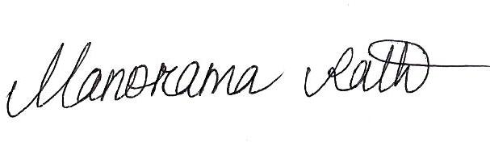

**Place: Bhubaneswar**

**Date:**