**Name  Mausam K. Parikh**

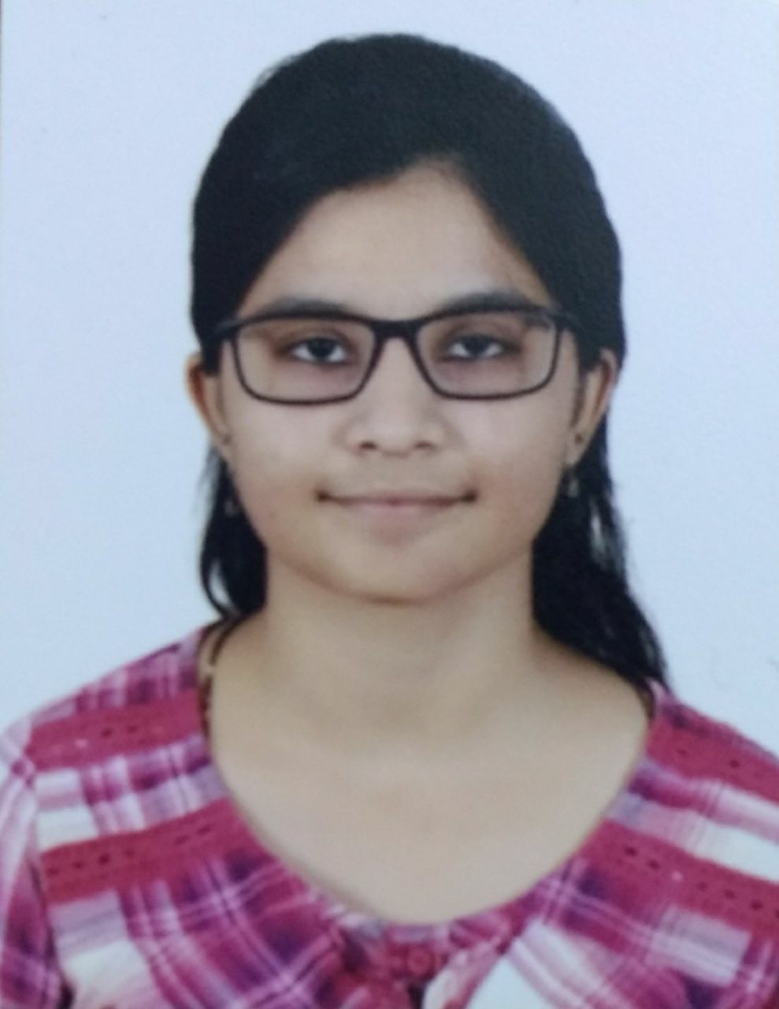

*Address*  74/633,Pushpak Appt.,

Near 132ft Ring Road,

Naranpura,Ahmedabad-380063

*Mobile no* - 8733973790

*Email id*  - mausamparikh15@gmail.com

**Career Objetive**

I want to peruse career in elemental fields of Marketing .

**Educational Qualifications**

|  |  |  |  |  |  |
| --- | --- | --- | --- | --- | --- |
| **Qualification** | **School/College** | **University/Board** | **Year** | **Specialization** | **Score** |
| MBA | Som-Lalit Institute of Management Studies | AICTE | 2016 -2018 | Marketing | pursuing |
| B.M.S | Gujarat University | Gujarat University | 2016 | N/A | 3.92/5 |
| Class XII | Navrang High School | Gujarat Board | 2013 | N/A | 78.80% |
| Class X | Navrang High School | Gujarat Board | 2011 | N/A | 76% |

**Summer Internship**

**Company : Indai Film Project**

Project Title : Marketing of Web series

Duration : 4 months

Accomplishments : Under this internship I have done maarketing of webseries of named TalkShop through different forms like facebook,Instagram,Newspapers,Seo etc.Along with I was taking care of their E-commerce and Digital Marketing of India Film Project Season 7.

**Academic Projects**

**Project Title : Feasibility Report on Bakery Products**

Duration : February 2015 to April 2015

Accomplishments : Under this project we done primary research through questionnaires to understand Consumer preference and current scenario of the market and we concluded that our project was feasible.

**Project Title : Feasibility Report on Event Managment**

Duration : February 2016 to April 2016

Accomplishments : Under this project we done primary research through questionnaires to understand Consumer preference and current scenario of the market and we concluded that our project was feasible.

**Project Title : Report on Vadilal**

Duration : December 2016

Accomplishments : Under this project we done primary as well as secondary research through questionnaires and observation to understand the management concepts.

**Volunteer Experience**

As an Event Coordinator in SPECTURM 2017 (College Fest)

As an Host at Café Coffee day in 2016(Event from Grapevine)

As an Event Coordinator at Go Green Marathon by DCB Bank

**Skills**

* Leadership skill
* Negotiation Skill
* Microsoft Excel
* Content Writing