**CURRICULUM VITAE**

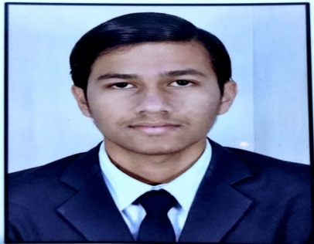Name: Mohit Satyanarayan Chauhan

Address: F/401 Yash Avenue, IOC Road,

Chandkheda ,Ahmedabad 382470

Mobile no.: 9664512042, 9998369644

Email: [mohitchauhan4302@gmail.com](mailto:mohitchauhan4302@gmail.com)

Linked id: [www.linkedin.com/in/mohit-chauhan-89a5011ab](http://www.linkedin.com/in/mohit-chauhan-89a5011ab)

**Career Objective:**

Looking for a challenging position and high growth in Pharmacy field to prove my competence in discharges of duties assigned and commitment in completion of assignment to the best of my working capabilities.

**Education:**

|  |  |  |  |  |
| --- | --- | --- | --- | --- |
| **DEGREE** | **YEAR** | **INSTITUTE** | **BOARD/UNIVERSITY** | **MARKS** |
| B.Pharm | 2022 | Arihant School of Pharmacy and Bio Research Institute | Gujarat Technological University | 8.09 CGPA or  75.9% |
| HSC | 2016 | Infocity Junior Science College | Gujarat Board | 70% |
| SSC | 2014 | The New Little Flower School | Gujarat Board | 75% |

**GPAT Score: 110/500**

**B.pharm Project:**

|  |  |
| --- | --- |
| TITLE | Formulation and evaluation of bupropion medicated lozenges for supporting smoking cessation therapy |

**Internship:**

I was a student intern in Production department, QA department and QC department at

Memphis Vision Care Private Limited.

**Seminar attended:**

Delegate in seminar GUJCOST Herbal marker used in evaluation of phytoconstituent.

**Technical Skill:**

Knowledge of ICH-GCP guideline.

Basic knowledge of clinical trials and clinical research.

Basic computer skill including MS word, MS PowerPoint, Excel, etc.

**Social work:**

Blood donation at Sanjivani blood bank and apheresis center ID No A1356119

**Reference:**

Dr. Nishith Patel Assistant Professor

Arihant School of Pharmacy and Bioresearch Institute

Mob No 8140094244

**Declaration:**

I hereby declare that the above mentioned facts are true to the best of my knowledge.

Date:

Place: Ghandinagar