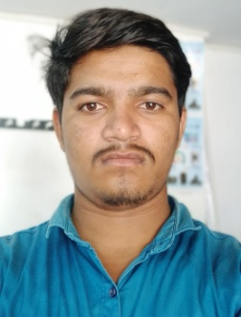

Resume

Pateliya Ranjit Address:-

ranjitpateliya1998@gmail.com At:Meni

Mo:7572808252 Po:Kheroli

Ta:Virpur

Career Objective:-

To Secure A Challenging Position Where I Can Effectively Contribute My Skill As Software Professional Excellent Communication Quick Learner And Can Easily Adapt To New And Changing Situations. Self Motivated Achiever With Established Reporting. Willingness To Learn And Work Hard.

Education Qualification:-

|  |  |  |  |  |  |
| --- | --- | --- | --- | --- | --- |
| **College/Board** | **Level** | **Year Of/Passing** | **Marksobtained** | **Total** | **Percentage** |
| Gujaratsecondaryeducatn Board | 10th  (Ssc) | March 2013 | 449 | 600 | 89.63% |
| (I.T.I) N.C.V.T | Electrical | July 2015 | 492 | 675 | 73.43% |

Personl Profile:-

Name : Pateliya Ranjitsinh

Father’s Name : Bhavansinh

Sex : Male

Marital Status : Married

Nationality : Indian

E-Mail : ranjitpateliya1998@Gmail.Com

Hobby : Drawing And Playing Cricket

Permanent Address : At-Meni

Po-Kheroli

Ta-Virpur

Dist-Mahisagar

Contact No : 7572808252

Date Of Birth : 03-06-1998

Languages Known : English,Gujarati,And Hindi

Declaration:-

I Hereby Declare That The Above Mentioned Information Is Correct Up To My Knowledge And

I Bear The Responsibility For The Correctness Of The Above Mentioned Particulars.

Good In Work:- Iti Electrical Ncvt

2 Year Apprenceship:- Iti Lunawada

Place:Virpur R B Pateliya