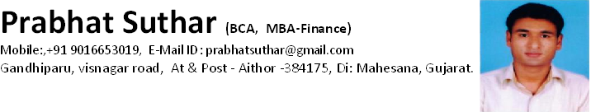

##### Educational Qualifications

|  |  |  |  |  |
| --- | --- | --- | --- | --- |
| **Degree** | **University** | **Year** | **Percentage** | **Class** |
| MBA  (Finance) | Hemchandracharya North Gujarat university, Patan | 2010 | 59.60 % | B |
| BCA | Hemchandracharya North Gujarat university, Patan | 2008 | 66.75% | Second |
| 12th | GSEB, Gandhinagar | 2005 | 64.83% | First |
| 10th | GSEB, Ganghinagar | 2003 | 66.00% | First |

**Computing Skills**

MS Office Package and Internet, C , C++, Oracle, DBMS, VB, COBOL.

##### Personal Profile

|  |  |  |
| --- | --- | --- |
| Full Name | : | Suthar Prabhatkumar Vinubhai. |
| Date of Birth | : | 07/06/1987 |
| Gender | : | Male |
| Marital Status | : | Unmarried |
| Nationality | : | Indian |
| Languages Known | : | Gujarati ,Hindi and English |
| Interests | : | Net surfing, Traveling and Playing outdoor games. |

**Experience:**

**Company Name: Intas Pharmaceuticals ltd. (Parma Div.)**

**Post : Field Sales officer**.

**Duration: 5-May-2012**  **to 30-Oct-2016**.

**Mehsana Pool**.

**Company Name: Intas Pharmaceuticals ltd. (Parma Div.)**

**Post : Area Business manager**.

**Duration: 1-Nov-2016**  **to till date**.

**Area : North Gujarat + Bhuj**.

**Company Name: Venetus Pharmaceuticals pvt ptd.**

**Post : Area Business Manager.**

**Duration: 1-April-2017**  **to till date**.

##### References

1. Mr. Anilkumar Sharma.

Area Business Manager.

Delcure life science ltd.

Ahmedabad.

Contact No.: 094273 19302

1. Mr. Rashmin J Patel.

Veterinary Sales Executive ,

Zydus AHA.

Surat.

Contact No.: 096243 25043