Name: Pranjyoti Saikia 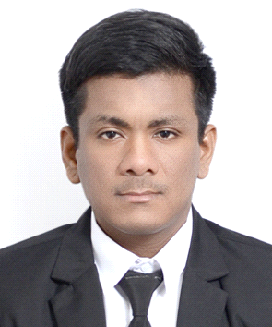

Date of Birth: 31st March, 1988

Nationality: Indian

Teaching Qualification:

American TESOL 120 hours in class certification from Bangkok.

Thailand temporary teacher’s permit.

Teaching experience:

* TESOL training and teaching practice. Taught English to Thai students of grade M1,M2 and P2 in government school. Taught basic English, listening and reading.
* Taught English, science and mathematics to poor kids under the TEACH INDIA campaign by TIMES OF INDIA newspaper. For one year every weekend taught poor kids basic English, science and mathematics.
* Worked as SPOKEN (CONVERSATIONAL) English instructor in S.K INSTITUTE in Ahmedabad, Gujarat for 6 months. Taught conversational English to intermediate students, company professionals.
* Private one-on-one English tuitions to Thai friends. Taught basic and conversational English to many Thai friends.
* Taught basic and conversational English to co-workers.
* Taught English, Science, Maths, Physical, Health to kindergarten and Prathom 1 and 2 at Tseban krabyai municipality kindergarten school, Ratchaburi, Thailand.
* Taught English online to Indian, Thai and Indonesian students as online tutor for Edume teacher.
* Taught Physics to English program Mathyom M4,M5,M6 at Rayongwittayakom school, Rayong, Thailand.
* Teaching Science to Mathyom 3 and Physics to Mathyom 4,5 and 6 at Mini English program at Yasothon pittayakom school,Yasothon, Thailand.
* Taught Marine and Mechanical engineering at Asian Maritime technological college, Chonburi, Thailand. Responsible for managing the Marine engineering and mechanical engineering department. Incharge of Full mission engine room simulator, leading simulator instructor and trainer.

Educational Qualification:

Bachelor of Technology (Mechanical engineering)

Certificate of competency of Engineer officer of watch

Languages known:

* ENGLISH(READ, WRITE, SPEAK)
* THAI(SPEAK{INTERMEDIATE})
* HINDI(READ, WRITE, SPEAK)
* PUNJABI(SPEAK)
* GUJARATI(READ, WRITE, SPEAK)
* ASSAMESS(SPEAK, WRITE, READ)

Work experience:

Worked as Marine engineer for two years in Siam lucky marine.

Computer skills:

* Microsoft Office
* Microsoft PowerPoint
* Microsoft Excel
* ANCI C,C++

TOEIC SCORE:945