PRASHANT KHADSE

**B U S I N E S S M A N A G E M E N T**

**P R O F E S S I O N A L**

# B R I E F O V E R V I E W

I am a seasoned Business Management professional with 30 years of diversified experience. I have work experience in multinational, multilingual environment across India, West Africa and Middle East. My core strenghs are Business

Analysis and assessment, Cost management, Innovation

Management, Business process strategy and automation,

Building high performing teams for core Functions

# E D U C A T I O N A L H I S T O R Y

***Bachelor of Engineering(Civil) Dec-1990***

Government College Of Engineering, Amravati

***Certificate Course in Building High Performing Teams-***

***May-2014***

*IIM Banglore*

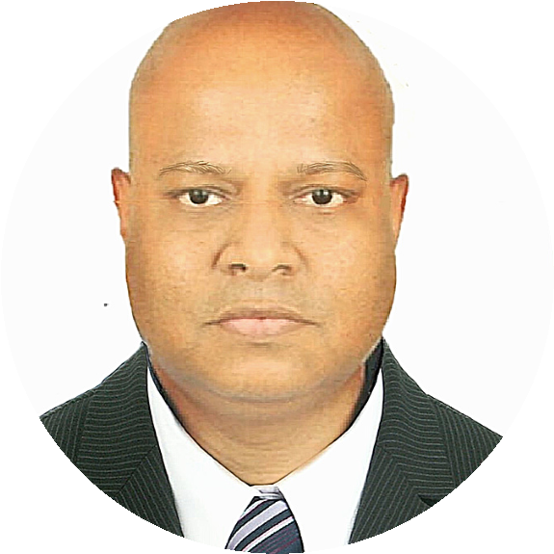

Address: SUREL APARTMENT,

BODAKDEV, AHMEDABAD

+91 7796111729

prashantkhadse@gmail.com

**C**

**O**

**N**

**T**

**A**

**C**

**T**

**M**

**E**

**A**

**T**

**C**

**O**

**R**

**E**

**K**

**N**

**O**

**W**

**L**

**E**

**D**

**G**

**E**

Business Management

Budgeting and Cost

Analysis

P&L Management

Operations Management

Impact Assessment

Process Launching and

automation

Acquisition Strategy

Innovation , Health &

Safety Culture

# W O R K E X P E R I E N C E

## Director of Operations

*Pacifc Pearl Infratech*

*Ahmedabad India. Feb 2018 - Till Date*

Smart City Project implementation

Business growth and scale up strategy

Business coaching and mentoring

Functional Gap analysis and solution

## National Quality Head

*Bharti Infratel Ltd ( Head Office)*

*Gurgaon India Nov 2011 - Jun 2017*

QAP for site, raw material, product, technical compliance

Launch business processes and drive for compliance

Automate the processes using IT support

Run PDCA cycle for all the processes periodically and make amendments

Create Operation's Health and Safety policy

Drive innovation culture

Plan all the Audits for Project and O&M

Review product performance wrt design specs

## National Civil Works Manager

*Nokia Siemens Networks*

*Riyadh, Saudi Arabia. Oct 2009 - Oct 2011* Drive team performance to get monthly targets

Managed to reduce the Civil Works Lead Time to acceptable global values of 20 days for consistent months.

Developed specific model suitable for HAJJ area where space is constraint.

Initiate dialogue with different Operators for possible Telecom Infrastructure hiving off via M&A

## Circle Head, Gujarat and Regional O&M Head (West)

*WTTIL( Subsidiary of Tata Tele Services), Ahmedabad*

*Ahmedabad, India. Feb 2008 - Sep 2009*

Achieved the highest mile stone for Network uptime in West Region as 99.99% for consistent period of time.

Initiated training for the maintenance of key equipments like AC, DG Power plant for quick problem solving.

This was the major factor in arresting the faults.

Bagged orders from the new entrants based on the highest quality of maintenance. This was the major advantage for our sales team.

Due to innovative measures for the power back up, our network uptime was increased to 99.99% across circles in West Region.

**G T L G R O U P**

**Circle Head, Maharastra & Goa** *GTL infrastructure LTD Oct’07- Feb’08*

Led a Circle with team of professionals like Deployment, O&M, HR, Finance, SCM, to roll out Telecom Tower Business as Profit centre unit.

## Project Head, Africa

*IGTL Solutions, Dubai*

*Lagos, Nigeria June2006- Oct 2007*

Handled Swapping of BTS project

Roll out GSM sites in Guinea Conakry for Ericsson

## Senior Manager

*GTL Limited Mar 2002 - June 2006*

*Key responsibility was managing OFC project, GSM site Infra and Telecom site rollout*

*OFC projects in Maharashtra, UP and WB*

*GSM rollout project in Rajasthan, Maharashtra, Gujarat.*

**P R E V I O U S W O R K E X P E R I E N C E** *J u n e 1 9 9 1 - F e b 2 0 0 2*

*Quantity survey of Municipal Project in Navi Mubai*

*OFC project for Huges Telecom in Mumbai*

*OFC project for Concept Group of Telecom in Nigeria and Yemen*

*ETP project for Enviro Consultant in Nasik*

*Industrial project construction of Tiles Factory and Drug plant for Dalal Consultants*

*ETP and DM Water plant for Thermax Ltd through Milind Kulkarni & Associate*

*Specialized Tremix Flooring for industrial units, road and bus depot for Master Floors*

**T R A I N I N G S**

Finance for Nonfinance

PMP Boot camp

MS Projects

Emotional Intellegence