**OBJECTIVE** 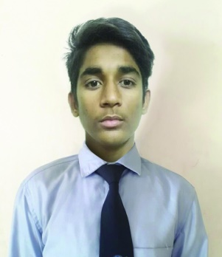

Give the best of my efforts & synergies towards the growth of your organization coupled with constant

learning& advancing my analytical skills.

**EDUCATION QUALIFICATION:**

* **BBA in Airport management** – (Pursuing) from Panache Academy, Ahemdabad, India
* **HSC** (2017) From PIONNER SR SEC. SCHOOL GADI (BANSWARA)
* **SSC** (2013) From VIDHYA NIKETAN SEC SCHOOL PALODA (BANSWARA)

**PERSONAL DETAILS**

Date of Birth : 22 November 2000

Sex : Male

Height : 168 cm

Weight : 52 kg

Meal : vegetarian

Eye-sight : Clear Vision

Marital Status : Unmarried

Nationality : Indian

Permanent Address : Sti Chauk Mohalla, Paloda, Banswara, Rajasthan - 327605

**HOBBIES AND INTEREST**

* Cricket
* Listening music

**PERSONAL COMPETENCIES**

* Hard Working
* Adjustable
* Knowledge and ability to solve problem

**COMPUTER SKILL**

* Basic knowledge

**LANGUAGE PROFICIENCY**

|  |  |  |  |  |  |  |  |  |  |
| --- | --- | --- | --- | --- | --- | --- | --- | --- | --- |
| Languages | READ | | | SPEAK & UNDERSTAND | | | WRITE | | |
| Excellent | Average | Poor | Excellent | Average | Poor | Excellent | Average | Poor |
| English |  |  |  |  |  |  |  |  |  |
| Hindi |  |  |  |  |  |  |  |  |  |

**REFERENCES**

|  |  |  |  |  |
| --- | --- | --- | --- | --- |
| Reference – 1 | |  | Reference – 2 | |
| Name | Ms. Khushnum Avari |  | Name | Mr.Pushkar Gupte |
| Address | Panache Academy,  211/212 Shangrila Arcade ,  Shyamal Cross Roads,  Shyamal, Ahmedabad |  | Address | Panache Academy,  211/212 Shangrila Arcade ,  Shyamal Cross Roads,  Shyamal, Ahmedabad |
| Mobile | +91 9879106350 |  | Mobile | +91 9909000450 |
| Mail ID | [panache.amd@gmail.com](mailto:panache.amd@gmail.com) |  | Mail ID | [pushkargupte03@gmail.com](mailto:pushkargupte03@gmail.com) |