**Rajput Virendra B (Retd)**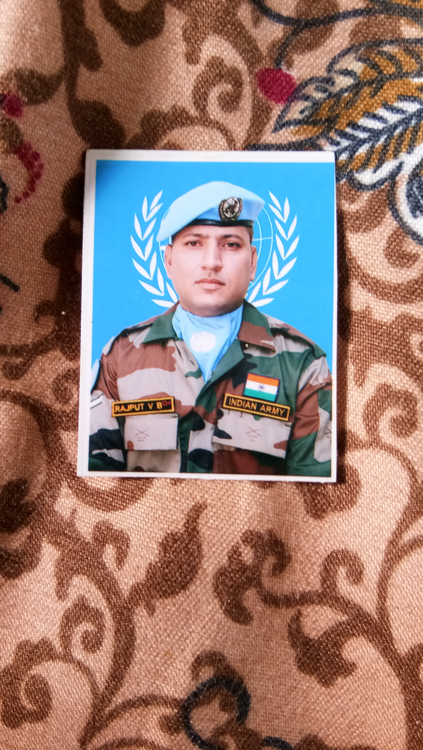

Ex-Service Man (Army signals)

Mobile no.8200623635

rajputvirendra36@gmail.com

**OBJECTIVE**

An ex service man seeks opportunity in Human resource management

,Flight following operator, communication network management,and security officer.

**PROFESSIONAL MATRIX**

Installed and managed all types of communication line.

Management of optical fiber communication network.

Analyzed the location and rectified all communication line.

Managed auto exchange and voice frequency telegraphy.

Human resource management.

**PROFESSIONAL EXPERINCE**

|  |  |  |  |  |  |  |
| --- | --- | --- | --- | --- | --- | --- |
| *S.NO* | *Designation* | *Unit* | *Duration* | *Duties* | *Additional duties* |  |
| *01* | *Supervisor* | *10 Idsr* | *2004 to 2007* | *Exchange duty* |  |  |
| *02* | *Supervisor* | *33 Cesr* | *2007 to 2009* | *Ofc laying and splicing* |  |  |
| *03* | *Supervisor* | *25 Idsr* | *2009 to 2012* | *Ofc laying in hard location* |  |  |
| *04* | *Storeman* | *4 Idsr* | *2012 to 2014* | *Store holding and handling* |  |  |
| *05* | *E ticket Ic* | *42 RR* | *2014 to 2016* | *Army e ticket train and Air* |  |  |
| *06* | *Exch supervisor* | *2 Afsr* | *2016 to 2017* | *Army exchange supervision* |  |  |
| *07* | *Operator* | *UN msn* | *2017 to 2018* | *Flight following operator* |  |  |
| *08* | *Supervisor* | *2 Afsr* | *2018 to 2020* | *Exchange and system supervision* |  |  |

**ACADEMIC BACKGROUND**

|  |  |  |  |  |  |
| --- | --- | --- | --- | --- | --- |
| *S.NO* | *Course/Degree* | *College/School* | *University/Board* | *Percentage* | *Year* |
| *01* | *10* | *Gayatri vidhya vihar* | *GBSC* | *71.29* | *2001* |
| *02* | *12* | *Gayatri vidhya vihar* | *GBSC* | *58.17* | *2003* |
| *03* | *BA* | *Gujarat University* | *Gujarat* | *45.11* | *2010* |

***SOFT SKILL***

*Punctual, Reliable, Hardworking, Managerial Skill, Team Work.*

***TECHNICAL SKILL***

*MS-word, excel, Basic computer Operations.*

**ACHIEVEMENT**

One year UN service as a flight following operator,Award during hard field service.

***PERSONAL DETAILS***

*Name. - Rajput Virendra B*

*Date of birth - 01/08/1986*

*Father’s name. - Rajput Bhim Singh*

*Marital status. - Married*

*Mailing address.- rajputvirendra36@gmail.com*

*Language known- Hindu, Gujarati, English*

*Hobbies. - Play wollybal , Cricket and outdoor games*

***DECLARATION***

I hereby declare that all the information furnished by me is true and best of my knowledge.

Date

Place SIGNATURE AND NAME