# 

# **Curriculum Vitae**

**Ravi Rajesh**

Vill- East Barwa; P.O-West Barwa;

P.S-Lakhaura; Pin-845302; India

Dist. -East Champaran, State: Bihar;

Contact-Number: 6372947433/9341040865

Email ID: ravias0207@gmail.com

Vill- EastBarwa; P.O-West Barwa;

P.S-Lakhaura; Pin-845302; India

Dist. -East Champaran, State: Bihar;

Contact-Number: 6372947433/7351658768

Email ID: ravias0207@gmail.com

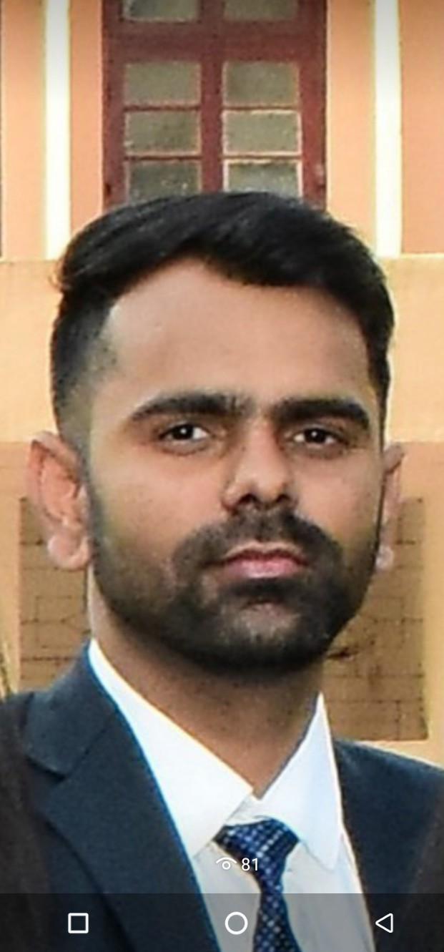

To secure a challenging position in your organization where I can effectively contribute/utilize my communication, interpersonal and Technical skills and be a part of the team to achieve the Organizational goals.

**Technical/Functional Competencies:**

* Operating System Familiar With: Windows XP, Windows 7 & Windows 8.

**Personal Competencies:**

* Comprehensive problem solving abilities and willingness to learn.
* Goal oriented, highly focused & self-motivated who excel in high pressure situation.
* Hard working ability in any condition, any situation.
* Maintain punctuality in every step of my life.
* Ready for immediate relocation, if required

**EMPLOYMENT HISTORY:**

# 

# 

# **Curriculum Vitae**

|  |  |  |
| --- | --- | --- |
| World Record During, Construction Phase   * World Record of Preheater Building RCC Construction of 13300 cum * RCC Start to RCC finish in & months.   **1.** PREHEATER BUILDING (Height -139.2 M ) DALMIA BHARAT LIMITED RAJGANPUR ODISHA   * EXCAVATION-7806.347 cum. * PCC- 1058.209 cum. * RCC -13300 cum. * SHUTTERING -31460.366 Sqm. * STEEL TMT Bar - 3546.035 MT. * BRICK WORK- 135.314 cum. * PLASTERING -1198.806 sqm   **2**. PREHEATER BUILDING ( Height – 138.048 M ) Shree Raipur Cement -3, Vill -Khapradih, Dist Balodabazar,Bhatapara , Raipur Chhattisgarh.   * PCC - 1974. Cum * RCC - 16622 Cum * SHUTTERING - 36006 Sqm. * STEEL TMT BAR - 3077 MT. * BRICK WORK - 80.314 Cum * PLASTERING - 700.0 Sqm. | | |
| **6 th sept**- **2018 To 30th Jun -2019** | **Job Title: Assistant Planning & Billing Engineer**  **Company: Buildmet Pvt. Ltd.**  **Client: Dalmia Cement Bharat Ltd.**  **Job Responsibility**:   * Responsible for study the BOQ as per Specification and taking out quantities from drawing. * Preparation & certification of Client RA Bills & Sub-Contractor Bills. * Preparation of monthly reconciliation statement of building materials. * Responsible for preparing BBS from construction drawings. * Responsible for client communications & coordinate with team members for smooth operation of the work. * Prepared Daily Progress Report, Monthly Project Report & Presentation making. * Arranging for and attending site visit, prepare details visit report & attending clarification meeting with client. * Prepare & tracking the project schedule. * Preparation of Day wise planning & Day wise Analysis. * Preparation of Delay Analysis. * Preparation of Rate Analysis. | |

|  |  |
| --- | --- |
| **30 th-Jun-2019 to 12th Nov-2020** | **Job Title: Assistant Engineer (Billing & Planning)**  **Company: Buildmet Pvt. Limited.**  **Client: Birla Corporation Limited.**  **Job Responsibility:**   * Responsible for study the BOQ as per Specification and taking out quantities from drawing. * Preparation & certification of Client RA Bills & Sub-Contractor Bills. * Preparation of monthly reconciliation statement of building materials. * Responsible for preparing BBS from construction drawings. * Responsible for client communications & coordinate with team members for smooth operation of the work. * Prepared Daily Progress Report, Monthly Project Report & Presentation making. * Arranging for and attending site visit, prepare details visit report & attending clarification meeting with client. * Prepare & tracking the project schedule. * Preparation of Day wise planning & Day wise Analysis. * Preparation of Delay Analysis. * Preparation of Rate Analysis. |

|  |  |
| --- | --- |
| **30 th-oct-2020 Till Date** | J**ob Title: Billing & Planning Engineer**  **Company: Buildmet Pvt. Limited**.  **Client: Shree Raipur Cement . Limited**  **Job Responsibility**:   * Responsible for study the BOQ as per Specification and taking out quantities from drawing. * Preparation & certification of Client RA Bills & Sub-Contractor Bills. * Preparation of monthly reconciliation statement of building materials. * Responsible for preparing BBS from construction drawings. * Responsible for client communications & coordinate with team members for smooth operation of the work. * Prepared Daily Progress Report, Monthly Project Report & Presentation making. * Arranging for and attending site visit, prepare details visit report & attending clarification meeting with client. * Prepare & tracking the project schedule. * Preparation of Day wise planning & Day wise Analysis. * Preparation of Delay Analysis. * Preparation of Rate Analysis. |

|  |  |  |  |  |
| --- | --- | --- | --- | --- |
| Degree | College/School | University/Board | Year Of Passing | Marks Obtained/ (DGPA) |
| M. Tech  (Civil Engineering) | National Institute of Technology Rourkela | National Institute of Technology Rourkela | 2018 | 70% |
| B. Tech  (Civil Engineering) | College of Engineering Roorkee, Roorkee | Uttrakhand Technical University | 2016 | 65.4% |
| Intermediate/ (12th) | M.S college Motihari | Bihar School  Examination Board Patna | 2010 | 65.4% |
| Matriculation/ (10th) | Ram Dawan Vibhishan High School Lakhaura | Bihar School Examination Board Patna | 2008 | 67.4% |

|  |
| --- |
| **Academic Educational Profile:** |

|  |
| --- |
| **Professional Training/ Projects Done:** |

|  |  |  |
| --- | --- | --- |
|  |  |  |
| **1** | Title |  |
|  | Training Institute | CETPA Infotech Pvt. ltd. |
|  | Duration | 2 Days |
|  | Discription | Structural analysis and design software which is widely used to analyze and design structures for bridges, towers, buildings, transportation, industrial and utility structures. |
| 2 | Title |  |
|  | Training Institute | IIT BHU |
|  | Duration | 2 Days |
|  | Discription | Design of Various Types of Bridge with Various Loads. |
|  |  |  |
| 3 | Title | AutoCAD |
|  | Training Institute | CETPA Infotech Pvt.ltd |
|  | Duration | I month |
|  | Discription | 2D & 3d Drawing |

|  |
| --- |
| **Personal Profile :** |

|  |  |
| --- | --- |
| Name | Ravi Rajesh |
| Father name | Ajay Kumar Singh |
| Mother Name | Suman Devi |
| Date Of Birth | 09-sep-1993 |
| Sex | Male |
| Marital Status | Married |
| Salary Expected | As per Industry Standard |
| Nationality | Indian |
| Religion | Hindu |
| referred Job Location | Anywhere in India. |
| Languages Known | Hindi , English, |
| Hobbies | Playing cricket Playing Football &Cricket, Show Cricket Match On The TV, Surfing The Net, and Chatting with friends., |

**Curriculum Vitae**

Declaration

I, hereby, solemnly declare that all the information made above are true and correct to the best of my knowledge and belief.

Date: 09-Sep-1993

Place: Motihari (Bihar) Ravi Rajesh

(Signature)