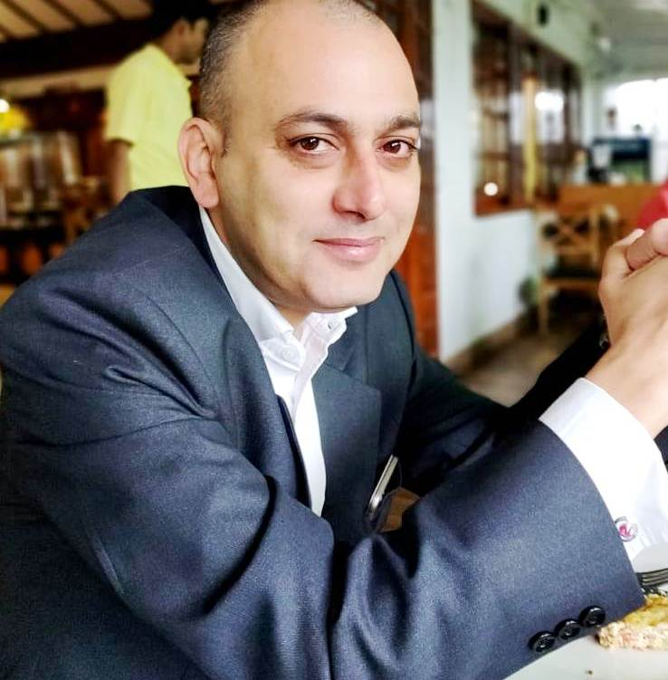

RITESH RANJAN

Mobile: +91 7620978312 / 8878661001

Email: [ranjaritesh@gmail.com](mailto:ranjaritesh@gmail.com)

**JOB OBJECTIVE**

**Seeking senior managerial level assignments with a reputed organization preferably in Hospitality/Real Estate/Retail Industry.**

## PROFESSIONAL PROFILE

* Over 19 years of experience in Operations Management/Finance/Sales and Marketing/Customer Care/L&D in various departments of Hotel and Hospitality Industry.
* Currently working as a Senior Hospitality Manager with Cadila Pharmaceuticals from June’2019 and looking after India and UK Based properties.
* Rich experience in generating sales for the Organization, Higher Customer Satisfaction and Developing & Empowering People through Learning and Development
* Certified Departmental trainer. ( Taj Group of Hotels)
* Ability to support and sustain a positive work environment that fosters team performance with strong communication and leadership management skills.

**ORGANISATIONAL EXPERIENCE**

Since June’2019:-

**At present working as a Senior Hospitality Manager at Cadila Pharmaceuticals -Ahmedabad. (June 2019 till date) and Looking after India and UK based properties.**

* May’02-Oct’02:-Operational trainee in Radha Krishna Hospitality Services (Apollo -Hyderabad).
* Joined as Guest service attendant in Nov’2002- Vivanta by Taj- Lucknow
* Promoted as a Captain in May’2003 –Vivanta by Taj -Lucknow
* Promoted as Asst Restaurant manager in April’2006 – Vivanta by Taj -Lucknow
* Promoted as Restaurant manager in April’2008- Vivanta by Taj-,Lucknow
* Promoted as F&B In charge in August’2010 – Taj Usha Kiran Palace -Gwalior
* Promoted as F&B manager in Apri’l2011 and continued till July’2016.
* Joined Club Mahindra -Tungi (Maharashtra) – Lonavala as F&B manager in December 2016.
* Promoted and Transferred to Club Mahindra Sherwood- Mahabaleshwar (Maharashtra) as Resort Manager in February 2018.

**AREAS OF EXPERTISE**

### *Operations Management*

* Leading Resort overall operation along with core management team to continuously improve revenue, customer satisfaction, cost control, Higher PBT, Employee satisfaction through improving skills by imparting learning’s.
* Leading operations of all the departments entailing development plans, estimation and procurement of resources and manpower required during the process.
* Maintaining harmonious work environment to ensure smooth functional processes.
* Coordinating amongst departments ensuring compliance to deliver products and services within specified parameters.
* Managing Operation related tasks including planning, control & trouble shooting for achieving the planned periodic schedules.
* Streamlining the SOPs and working on continuous process improvement systems for enhancing the operational efficiencies.
* Developing distribution strategies for ensuring availability of services at each end point and handling logistics/ commercial operations pertaining to the same.

*Sales and Marketing*

* Overseeing marketing operations thereby achieving increased sales growth/ maximized profitability.
* Identifying and developing new streams for long term revenue growth and maintaining relationships with customers to achieve repeat/ referral business.
* Designing & managing corporate communication, brand image building and product awareness campaigns.
* Maintaining Guest History Data & utilizing the same for revenue growth through repeat business.
* LCoordinating with government and other senior officials to comply with all required legal documents and licenses.

### *Customer Care*

* Rendering effective customer service by addressing queries/ grievances of clients so as to ensure smooth flow of operations and adherence to service norms for continuous growth in customer satisfaction and Brand image.
* Enhancing customer satisfaction matrices through on-time delivery of exemplary services.
* Continuous innovation and improvement in product and Services and other areas based on customer feedback.

**SIGNIFICANT ACCOMPLISHMENTS**

*At Taj Residency – Lucknow*

* Achieved the ‘Taj Business Excellence award for business excellence’ in the category of ‘Excellence in restaurants’, for the hotel.
* Spearheading & profitably operating the food & beverage department, generating revenue of upto 55% of the total sales of the hotel.
* Awarded the certificate for the ‘Advanced Hospitality Foundation Module’ & operated the ‘Tata Business Excellence Module’ & got a score which few Hotels had scored & got a motivating letter for the same from our chief operating officer of our group.
* Certified departmental trainer. ( Across Taj Group of Hotels – IHCL)

At Taj Usha Kiran Palace – Gwalior ( Role – F&B Manager)

* Hotel got runner up award in 2010-11 for overall service experience out of 32 hotels in SBU.
* Hotel got the 2010-11 award for best 10 heritage hotel in India by Trip Advisor.
* Hotel got the 2011-12 awards for best 25 luxury hotels of India by Trip advisor.
* Hotel got the prestigious 2012 Certificate of Excellence award from Trip Advisor.
* Significant growth in Customer satisfaction of around 30 to 35% in all the attributes of food and beverage.
* Delta Improvement in Audit Score from 73% to 80% in 2011-12.

**TRAINING**

Organization Holiday Inn- Pune

Duration 7months ( April’2000 to December’2000)

**ACADEMIC QUALIFICATION**

* B.A. in Hospitality Management from the 'Robert Gordon University'- Aberdeen, Scotland, U.K in 2002
* Diploma in Hotel and Catering Management from the 'Institute of Advanced Management', Calcutta, India.
* Diploma in Hospitality Management from the Educational Institute of ‘American Hotel & Motel Association', U.S.A

**PERSONAL DETAILS**

* Date of Birth 10th Jan. 1980
* Present Address Cadila Pharmaceuticals Pvt.Ltd -

Ahmedabad

* Nationality Indian.
* Height 178cm

* Weight 58 kg
* Martial status Married
* Passport no F9212181

* CTC 13.50 Lakhs P/A.