**CURRICULUM VITAE**

**SATHVARA RAVI MAHESHKUMAR Mob. : 9737074873**

E-Mail ID: ravimsathvara@gmail.com

**CONTACT INFORMATION:**

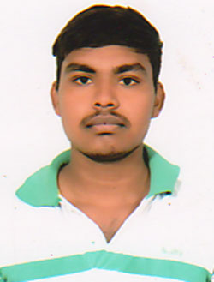

**Residental Address:**

Near-High School.

At-Kherva,

Ta & Di-Mehsana. (N.G.)

Gujarat, India.

Pin:382711.

**CAREER OBJECTIVE:**

* contributing to the success of the organization by my creative and innovative skills.
* To be a part of an organization that initiates learning process & provides a great career path & platform for continuous growth.

**ACADEMIC EDUCATION:**

|  |  |  |  |
| --- | --- | --- | --- |
| **Course** | **Board/University** | **Year of Passing** | **Result** |
| S.S.C. | G.S.E.B. | March 2012 | 66.80 % |
| H.S.C. | G.H.S.E.B.Gandhinagar | March 2014 | 58.00 % |
| B.SC | Ganpat University | March 2017 | 69.80% |
| ONGC (Apprentice) | Mehsana |  | Running |

**TECHNICAL SKILLS:**

* Basic
* Internet

**KEY STRENGTHENS:**

* Positive attitude.
* Technical minded with a sound ability to solve problems.
* Fire in the belly for success.
* Believer in systems, good culture & values.
* **SOFT SKILLS:** well honed communication skill, both verbal and written & self-confidence, Willingness to Work Hard & to learn new things, Leadership and Team skills.

**PERSONAL PROFILE:**

|  |  |
| --- | --- |
| Name | : SATHVARA RAVI MAHESHKUMAR |
| Date of Birth | : 11TH Nov1996 |
| Gender | : Male |
| Nationality | : Indian |
| Religion & Caste | : Hindu-Sathvara |
| Marital Status | : Unmarried |
| Mother Tongue | : Gujarati |
| Languages Known | : Hindi, English, Gujarati |
| Hobbies | : Music, Travelling . |

**DECLARATION:**

I hereby declare that the above mentioned information is true to the best of my knowledge.

Yours faithfully

***(Ravi M. Sathvara)***