**Resume**

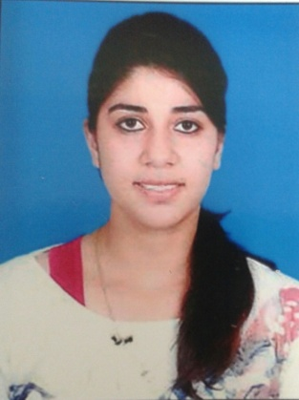

**Name:** SHREYA DOGRA

**Age**: 21 years

**Date of Birth:** 22.08.1992

**Father’s Name:** Harsh Sharma

**Address for correspondence:** 172/2 Officers Enclave, Shahibaug

Ahmedabad. 380004

**Contact Number:** 8469200455

**E-mail Address:** dogra.shreya@gmail.com

**Educational Qualifications:**

|  |  |  |  |  |
| --- | --- | --- | --- | --- |
| **Examination** | **Board/ University** | **School/ College** | **Year** | **% Obtained** |
| Matriculation | CBSE | Army Public School, Jalandhar | 2008 | 88.4% |
| HSC | CBSE | Kendriya Vidyalaya, Ahmedabad Cantt | 2010 | 88.6% |
| B.Com | Gujarat Board | H.L.College of Commerce, Ahmedabad | 2013 | 70%, Distinction |

**Strengths**  : My confidence, my leadership quality and ability to tackle any situation

**Object**  : Looking for a challenging and responsible opportunity, to learn, to explore my strengths and potential in a professional organisation, gain experience and meet my employer’s expectations.

**Extra Interests and Hobbies:**

(a) An avid reader.

(b) Cooking.

(c) Meeting new people and visiting new places.

(d) Philanthropic by nature.

(e) Teaching.

**References:**

Mr. Rahul Sehgal Mrs. Jyotsna Bhatnagar

Director Chief Editor

Humane Society International Financial Express

09909007989 09825320037