

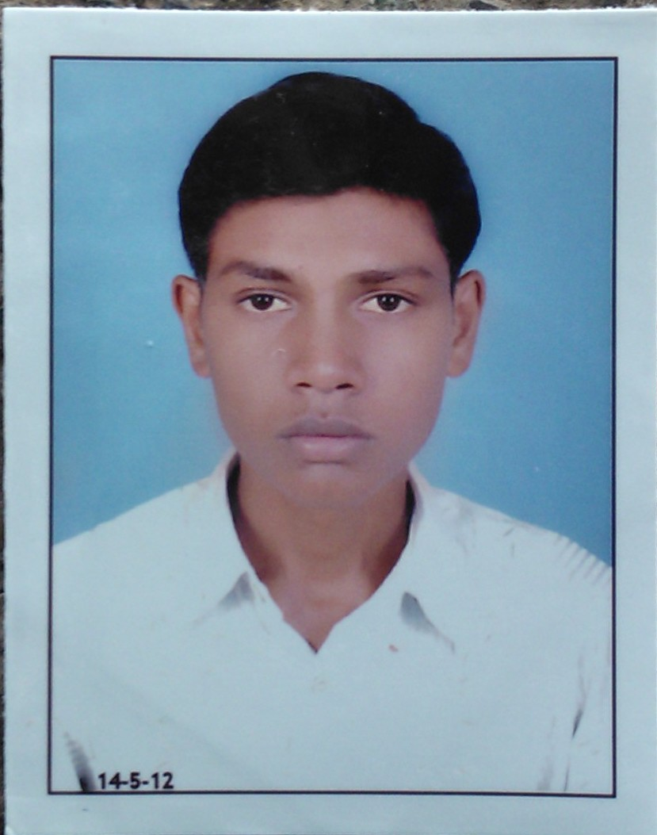

Paste your Pa ssport Size Photo Here

**Name:PARMAR SURESHBHAI G.**

**(MBA FINANCE)**

**C**

**Email:sureshparmar072@gmail.com**

**Mobile:9904359434**

**Career Objective (Marketing/Finance/HR): FINANCE**

**For E.g.:** - To embark a successful career as a management professional, I want to be associated with an organization that provides me with ample opportunities to broaden my skills and develop myself into a successful professional. and ultimately gain such experience so as to embark my journey into entrepreneurship.

**Academic Qualifications:**

|  |  |  |  |  |  |
| --- | --- | --- | --- | --- | --- |
| **Degree** | **Institute** | **Board/University** | **From/To** | | **CGPA/%** |
| MBA (finance) | L.J INSTITUTE OF MANAGEMENT STUDEIS. | GUJARAT TECHNOLOGICAL UNIVERSITY. | | 2013-15 |  |
| BBA | SHREE C.U SHAH CILLEGE OF COMM.MGT. & COMP EDU,WADHAWAN  . | SAURASHTRA UNIVERSITY. | | 2012-13 | 61.35% |
| XII | SHREE PATEL EDU. & CHARI.TRUST-BOTAD | GHSEB | | 2010 | 62.29% |
| X | SHREE B.D SHAH MA. SHALA BOTAD | GSEB | | 2008 | 41.23% |

**Internships & Projects:**

(1)J.M.FINANCIAL SERVICES LIMITED

(2)CAREFUL LABORATORIES

(3) PARMAR TEXTILES

**Extra Curricular Activities:**

**E.g.** – Sports

**Proficiencies:**

* **Languages known:** English, Hindi, Gujarati
* **Computer Skills:** Basic knowledge



**Personal Details:**

**Name:**- Parmar Sureshbhai G

**Date of Birth:-** 1th Sep. 1993

**Sex:-** Male

**Marital status:-** Unmarried

**Religion:-** Hindu

**Nationality:**- Indian

Address:- Turkha Road,Jalaram nagar,

Bhoyra same, Botad.

Dist:- Botad-364710

**E-mail :-** sureshparmar072@gmail.com

**Mobile :-** 9904359434

**Hobbies / Interests:**

* Travelling
* Reading
* Music / Movies / Entertainment

**Signature:-**

S.G.Parmar