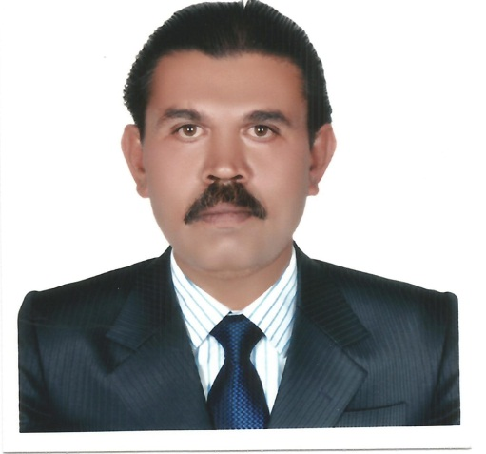**YUSUF IBRAHIM SHAIKH**

Mobile No.: 0501109290

Email Address: yusuf648@yahoo.com

**Position**: **REF AND HVAC SUPERVISOR**

**Objectives**

To acquire a job position where my skills, experience and creativity are develop with the possibility to enhance and promote innovation based upon performance.

**Purpose**

I am interested in pursuing a career with your establishment & submitting C.V, for your review perusals

|  |  |  |
| --- | --- | --- |
| **Personal Information** | | |
| Permanent Address | Nabi House, New Shahealam Nagar | |
|  | M.Nr.Mehar Row House, | |
|  | B.H.old Naka Narol Road, | |
|  | Ahmedabad (Gujart) | |
|  | India. | |
|  |  | |
| *Marital Status* | Married | |
| *Date of Birth* | 01st June 1970 | |
| *Age* | 47 years | |
|  |  | |
| **Educational Background** | | |
| *S.S.L.C. India* | Passed in 1988 with 68.85% | |
| *National Council for Vocational Training (I.T.I)* | Passed in 1991 in the trade of Refrigeration and Air Conditioning With 57.00% | |
|  | | |
| **Work Experience** | | |
| *2008 up to present* | *HVAC SUPERVISOR*  *MECHANICAL SUPERVISOR* | **Al Reem Hospico LLC (AL AIN Hospital Electro Mechanical Maintenance Project)**  ISO 9001 Certified  Al Ain Hospitals and Associated Clinics  Al Ain, UAE  Sheikh Khalifa General Hospital  Umm Al Quwain |
|  | *JOB DESCRIPTION* | - To report to Mechanical Engineers and get instruction regarding day to day works |
|  |  | - To carry out the works given by A/C Supervisor and work under his supervision. |
|  |  | - To attend the complaints and complete the Maintenance Requisitions & Erecting works, Shutdown works within the specified time. |
|  |  | - Taking necessary action before troubleshooting & completing the specified work |
|  |  | - To carry out PPM work as per frequency and PPM schedule |
|  |  | - To bring to the notice of Supervisor or Engineer regarding lack spares or any other problems they observe. |
|  |  | - To take safety precautions while carrying out the job. |
|  |  | -Operation and troubleshooting of chiller plant.(150 TR to 320TR) |
|  |  | -Operation and troubleshooting of AHU, FCU, CCU. |
|  |  | -Operation and troubleshooting of DS UNITS and PU. |
|  |  | -Operation and troubleshooting of SPLIT UNITS and CASSETE UNITS. |
|  |  | Operation and troubleshooting of the modular operation theater all a/c equipment’s including the air pressure (ei. Negative Pressure such as Isolation Rooms and operation Theater and other critical areas inside the hospitals, and Positive Pressure such as normal rooms located in the hospitals) |
|  |  | -Operation and troubleshooting of laminar air system. |
|  |  | -Operation and troubleshooting of VFD, VFC, VAV, CAV, VCD and DDC Panel. |
|  |  | -Operation and troubleshooting of low temperature equipment’s. |
|  |  |  |
| *June 2007 to December 2007* | *A/C Technician* | **Al Sultan Electro Mechanical Dubai (UAE)** |
|  | *JOB DESCRIPTION* | To report to Mechanical Engineers and get instruction from him regarding works. |
|  |  | -Installations of Ducted, Package and Split A/C |
|  |  | -Maintenance ,Servicing and Trouble Shooting of Ducted, Package and Split A/C |
|  |  | -To take safety precautions while carrying out the job. |
|  |  |  |
| *March 2004 to June 2007* | *A/C Technician* | **United Engineering Trading & company Al Ain (UAE)** |
|  | *JOB DESCRIPTION* | -To report to Mechanical Engineers and get instruction from him regarding works. |
|  |  | -To attend the complaints and complete the Maintenance Requisitions & Erecting works, Shutdown works with in the specified time. |
|  |  | -Taking necessary action before troubleshooting & completing the specified work |
|  |  | -To carry out PPM work as per PPM schedule. |
|  |  |  |
| *July 2001 to Feb 2004* | *A/c Supervisor* | **Air Mech. Ref. A/C. Equipment (Mahad)** |
|  |  | -Repairing, Installation, Maintenance, Servicing and Trouble Shooting of Ducted, Package, Split A/C and Refrigeration. |
|  |  | -Coordinate with the A/c Technician while they doing the job |
| *December 1997 to May 2001.* | *A/c Technician* | **Razvi Refrigeration co Pvt Ltd (Ahemadabad)** |
|  |  | -Repairing, Installation, Maintenance, Servicing and Trouble Shooting of Ducted, Package, Split A/C and Refrigeration. |
| *December 1992 to November 1997* | *A/c Technician* | **V. Krishna & Co. Pvt Ltd. (Mahad)** |
|  |  | -Repairing, Installation, Maintenance, Servicing and Trouble Shooting of Ducted, Package, Split A/C and Refrigeration Split A/C and Refrigeration. |
| *April 1990 to March 1991* | *Trainee Mechanic in Refrigeration and air Conditioner* | **Rekha Services Station, Jalgaon** |
|  |  | -Repairing, Installation, Maintenance, Servicing and Trouble Shooting of Ducted, Package, Split A/C and Refrigeration. |
|  |  |  |
| **Skills** | | |
|  | Well knowledge in commissioning, service, and maintenance of various Refrigeration & Air conditioners | |
|  | Total 16years Experiences in the fields of different types of Refrigeration & Air conditioner. | |
|  | | |
| **Language** | | |
| *English* | Understanding and spoken knowledge | |
| *Marathi* | Fluent | |
| *Hindi* | Fluent | |
| *Arabic* | Understanding Knowledge | |
| *All the information stated above is true to the best of my knowledge and you may please consider this application for suitable post vacant in your Organization. I will be happy and I will discharge my duties to your entire satisfaction.* | | |
| **PASSPORT NO. 1525890 – Issued on 12/04/2005 at ABU DHABI**  Expires on 11/04/2015 | | |

Yusuf Ibrahim Shaikh

Signature over printed Name