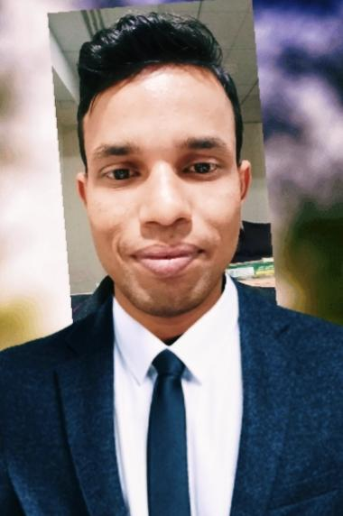

SRIKANTA DEY

**Kalikapur Jhikarti Murshiabad west Bengal pin-742168**

**DOB: 16/03/1994 Email: srikantadey94@gmail.com**

**Mob: 9664786459**

**OBJECTIVE**

To deliver my duties to the fullest satisfaction of the superiors and subordinates and to reach responsible position in future, work for the betterment of the company in any circumstances.

**PROFILE**

A dynamic professional with **6 years** of experience in **Food & Beverage Services & Operations**. Very apt and organized in systems & procedures of 5 star hotel and its operations. In addition to above is very analytical in approach.

**PROFESSIONAL EXPERIENCES**

***F&B Executive***

***The Orchid Hotel Pune***

*02nd Nov2018– 16th June 2022*

# Handling 55000 SFT Lawn(Meadows)

# Handling 10863 SFT event area with the capacity of 1000 people, (including seven banquet hall and one board room.)

# Manage F&B in daily operations within budgeted guidelines and to the highest standards without Manager

# Handling 18000 SFT Lawn (convention Lawn)

# Identify customers need and respond proactively to their concerns.

# Lead F&B team by attracting, training and appraising talented personnel.

# Provide a two way communication and nurture an ownership environment with emphasis in motivation and teamwork.

# Comply with all the health and safety regulations.

***Food & Beverage Team Leader***

***Pride Plaza Hotel, Ahemdabad***

*2nd Dec 2016 to 7th June 2018*

# Handling 8000SF event area with the capacity of 900 people, (including six banquet hall and one board room.)

# Manage F&B in daily operations within budgeted guidelines and to the highest standards.

# Preserve excellent levels of internal and external customer service.

# Design exceptional menu, purchase goods and continuously make necessary improvements.

# Report to the management for the overall performance of Banquets and staffs.

***Senior Food & Beverage Associate***

***THE Lalit Golf &Spa Resort ,Goa***

*10th 2016 to 17th July 2016*

# To support the F&B Management team to supervise the administration, Banquets and bars as an independently profitable unit and set performance standards for a great dining experience.

# Knowing and understanding the job description of all positions in F&B: overall functions, service and performance.

# Understanding menus, cooking techniques, and to be able to describe dishes respectively.

# Practice effective and responsible hosting to all guests.

# Lead by example in all work related interactions and occasions.

# Deliver exceptional customer service to all valued customers

***Food and Beverage Associate***

***The Pride Hotel ,Bangalore***

*24th June2014 to 20th Dec 2015*

# To assist in the preparation of mise en place for service as required, in accordance

# With the required hotel standards.

# To ensure that all food & beverage items served at a quality and recorded in an appropriate manner in order that guests may be charged, and to operate a cash bar as and when required.

# To display professional salesmanship and positive sales techniques at all times.

# To comply with all Hotel and Company policies and procedure

| **TRAINING EXPOUSRE & ACHIEVEMENTS** |
| --- |

# **As an associate I got a Best Employee of the month awards. Of 2015 ,The Pride Hotel Bangalore**

# **Employee of the year month of October 2018, The Orchid Hotel Pune.**

**EDUCATION**

| **Qualification** | **Institute / Organization** | **Board / University** |
| --- | --- | --- |
| BBMH | Bengal Institute of technology and management | WBUT |
| HSC | Andi LCC High School | WBCHSE |
| SSC | Kundal High School | WBBSE |

**SUMMARY**

* Extensive experience of the Food & beverage industry
* Setting up of various Banqueting venues with different types of set up.
* Handling bar counter for various events.
* Ensuring guest satisfaction with appropriate standards maintained.
* Maintaining Guest relations.
* Check the function for the day and study the BEO (Banquets Event Order) for the function assigned.
* To assist in setting up the hall or outdoor location.
* Communicate with the sales department to make sure that function goes successfully.
* Communicate with Host of the event to satisfy him/her that everything is going well.
* To ensure that guest is happy with my service and co-operation, and at last billing on time.
* Superior customer service and supervisory skills
* Skilled in hiring and firing staff
* Superior leadership quality and management skills
* Physically fit to be on feet for a longer period

## 

**DECLARATION:**

I hereby declare that all above information provided are true, complete and correct**.**

**DATE:**

**PLACE:**

Srikanta Dey