**SUPRIYA SHARMA**

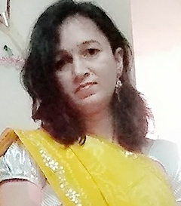

[supriya21092015@gmail.com](mailto:supriya21092015@gmail.com)

+91 – 8209937732

**Personal statement**

A highly motivated person, currently looking to resume my professional career after dedicating the last five years to raising a family. Excellent admin skills with knowledge of Microsoft Office programs, now fully committed to continuing my career on a full-time basis.

**Employment history**

**Visiting Faculty**, **Vishwakarma Government Engineering College, Ahmedabad (2012-2013)**

Competencies:

* Lesson Plan Development
* Maintaining Course File
* Classroom Management

**S.L.B.S.** **Engineering** **College, Jodhpur (2010-2012)**

Competencies:

* Lesson Plan Development
* Maintaining Course File
* Classroom Management
* Student Development
* Extracurricular Activities

**Supervisor, Thycon India Private Limited, Jaipur (2001-2006)**

Competencies:

* Maintaining the records of trainees
* Over all management

**Education**

**Rajasthan University, Jaipur**

B.E. in Electronics and Communication

Class of 2009

**Board of Technical Education, Jodhpur**

Diploma in Electronics and Communication

Class of 2001

**D.A.V. Public School, Khalari, Ranchi**

Sr. Secondary (XII, CBSE)

Class of 1997

**Kendriya Vidyalaya, Dakra, Ranchi**

Secondary (X, CBSE)

Class of 1995