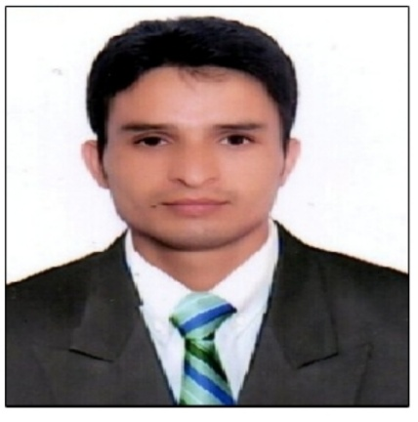**CURRICULUM VITAE (CV)**

|  |  |
| --- | --- |
| **Position Title and No.** | English lecturer/ PGT English/TGT English |
| **Name of Firm** | Higher Education Department J&K, DPS Mehsana, DPS BOPAL |
| **Name of Expert:** | Tariq Ahmad Lone |
| **Date of Birth:** | 20/02/1984 |
| **Citizenship** | Indian |

**Education:**

|  |  |  |
| --- | --- | --- |
| **School, college and/or University Attended** | **Degree/certificate or other specialized Education obtained** | **Date Attended** |
| Govt. High School Zaloora JKBOSE | 10th | 1999 |
| Govt. Higher Secondary Sopore JKBOSE | 12th | 2002 |
| University of Kashmir | B.A | 2004 |
| University of Kashmir | P G in English | 2007 |
| University of Kashmir | B.Ed | 2008 |
| IGNOU | One Year Diploma in Computer Applications | 2015 |

**Employment record relevant to the assignment:**

|  |  |  |  |
| --- | --- | --- | --- |
| **Period** | **Employing organization and your title/position. Contact information for references** | **Country** | **Summary of activities performed relevant to the Assignment** |
| 2007 to 2019 | GDC Women Baramulla 2007  GDC Handwara 2008  GDC Kupwara 2009  GDC Handwara 2010  GDC Kupwara 2011  GDC Women Kupwara 2012  GDC Women Sopore 2013  GDC Sopore 2014  GDC Kupwara 2015  GDC Women Kupwara&Handwara 2016  GDC Kokernag 2017  GDC Handwara 2018-2019 | Kashmir | * Training of candidates on soft skill Domain and role as per syllabus schedule * Delivered classes on Technical grammar and phonetics * Project Documentation including Attendance and Batch records * Coordination among faculty team members regarding project activities * Evaluation of UG examination papers * Superintendent in UG examinations * Convener of Co-Curricular Activities * Training of student on group discussion, public speaking and sentence stress * Communication and Coordination among the students for mission and vision. |
| 2021 to 2022 | Freelancer | Kashmir | * Delivering online Classes * Training modules on IT skills * Trainings on Job Process knowledge * Conducting Soft Skill Trainings * Conducting refresher training * Public Speaking and Group discussion |
| 2007 to 2019 | PGT Tutor | Kashmir | * Tutored Students of class 9th, 10th, 11th & 12th (both JKBOSE & CBSE) to develop deeper comprehension of English course materials and better understanding of assignments to improve academic success. * Conducted academic skill reviews and led workshops to develop writing skills and language comprehension. * Participated in tutor orientation and attended professional development and training sessions to increase English competency and improve tutoring skills. * Taught students study techniques and strategies for succeeding on grammar and composition tests. |
| 2019 to 2020  2022 | Delhi Public School Mehsana ( PGT English)  DPS Bopal TGT English | **Gujrat**  **Do** | * Taught class 9th &10th English subject * Apart from subject material, I delivered special lectures on technical grammar and communication skills. |

**Membership in Professional Associations and Publications:**

1. Conducted Event on mock interview in different colleges of kashmir and provided all students training in soft skill courses.
2. Seminar conducted in GDC Handwara and managed 2000 students to improve their reading. Writing, Speaking and Listening Skills.
3. During lockdown Online Zoom session conducted for students on soft skill awareness.

**Language Skills (indicate only languages in which you can work):**

|  |  |  |  |
| --- | --- | --- | --- |
| **Language** | **Speaking** | **Reading** | **Writing** |
| English | Yes | Yes | Yes |
| Hindi | Yes | No | No |
| Urdu | Yes | Yes | Yes |

**Expert’s contact information:**

Email ID: tariqlone44@gmail.com

Phone: +919103089185

Date:

[Signature of the Applicant]