**Curriculum – Vitae**

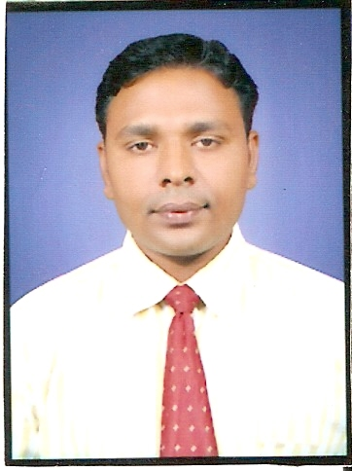

**Yashvant Banke**

Add : chunni mama bilding

Opp. Mama coplex chipaner

road Harda mp

Mob :9669087038 ,9926732416,

E-mail ID : yeshvantbankemba@yahoo.co.in

**career OBJECTIVE**

To work in challenging and responsible position if commercial officer in a reputed organization where in I can contributed significantly to the over all growth and success of the team &organization

**CURRENTCTC 4.76 L+**

**TOTALWORKEXPERIENCE 12.6 Yr s**

➢ Working with Adarsh credit co operative society as a Cluster HEAD

(from July 2016 till date)

Raipur CG

➢ Working with Shriram Fortune Ltd joining as Branch Manager

{From January2013 to july2016

Bhopal MP

➢Working with AVIVA LIFE INSURANCE joining as SSM

{From 17 JUNE 2012 to 16 jan.2013 }

Indore MP

➢ Working with RELIANCE LIFE INSURANCE joining as **SM**

{From 1 sep.2007 to June 2012

HARDAMP

➢ Working with pioneer institute science& management Indore

(From 1sep.2006to aug2007)

➢ Working with CA kabra & kabra company

(compulsory 2.5yr artisanship with CA PE-II)

( From 1march.2002 to jan2005)

➢**Achievement TASK APRITION Activisation SFS at BHOPAL REGION**

➢**Achievement long service award in RLIC at BHOPAL REGION**

➢**Achievement BIG TIKIT SIZ WRP in RLIC at BHOPAL REGION**

➢**Achievement no. One in Recruiting & licensing category in BHOPALREGION for year 2010-11**

➢**Achievement no. One march contest Thailand 3 advisors trip & my Thailand trip Qliffy.** in BHOPAL REGION for year 2010-11

➢**Achievement1ST in AVIVA LIFE tasks of 10 vs. 10 FPA pass 100% IRDA Exams ,august 2012**

➢**Achievement in AVIVA LIFE requirement FPAs 27 FPA in 1st month**

**No.1 req. in India aug2012**

➢**Achievement no. One fast trek conformation month act 2012**

➢ **Job Profile**

**Team leading on roles Branch Head and Branch incharge and back office and cashier no of branch 8 all in CG**

1. Responsible for Sales of financial products of the company like debenture/FDs etc, motor insurance , Health insurance Gm
2. Taking care of recruiting, training & developing sales team, agents & back–office executive for client pitch & client handling and to ensure selling skills & product knowledge. Deposits, Motor insurance, Health insurance MF
3. Conducting market analysis to assess prevalent financial & economic environment, identify business risks & implement effective mechanisms to mitigate the same.
4. Mapping various prospective client’s requirements and rendering Responsible for Sales of financial products of the company like life insurance policies.

**Qualifications**

➢ **Master of Business Administration**

Pioneer Institute of Professional Studies, affiliated to Devi Ahilya Vishvavidyalaya, Indore.

➢ **CA PE -2.**

Passed in second **group and 1stgroup one sub is Exempted**

affiliated**Charter Accountant of India**

➢ **Master of Commerce**

Passed with Marketing, e-Commerce and Tax Planning, from **PMB Gujarati College** p/v affiliated to **Devi Ahilya Vishvavidyalaya, Indore**.

➢   **Bachelor of Commerce**

Passed with Income Tax, Sales Tax and Statistics, from **PMB Gujarati College** affiliated to **Devi Ahilya Vishvavidyalaya, Indore**.

➢   **Higher Secondary**

Passed with Accountancy, Commerce and Economics, Sadhana Higher Secondary School, Harda (M.P.) (Madhya Pradesh Board of Secondary Education, Bhopal)

➢   **High School**

Sadhana Higher Secondary School, Harda (M.P.)(Madhya Pradesh Board **of Secondary Education, Bhopal).**

**speclalizetion**

**➢      Major – Marketing Management ➢      Minor – Finance Management**

**area of interest**

**➢      Marketing /finance and management**

**computer proficiency**

**➢      Windows, M-S Office**

**➢      Internet, & dos , Exile, office automation**

**  extra curricular activity**

➢      Active participation in various activities likes play, Quiz Campaigns, Sports etc.

**personal ethics**

➢      *“If the work is difficult so it is done able, Otherwise easy work can be done by everyone.”*

**personal information**

Name : Yeshvant Banke

Father’s Name : Shri Lakhan Lal Banke

Date of Birth : 15-10-1979

Marital Status : married

Sex : Male

Languages Known : Hindi, English

Hobbies : Reading Newspaper, Travelling, Listening Music

Corresponding Add. : Villag-Mohanpur, HARDA MP

**Reference :-**

➢      **Mr.amit thakur**

**mob 9302954419**

***Declaration***

I hereby declare that the above information is true and correct to the best of my knowledge and belief.

Date :

Place :  **(Yeshvant Banke)**