**RECIPROCAL LATTICE CONCEPT (MILLER INDICES)**

X-ray crystallography deals with determining the arrangement of atoms within a crystal

This arrangement is deduced from the manner in which a beam of X-rays is scattered by a beam of electrons within a crystal.

***Note:*** *X-rays primarily interact with electrons in atoms. When x-ray photons collide with electrons, some photons from the incident beam will be deflected away from the direction where they original travel, much like billiard balls bouncing off one anther*

**Crystal**:

* It is a solid substance in which arrangement of atom (its unit cell) is repeated indefinitely along 3 principle dimensions. These dimensions are called as ***lattice / basis / vectors.***
* The arrangement need not be perpendicular to the axises

**Lattice:**

* Representation of crystal structure as an array of points in space.
* These points represents atoms or ions
* They extends in a 3D network
* Can also be defined as the points of intersection between straight lines (the intersection points) in a three-dimensional network

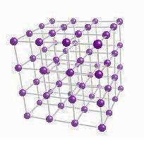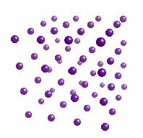

**Unit cell:**

* 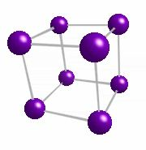A unit cell is the smallest component of the crystal lattice and describes the arrangement of atoms in a crystal.
* The unit cell when repeated over & over again results in a given crystal structure
* The unit cell is characterized by its lattice parameters which consist of the length of the cell edges and the angles between them.

OR

*The unit cell of the crystal lattice is a box or frame which is arbitrarily constructed from the lattice of a crystal. Repeating the unit cell indefinitely reproduces the crystal lattice. Conventionally a unit cell is chosen which joins up lattice points*

**Lattice planes:**

They are parallel equidistant planes passing through lattice points

For a given lattice, the lattice planes can be chosen in a carious number of ways as shown in the diagram below:

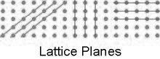

* The problem of how to designate a plane was solved via: **Miller indices**
* Miller Indices are a method of describing the orientation of a plane or set of planes within a lattice in relation to the unit cell.
* Denoted by (h, k, l)
* They were developed by [***William Hallows Miller***](http://en.wikipedia.org/wiki/William_Hallowes_Miller)

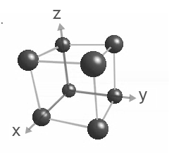Miller indices are a notation in crystallography for planes and directions in crystal lattices

If x,y,z are directions, then h,k,l denotes Miller indices

Consider a single unit cell

We can define a set of axes: x, y, z which describes the edges of this unit cell

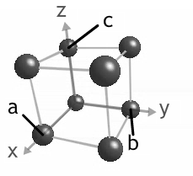The length of the edges are defined by distances, known as lattice parameters

a: on x-axis

b: on y-axis

c: on z-axis

Suppose we have a plane within the unit cell having a=4, b=2 & c=6

Miller indices can be calculated as:

1. Take reciprocals: 1/4, 1/2, 1/6
2. Clear fractions (here, multiply by 4x2x6=48): 12, 24, 8
3. Reduce to lowest terms (here, divide by 4): 3, 6, 2

Thus the Miller indices are (h,k,l) = (3, 6, 2)

**Use of Miller indices:**

* Using reciprocals spares the complication of infinite intercepts
* The formulas involving Miller indices are very similar to those in analytical geometry
* Same label can be applied to any face with a similar stacking pattern as the values are specified on the basis of unit cell terms

**General properties:**

* If MI=0, then plane is parallel to that axis
* The smaller the M, the more parallel the plane is to the axis
* Larger the MI, more perpendicular to the axis
* Multiplying or dividing the MI with a constant has no effect on the orientation of plane (affects only crystal size)
* MI are always almost small