Bhaveshkumar Bijalbhai Jadav

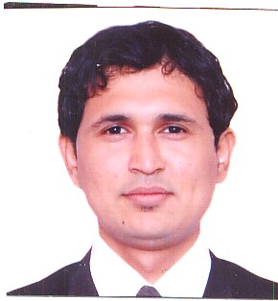Plot No.345/A/1

Sector-12/C,

Gandhinagar.( Gujarat) (India)

Pin Code No-382016.

Tel.No:Res # 0091-079-23237772

Cell : # 0091-9898065772

E-Mail : [bhavesh.Jdv@GMail.Com](mailto:bhavesh.Jdv@GMail.Com)

**EDUCATION:**

June-2014 **:**  The Institute Of Computer Accounts.Gandhinagar,Gujarat,India

**CERTIFIED INDUSRIAL ACCOUNT PLUS**

**( Purshing ) ( Fresher )**

March-2014 **:** Government commerce College, Gandhinagar**.**

**T. Y. B. COM.**

May-2004  **:** Institute of Hotel Management&Catering Tecnology,Ahmedabad.Gujarat.

**DIPLOMA IN FOOD PRODUCTION**

March-1999 **:** Government High School, Gandhinagar, Gujarat.

**HIGHER SECONDARY SCHOOL CERTIFICATE**

March-1997 **:** Government High School, Gandhinagar, Gujarat

**SECONDARY SCHOOL CERTIFICATE**

**PROFESSIONAL EXPERIENCE**

INDUSTRIAL TRAINIGN INSTITUTE (ITI) GANDHINAGAR.(GUJARAT)

( date- 20-12-2008 to03-08-02011)

Position **: (** supervisor Instructor )

HOTEL CHICAGO, AHMEDABAD. ( INDIA)

( date-15-04-2005 to 14-04-2008 )

Position : Apprentice.

HOTEL INDER RESIDENCY, AHMEDABAD. ( INDIA )

( May-2002 to September-2002 )

Position : Trainee.

**LANGUGES**  **:** English, Hindi, Gujarati

**COMPUTER SKILLS :** M.S.Office , Internet, E-Mail & Web page Development and

Tally ERP 9,

**OTHER ACTIVITIES :** I got the award of appreciation INTERNATIONAL

ASSOCIATION OF EDUCATION FOR WORLD

PEACE (NGO : UNITED NATIONS & UNESCO)

**HOBBIES :** Cooking, Travelling, Reading

**DATE AND PLACE OF BIRTH :** 16th October 1982,Mumbai

**GENDER :** Male

**RELIGION :** Hindu

**NATIONALITY :**  Indian

**DECLERARATION**

I hereby affirm that the above information is true to the best of my knowledge.

Date :

Place: Gandhinagar (BHAVESH)