RESUME
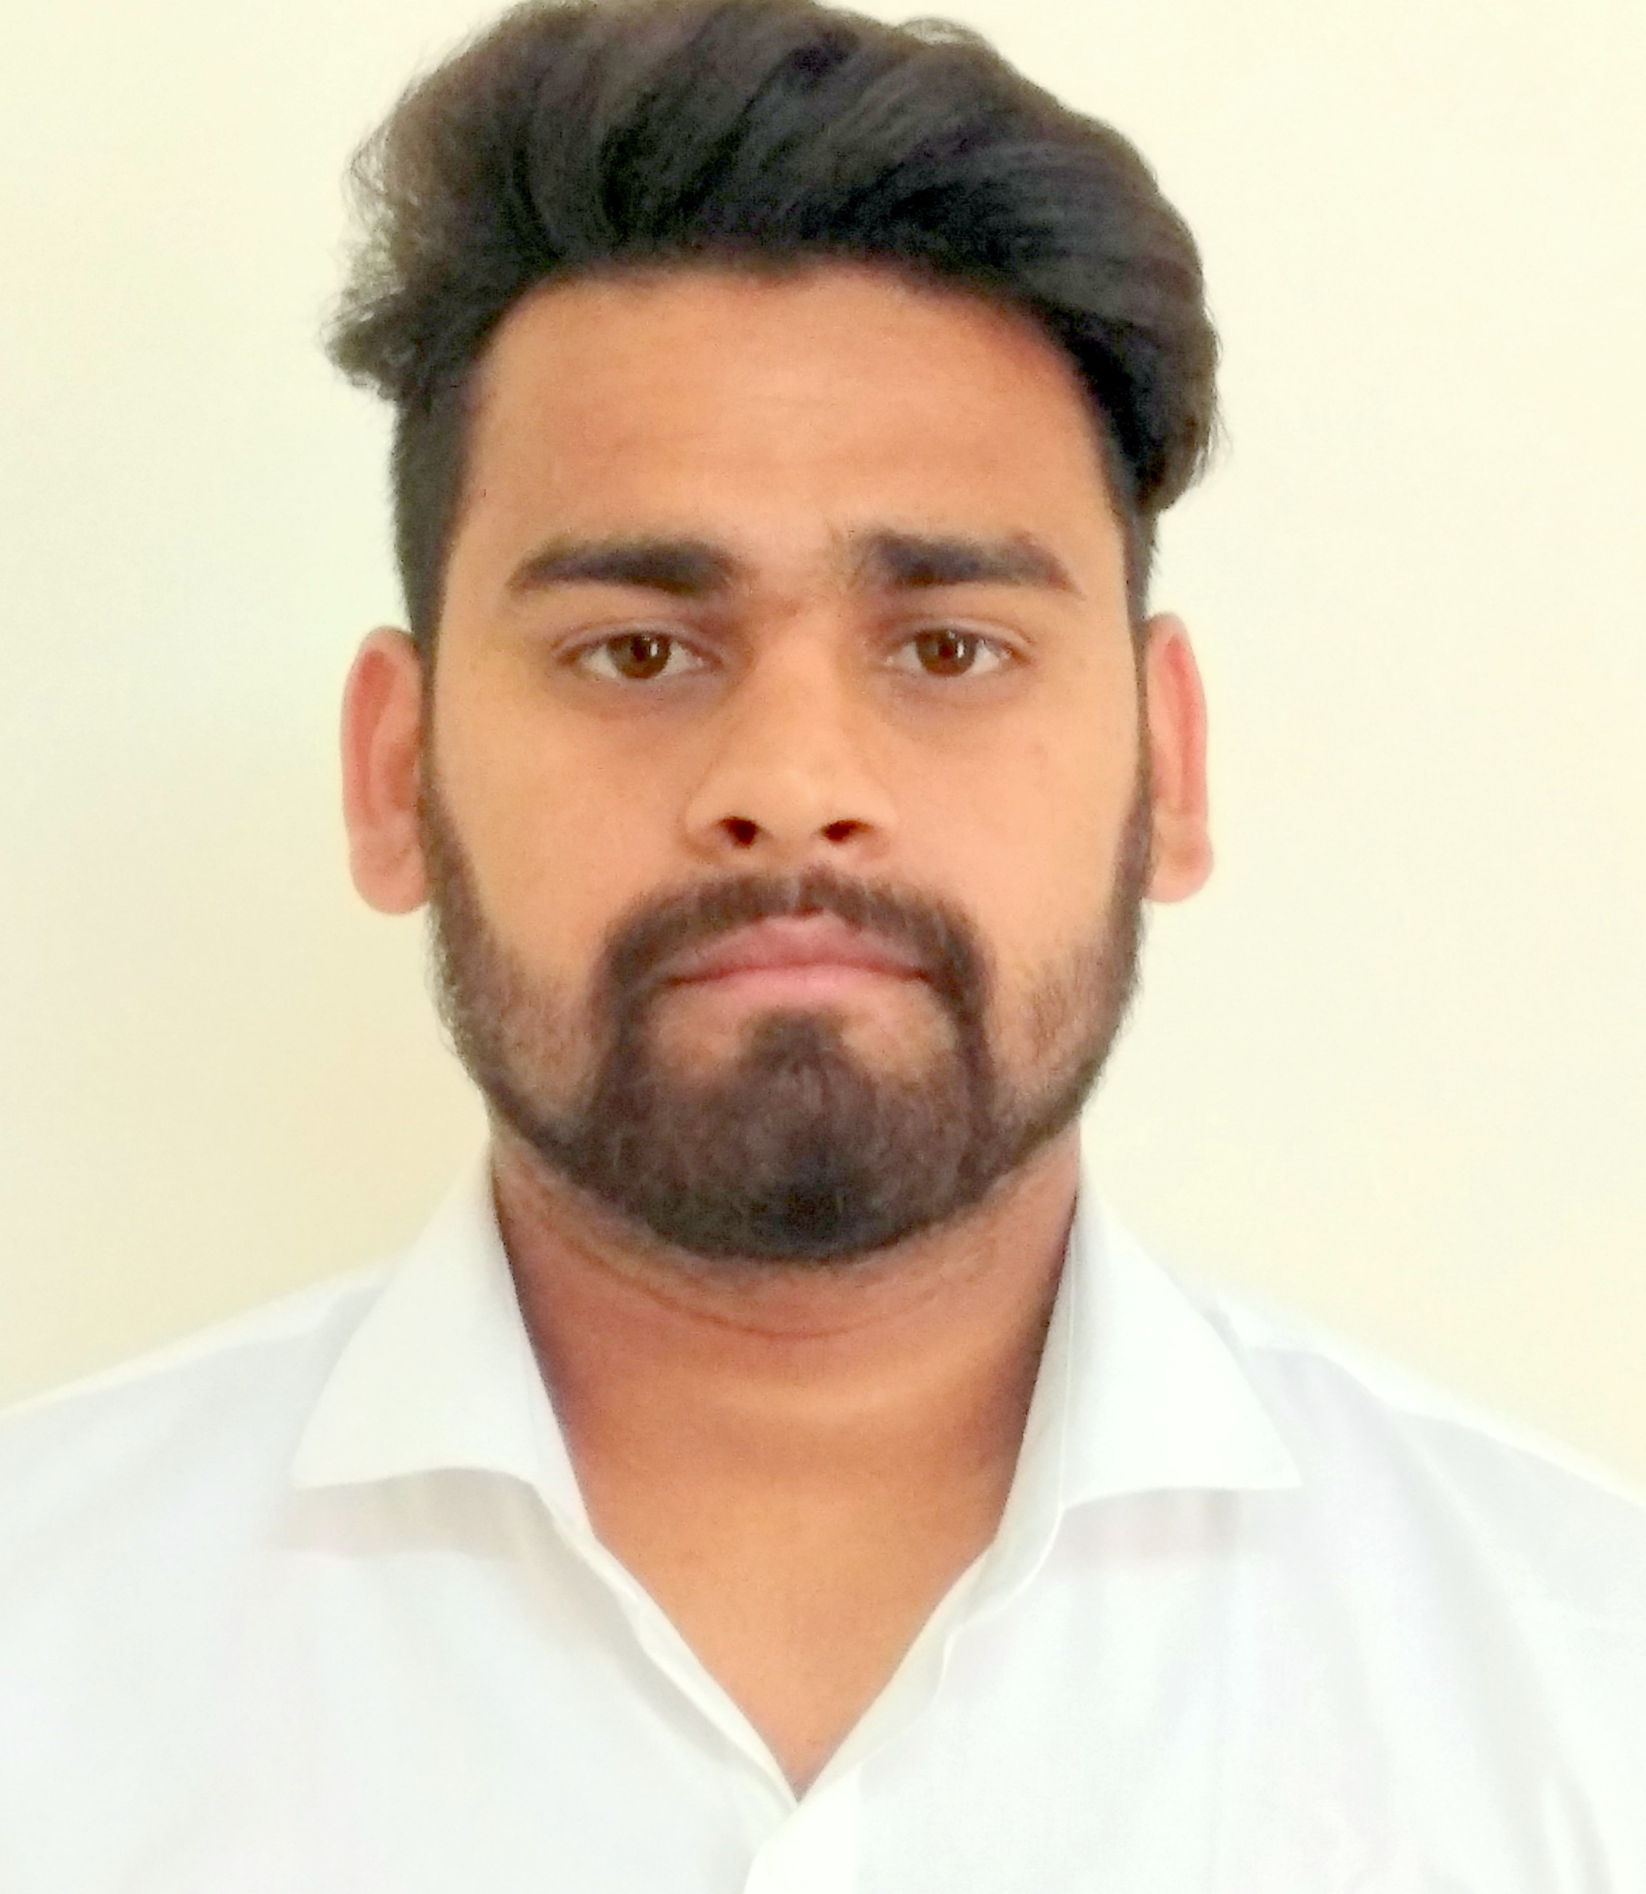
ankush rathour

Permanent Address:-
V. P. O - Cholthara
Teh-: Sarkaghat Distt-Mandi
(Himachal Pradesh) 175037

Email- rathour2905@gmail.com
: +91-9817691213

Career Objective

- To be an enthusiastic professional and promote my abilities and talent towards a growth oriented career and to give the best services to the Organization with the qualities of adaptability, dynamism & perseverance.
- To be able to find a decent job that can enhance my skills and knowledge and contribute to the business.

Educational QUALIFICATION

- Pursuing B.Tech Electronics and Communication Engineering(2015-2018) from KURUKSHETRA UNIVERSITY, KURUKSHETRA (HARYANA) is to be held on May 2018.
- Diploma in Electronics and Communication Engineering from JAYPEE UNIVERSITY OF INFORMATION TECHNOLOGY WAKNAGHAT(2010-2013), Solan (H.P.)
- XII from H.P.B.O.S.E Dharamshala in 2010.
- X from H.P.B.O.S.E Dharamshala in 2008.

WORKING EXPERIENCE:-

Worked with Vision Engineer (INDIA) as a Site Engineer (Electronics) from Feb 2014 to may 2015. (BARA, ALLAHABAD, U.P)
- Worked with Cenzer Industry Limited as a Production Engineer from Aug 2013 to Feb 2014.

TRAINING PERFORMANCE:-

- Did my summer training in JAYPEE HIMACHAL CEMENT PLANT BAGA (BILASPUR) with excellent grade.
- Did my summer training in BSNL (HAMIRPUR) with excellent work.

ACADEMIC PROJECT:- Minor Project & Major Project

- 5v power supply & solar lamp with variable power supply and charge. P.T.O
- Knowledge to implement the circuits on PCB Summer Internship Project on Traffic Signal Light Controller using with 8051 Microcontroller and 5V & 12V Power supply using PCB and Software.

sharp side:-

- Punctual and hardworking
- Can work under Challenging Environment
- Self-Motivated and Determined
- Good Communication

HOBBIES :-

- Making new friends
- Watching TED-talk
- Playing Basketball
- Reading books( Dr. A.P.J Abdul Kalam)

Personal Details:-

Name | Ankush Rathour
Father’s Name | Sh. Hardev Singh
Mother’s Name | Smt. Lalita Devi
Sex | Male
Marital Status | Single
Nationality | Indian
Age | 25 years
Date of Birth | 29 May 1992
Languages known | Hindi, English,Punjabi,Bhojpuri

clearance:-

I hereby declare that the given information is true to best of my knowledge and i would be responsible if there would be any mistake in filled information.

DATE: (Ankush Rathour)
PLACE:

