
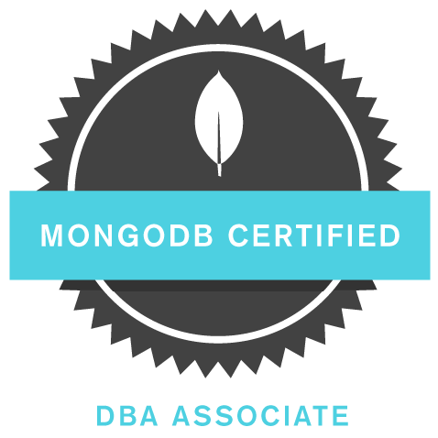
ypos:-0.712500in; frame-width:1.175000in; frame-height:1.175000in; xpos:-0.354167in; frame-type:imageypos:-0.710417in; frame-width:1.235417in; frame-height:1.235417in; xpos:6.190278in; frame-type:image

DHAVAL SINGH
Database Consultant
mail.dhavalsingh@gmail.com
Mob: +91 (0) 9712477923

Oracle Database & PL/SQL Developer
MongoDB Developer
Oracle DBA
Web Application Developer

PROFILE SUMMARY

- 5 years of experience in the areas of Software Development with expertise in designing and developing large-scale applications using Oracle Database, and PL/SQL.
- In-depth knowledge with Oracle Database Administration, Data Modeling, relational database and SQL.
- Working knowledge and experience in front end as well as back end web development using JavaScript, nodeJS, node Express, Ajax, jQuery, REST, Bootstrap, HTML5, and CSS3
- In-depth knowledge with technologies such as REST Web Services using nodeJS and express, XML, JSON.
- Experience and working knowledge of NoSQL databases like MongoDB
- Experience in Requirements Analysis, Preparing of Design Documents, Development Effort Estimation and Proposal Writing, managing large teams, traditional Waterfall and Agile(Sprint based) SDLCs.

WORK EXPERIENCE

Company Name : Tata Consultancy Services Limited. Duration: Dec 2013 to Till Date

Tata Consultancy Services Limited is an Indian multinational information technology service, consulting and business solutions SEI-CMM Level 5, PCMM Level 3 and an ISO 9001 Company; offering high-end consultancy in areas like Healthcare, Telecommunications, Manufacturing, Utilities, Public Sector & Government.
Title : Technical Project Lead and Senior Developer

Project -1 : Commercial Tax Department for the state of Rajasthan,
Commercial Tax Department for the Jammu & Kashmir.
Client : Tax Authority of Rajasthan, Tax Authority of Jammu & Kashmir
Location : Ahmedabad, Gujarat

Description : The Commercial Tax Department administers collection of various taxes such as Value Added Tax, Central Sales Tax, Entertainment Tax, Entry Tax, Luxury Tax and the recently introduced Goods and Services Tax. The dealers registered with the Web Portal of the department use it for services such as Filing e-Returns, availing Refunds, and Subsidies. The application for the CTD Officials enables them to monitor the applications filed by the dealers and carry out the Assessment of the returns. The Department is a major contributor to the Tax Revenue collected by the State Government. Nearly 50 percent of the Tax Revenue received by the State Government.

Technical Responsibilities:
- Implementing Database design and PLSQL package, procedure and other data object for Numerous of Modules including Registration, Returns, Refund, Assessment and many more.
- Data Security Implementation using various in-house tools and packages to enhance the data privacy.
- Worked on Implementation of Tax data analytic and created numerous reports showing various trends.
- Android application development called Raj VAT.
- Successfully transferred inbound data from various sources like flat files, MS Access, and Excel into database using various tools.
- Responsible for optimizing SQL queries, stored procedures to improve the performance time of the overall application.
- Implemented data reconciliation, data masking and data encryption.
- Implemented auditing using triggers and enforcing business rules via checks and constraints. Proper use of views to prevent unauthorized access to sensitive data.
- Monitored and tuned database performance.
- Automated and implemented backup and recovery procedures.
- Leading an offshore team to provide extensive support and CR developments.

Team Size : 50
Role : Technical Lead and DBA
Tools Used : Toad, PLSQL Developer, Eclipse, Jdeveloper, Putty, WinSCP, Mastercraft, Jenkins, Beyond Comparator, Examdiff, SVN Tortoise

Project -2 : Zimmer End to End Data Validations and Manufacturing design
Client : Zimmer Biomet
Location : Pune, Maharashtra
Description : Zimmer is one of the biggest manufacturing of body implants in USA. As a part of end to end validation, data analysis that accumulates from various manufacturing parts and tests to eliminate the errors to improve the overall quality if the implants. Implementations of Automated process for data accumulation from various manufacturing process.

Team Size : 20
Role : Database Developer
Environment :
Tools Used - Toad, PLSQL Developer, MongoDB Compass, Studio 3T, MS Access, MS Visio

Technical Responsibilities:
- Data Extraction.
- Data warehousing for reporting purpose.
- Analyzing the data for various manufacturing, design and test instruments to eliminate the error prone products.

Project -3 : Good and Sales Tax Analytic Reporting Framework
Client : Commercial Tax Officials for the State Government of India
Location : Gandhinagar, Gujarat
Description : A customized reporting framework for the various states including Gujarat, Bihar, HP, Rajasthan and more that produces analytical reports based on different indirect taxes.
Team Size : 20
Role : Database Developer
Tools Used : MongoDB Compass, Studio 3T, Microsoft Visual code, npm package manager

Technical Responsibilities:
- Data Extraction, filtration and warehousing from Data API.
- Creating a Scheduling a procedure/methods to analyze various data trends and forecasting.
- Building a RESTful API for different Tax attribute.
- Performance and Tuning.
- Data security and encryption.

ADDITIONAL INFORMATION

Country of birth : India
Nationality : Indian
Sex : Male
Date of birth : 31st May 1992
Marital status : Married
Permanent Address : C/7 Sarvottam nagar Sabarmati Ahmedabad –380019. Gujarat, India

ACADEMIC EDUCATION

Course Name | From | Passed Year
Graduation | L.D College of Engineering, Gujarat University. | 2013
H.S.C. (10+2) | GSERT, Gujarat | 2009
S.S.C | GSERT, Gujarat | 2007

PROFESSIONAL QUALIFICATION

Course Name | From | Duration
Oracle 11g SQL/PLSQL Fundamentals | ITS Data Solution Ahmedabad | 1 Months
Oracle 11g Database Administration | ITS Data Solution Ahmedabad | 1 Months
Object oriented Programming with Java | Gujarat Knowledge Society | 3 Months
Front end web development | Indylogix Solution | 2 Months

CERTIFICATIONS

- Oracle Certified Associate
- BRAIN BENCH CERTIFIED [PL/SQL Programmer, RDBMS Concepts, SQL Fundamentals, Javascript, Java Fundamentals]

MongoDB Certified DBA Associate
- SQL for Data Reporting and Analysis
- SQL Performance tuning
- Android App Development Essential Training
- Front End Web development from freecodecamp

OTHER TRCHNOLOGIES/TOOLS

- MySQL
- Microsoft SQL Server.
- Android application development.
- Adobe Photoshop.
- Adobe Dreamweaver.

