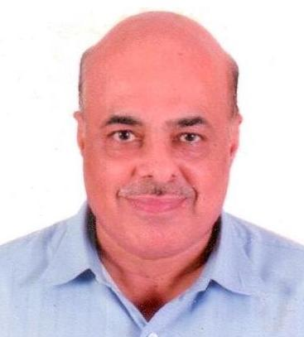
Saluja, kiran Deepak
 |  |  | Last Update: 11 Jan 2009
Contact Info |  |  |  |  |  | Edit
Address | : | C - 302, SUKIRTI PARK,NEAR KANCHAN BHOOMI APPTS,, 100fT. RING ROAD, SATELITE, AHMEDABAD, 380 051, Gujarat, India.
Telephone No. | : | 91- 079- 40064118
Mobile No. | : | 9825900119
Email | : | kirandeepak.saluja@gmail.com
Personal Particulars |  |  |  |  |  | Edit
Age | : | 54 years | Date of Birth | : | 07 Jan 1955
Nationality | : | India | Gender | : | Male
Marital Status | : | Married
Educational Background |  |  |  |  |  | Edit
Highest Education
Level | : | Bachelor of Commerce (B.Com) | Grade | : | Grade B/2nd Class Upper
Field of Study | : | Commerce
Major | :
Institute / University | : | Gujarat University
Located In | : | India | Graduation Date | : | Apr 1979
Employment History |  |  |  |  |  | Edit
1. | Company Name | : | Kan Alloys Pvt. Ltd
 | Position Title | : | General Manager
 | Position Level | : | Senior Manager
 | Specialization | : | Marketing/Business Development
 | Industry | : | Manufacturing / Production
 | Monthly Salary | : | INR 40000
 | Date Joined | : | Jul 2007 | Date Left | :

 | Work Description | :
RESPONSIBILITIES:
Administrating day 2 day work, includes Production Planning, Production, Foundry administration, daily in touch with stores regarding minimum balance of stock etc. Arranging / conducting daily meeting with head of departments, regarding planning, achiement.
Looking after sales, which includes development of new customers, dispatches and collection of payment.
2. | Company Name | : | M/s. Roll Cast Engineering Pvt. Ltd.,
 | Position Title | : | Assistant General Manager
 | Position Level | : | Senior Manager
 | Specialization | : | Marketing/Business Development
 | Industry | : | Manufacturing / Production
 | Monthly Salary | : | INR 35000
 | Date Joined | : | Jun 1986 | Date Left | : | Jun 2006

 | Work Description | :
RESPONSIBILITIES:
Administrating day 2 day work, includes Production Planning, Production, Foundry administration, daily in touch with stores regarding minimum balance of stock etc. Arranging / conducting daily meeting with head of departments, regarding planning, achiement.
Looking after sales, which includes development of new customers, dispatches and collection of payment.
3 Company Name :M/s. Anand Engineering Company
Position Title :Marketing Executive
Position Level : Marketing executive
Specialization : Marketing / Production of Rolls of Rolling Mill.
Industry : Manufacturing / Production
Monthly Salary : INR 12000
Date of Joining : July 1979 Date Left : April1985

Top Skills |  |  |  |  |  | Edit
Skill | Years | Proficiency
Having strong Administrtion & marketing | >5 | Advanced

Languages |  |  |  |  |  | Edit
 | Proficiency (0=Poor - 10=Excellent)
Language | Spoken | Written
Gujarati | 10 | 10
Hindi | 10 | 10
English | 10 | 10
Punjabi | 10 | 6

Additional Info |  |  |  |  |  | Edit
CAREER OBJECTIVE:
Managerial position in domestic marketing and sales within South-East Asian region.
SUMMARY OF QUALIFICATIONS:
* Top-notch administrator with more than 32 years of experience in marketing
* Unique combination of expertise in training, sales and finance
* Comprehensive knowledge of import/export regulations and documentation
PERSONAL TRAITS AND ATTITUDE:
* Excellent cross-cultural communication skills
* International living experience and regional exposure
* Passion for continuous learning and personal growth
* Highly motivated and driven, with strong desire to excel
Availability | : | Immediately after notice period of 1 month(s)

Miscellaneous |  |  |  |  |  | Edit
Expected Monthly Salary | : | INR 80000 (Negotiable)
Willing to Travel | : | Moderate (25% to 50%)
Willing to Relocate | : | Will Consider
Possess Own Transport | : | Yes

