RESUME

NAME:- MANISHA .V. RATHOD
ADD:- B-14,MEGHNA BANGLO.
B/H-INDUCTOTHE.
AT POST:-BOPALA,GHUMA GAM.
DIST:- AHMEDABAD
PIN:- 380058
GUJARAT ,INDIA

OBJECTIVE

To take up a challenging assignment with an organization of repute my talent and capabilities for my career oriented success.
PHOTO
PROFESSIONAL EXPERIENCE
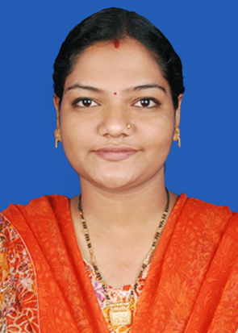
JOB PROFILE:-

ORGANIZATION :- BARMECHA’S IMPEX PVT.LTD.SURAT
OCCUPATION :- JEWELLRY DESAIGNER
EXPERIENCE :- ONE YEAR

- MENUALLY DESAIGN
- COMPUTER DESAIGNING

JOB PROFILE:-

ORGANIZATION :- R.S.M POONAWALA EXPERIMENTAL SCHOOL.SURAT
OCCUPATION :- COMPUTER TEACHER
EXPERIENCE :- 2 YEAR

- A HELP IN SLIDE SHOW
- GUJRATI & ENGLISH TYPING
- PARTICIPET TO ALL CULTURAL PROGRAMME IN THE SCHOOL & ANOTHER COMPETITION.

JOB PROFILE:-

ORGANIZATON :- SUNFLOWER SCHOOL,SURAT
OCCUPATION :- COMPUTER TEACHER
EXPERIENCE :- 2 YEAR.

- A HELP IN SLIDE SHOW
- GUJRATI & ENGLISH TYPING
- PARTICIPET TO ALL CULTURAL PROGRAMME IN THE SCHOOL & ANOTHER COMPETITION.

JOB PROFILE:-

- WORKING AS COMPUTER TUTOR OF B.R.S.,M.R.S,M.S.W.,& CCC(BAOU) STUDENTS IN SHREE SARSWATI GRAM VIDHYAPITH FROM FEB-2010 ON WORDS.
- ORGANIZATON :- SHREE SARSWATI GRAM VIDHYAPITH
- OCCUPATION :- COMPUTER TUTOR
- EXPERIENCE :- FEB-2010 ON WORDS.

COMPUTER KNOWLEDGE:-
- BASIC KNOWLEG
- D.T.P
- MS OFFICE,HTML,3D MAX,FLESH
- MASTRY IN COREL DROW & PHOTOSHOP
- INTERNET

EDUCATION QUALIFICATIONS

DEGREE | NAME OF INSTITUTE/BOARD | YEAR OF PASSING | PERCENTAGE
DIPLOMA IN COMMERCIAL ART | GOVT.POLY.GIRLS COLLAG,SURAT GANDHINAGAR BOARD | 2004 | 73.33%
10TH | SUNFLOWER SCHOOL,KRIBHCO/G.S.E.B | 2001 | 65.86%
12 TH | SUNFLOWER SCHOOL,KRIBHCO/G.S.E.B-Art | 2011 | 50.00%

PERSONAL DETAILS

Name :- RATHOD MANISHA V
Husband name :- RATHOD VIJAY BALSANGBHAI
Sex :- FEMALE
Marital status :- MARRIED
Nationality :- INDIAN
Date of birth :- 29/03/1986
Age :- 29
Hobbies :- READING,WRITING,PAINTING,DANCING,
SINGING,PLAYING,DRIVING.
Languages known :-ENGLISH,GUJARATI,HINDI
Email address :-manishathakor2@gmail.com
Phon no :-9879406894.+9913675366.

ACHIEVEMENTS AND STRENGHTS

1. Discipline volunteer in school
2. Possess leadership qualities
3. Task driven
4. Time management for achieving assigned goals
5. Positive attitude & commitment
6. co-ordination skills within & outside team
7. honest & hardworking .

DECLARATON
I hereby declare that the details furnished above are true to the best of my knowledge and belief. 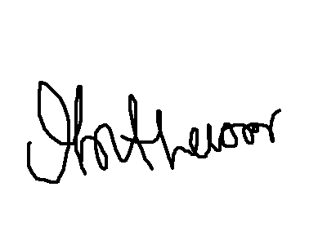
SIGN
MANISHA .V.RATHOD

