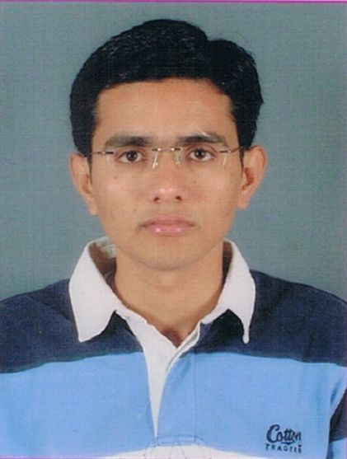
RESUME

MAULIK MAHESHKUMAR PANDYA

7-A , “sharan”
Bapunagar ,
Near Alka Chowk,
Surendranagar,
Gujarat, INDIA
Ph: (M) 9429279125
(R)02752 231690
Email: maulik1991@gmail.com

Career objective:

To pursue a highly challenging and creative career, where i can apply my existing knowledge and creativity,acquire new skills and contribute effectively to the organization

Academic Records:

Educational Qualification:

Qualification | Year of Passing | Percentage  (%) | Conducting Authority
B.Pharm | 2012 | CGPA=7.29 | Gujarat technological University, Ahemedabad.
H.S.C. | 2008 | 65.40% | GHSEB,Gandhinagar
S.S.C | 2006 | 79.86% | GSEB,Gandhinagar

Skill & Strength:

- Good Analytical Skill
- Problem solving nature and Quick learner
- Good command on Tablet Punching machine
- Good command on computer
Area Of Interest

- Production and Marketing
Other Achievements:

- Present a paper on “ADVANCE TREATMENT OF CANCER”
- Pass a NATIONAL LEVEL SCIENCE TALENT SERCH EXAMINATION 2007
- Also engaged with sports and other activities
Industrial training:

- Training in PRAYASH PHARMACEUTICALS at SURENDRANAGAR

Personal Information:

Name :Maulik M Pandya
Father’s Name : Maheshkumar A Pandya.
Date of Birth : 05th jan 1991
Nationality : Indian
Mother Tongue : Gujarati
Marital Status : Single
Other languages known : English
Hindi
Reference:

- Kinjal Patel
Franco India pharma
Mo.9428714996
Declaration:
I hereby declare that the above-mentioned information is true and to the best of my knowledge.
Your Faithful
Maulik Pandya

