
Pathan Mo. Parvej Khan
MBA (Marketing)
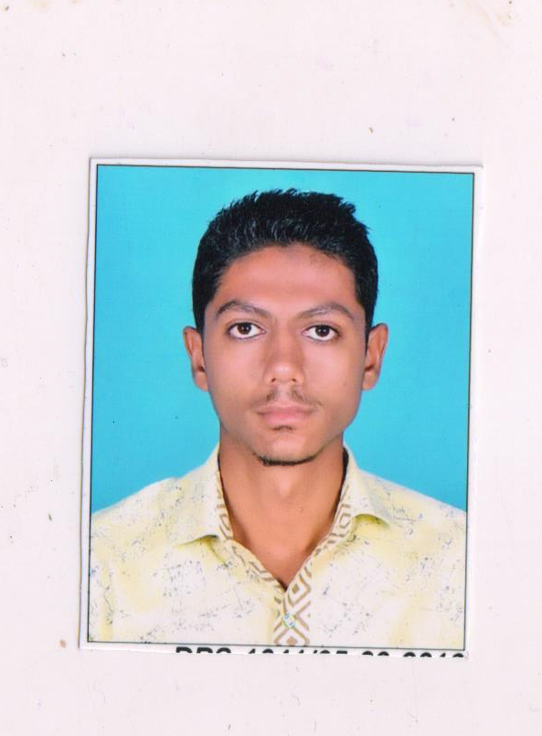

Email : maddakhan94@gmail.com
Mobile: 8200763670

Career Objective: To have acquire a challenging career with a company in order to utilizing the opportunity & effective in the company.

Academic Qualifications:
Degree | Institute/School | Board/University | From/To |  | CGPA/%
M.B.A (Marketing) | L.J INSTITUTE OF COMPUTER APPLICATION | GUJARAT TECHNOLOGICAL UNIVERSITY |  | 2016-18 | 6.35
B.COM | BHAVAN’S SHETH R.A COMMERCE COLLAGE | GUJARAT UNIVERSITY |  | 2013-16 | 59.00%
HSC | SWAMINARAYAN HIGH SCHOOL | G.S.H.E.B |  | 2012-13 | 65.00%
SSC | SWAMINARAYAN HIGH SCHOOL | G.S.E.B |  | 2010-11 | 62.00%

Internships and Projects:

- SUMMER INTERNSHIP PROGRAM
- Company Name :- Hardy Smith
- Duration : 45 Days
- Objective:- Study on scope of New Market Development of WPC (Wood Polymer Composite ) Product Of Hardy smith WPC Center

Extra Curricular Activities

- Got Silver & Gold Medal In Kabaddi At L.J M.B.A
- Got Trophy in Cricket At Various Tournament
- Participate in Various Event like Hat Speech, Tongue Twister, etc…
Proficiencies:
Languages known: English, Hindi, Gujarati
- Language Known: Hindi,English,gujarati.
- Computer Skills: M.s office.
Hobbies / Interests:

- I like to Play Cricket And other Sport Games

Personal Details:

Address: 449/12, Vakil Chawl
Opp. Usha Cinema Gomtipur Ahmedabad -380021
Date of Birth: 16/07/1995
Gender: MALE
Nationality: INDIAN
Marital Status: Single

Signature Date:

