CURRICULUM-VITAE
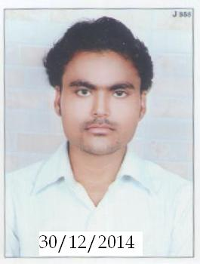
RAHUL KUMAR YAGIK
Address: A-1200 RAJEEV PARK ADINATH NAGAR
ODAV AHMEDABAD,
POST:-AHMEDABAD,
DIST:- AHMEDABAD (GUJRAT) PIN- 382415
MOB No: +91 9616636126
E-mail:- yagnikrahul1991@gmail.com

CAREER OBJECTIVE:
I seek a challenging a meaningful career where hard working is main task and that is a plus point of dynamic result oriented organization specially.

ACADEMICS QUALIFICATIONS:
- B.Sc. FROM LATE.BAHADUR SINGH MAHAVIDYALAYA MADHAUGARH WITH 59% MARKS
- INTERMEDIATE FROM RASHTRIYA INTER COLLEGE ORAI WITH 61% MARKS
- HIGH SCHOOL FROM SETH GOVIND DAS SARASWATI VIDYA MANDIR MADHAUGARH WITH 65% MARKS

TECHNICAL SKILLS:
APPLICATION SOFTWARES | - Internet Browsing (Mailing)  - MS DOS  - Auto CAD  - STAAD.PRO  - MS OFFICE & OUTLOOK
OPERATING SYSTEM | Windows 2000. XP, Vista, Seven, 8 & 8.1

INDUSTRIAL EXPLOSURE:
COMPANY | DHRUVIKA CHEMICAL PVT. LTD. KANPUR (U.P.)
Duration | 1 YEAR 8 MONTHS
Topic | SELLS MARKETING AND BUSSINESS
COMPANY | PLADA INFOTECH SERVICES PVT. LTD.
DURATION | 4 JAN 2016 TO 9 OCT 2016
DESIGNATION | SELLS MARKETING & EXECUTIVE
SALARY | 11000/-
COMPANY | YES BANK LTD
DESIGNATION | CLIEN RELATIONSHIP PARTNER
DURATION | CURRENTLY WORKING ON 10TH OCT. 2016
SALARY | 210000 PER ANUM.
EXPECTED SALARY | ABOVE 3 LACS.
PROJECT DETAILS:
Project Title: | To Study the “LEARNING OF COMPUTER”
Key Activities Areas | - PROJECT ASSISTANCE  - KNOWLADGE OF COMPUTER

PERSONAL INFORMATION:
Father’s Name | Mr. SANTOSH KUMAR
DOB | 07 AUG 1992
Religion | Hindu
Languages known | English & Hindi
Permanent Address | A1200 RAJEEV PARK ADINATH NAGAR ODAV AHMEDABAD  (GUJRAT) PIN- 382415
E-mail ID | Yagnikrahul1991@gmail.com
Mobile Number | +91 9616636126

HOBBIES:
LISTENING MUSIC & INTERNET SURFING

I hereby declare that the above written particulars are true to the best of my knowledge and belief.
(RAHUL KUMAR YAGIK)
PLACE:
DATE: / /

