RAKESH BAIRI
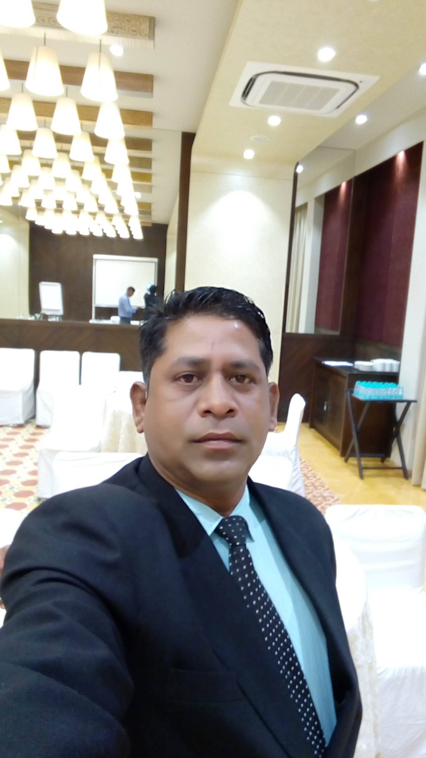

Productive, dynamic and ambitious individual seeking a position with Hotel/Restaurant utilizing exceptional customer service and hospitality skills to maximize the satisfaction of Clients and increase repute of employer

AREAS OF EXPERTISE  - Guest Relations  - Corporate Hospitality  - Budgeting  - Inventory Management  - Strategic Planning  - Banqueting  - Customer Service  - Promotional Activities  - Performance Management  - Business Development  - People Management  - Restaurant Management  - Food & Beverages  - Kitchen Management  - Menu Planning/Pricing  - Waste Management  - Business Administration  - Event management  ACADEMIA  Diploma in Hospitality Management | i.i.a.s School of Management SILIGURI West Bengal in 2000  - Training Exposure in Quality Inn Aruna, Chennai for 6 Months in all the major departments  - Hotel Sinclair’s Bay view Port Blair Andaman Islands Industrial Trainee Specialization in Food & Beverage Services 6 months  - Actively participated in I.I.A.S. Monsoon Mania (Fete).Worked for Teesta Tea & Tourism Festival under West Bengal Tourism  - Completed Leadership Skill module; Service Excellence module from Hyatt Regency Kolkata  PERSONAL DETAILS  Anand Vihar, Phase II, Block A, Flat No. 201, 2nd Floor, 25, N.N. Road, Kolkata 28.  Mail: rakesh.bairi@gmail.com  Mob:8980002808  Date of Birth: 9th Dec’ 1979  Languages Known: English ,Hindi, Telugu and Bengali | PERSONAL SUMMARY  An astute professional with over 17 years of experience in the field of Food and Beverage Service. Currently linked with GRAND O7 Suite n Convention as GENERAL MANAGER.  Proven track record of effectively leading and managing all aspects of a hotel, and of making guests feels cared for, valued, and respected. Adaptable & flexible with ability to lead from the front and coordinate activities like Bond, F&B, Production, Accounts and Transports, etc. Excellent knowledge of expected standards for service to guests and members, decor, food quality, and banquet operations.  Consummate professional with excellent planning, execution, monitoring and resource balancing skills, attention to detail as well as the ability to build and lead effective teams. A versatile and hardworking person possessing excellent analytical and & smart working person possessing excellent analytical and communication skills.  KEY ACCOUNTABILITIES  - Planning and organizing Big Banqueting and other hotel services; promoting and marketing the business.  - Managing budgets and financial plans as well as controlling expenditure and maintaining statistical and financial records.  - Recruiting, training and monitoring staff along with planning work schedules for individuals and teams.  - Identifying and networking with cost effective & reliable Vendors/ Suppliers for purchase of requisite materials and spares as well as project procurements.  - Ensuring events and conferences run smoothly.  - Supervising maintenance, supplies, renovations and furnishings;  - Ensuring compliance with licensing laws, health and safety and other statutory regulations.  - Observe and monitor workers' performance to make sure that company rules and procedures are being followed.  - Confer and cooperate with other department managers to coordinate hotel activities, such as weddings.  - Answer questions about hotel policies and services and also resolve customer’s complaints.  - Arrange telephone answering service, mail delivery, and answers customers questions about area.  - Assign duties to workers and schedule shifts.  - Analyze financial information on computer and create reports for owners.  - Answer customers' questions, make them feel at home, and build on-going relationships.  - Auditing operations to ensure compliance of Standard Operating Procedures.  - Schedule work activities and communicate duties and hours to staff. Coach staff on how to do the job and motivate them to finish projects.  - Maintaining quality & hygiene standards for streamlining processes and generating cost savings in operations.  - Designing, developing and implementing the Standard operating system manual/ SOPs for the systems.  - Ensuring profitability of operations and supervise all aspects of Kitchen management including menu-planning, monitoring food production standards to ensure compliance with quality & hygiene standards.  - Interview applicants and judge the quality of their skills to staff various positions in hotels.  - Creating & measuring guest satisfaction index GSI as well as involved in Complaint management.  WORK EXPERIENCE  GENERAL MANAGER| GRAND O7- Suite & convention, ahmedabad | TILL DATE ( JUly 2018)  www.grando7.com  GrandO7 offers 160 Grand Lavish rooms, Amongst 32 elegant & rich rooms, 96 suites and 32 large and extra ordinary suites. Guests can choose from... We have an all day dining restaurant that serves world cuisines; make your important decisions over a cup of coffee in our 24 hrs coffee shop that offers grandeur coffee & cookie culture, 05 F&B outlets with different cuisine from different regions.  Banquet Halls and grand lawns to host celebrations, occasions and events. Our grand lawn is carefully-tended outdoor space that can comfortably accommodate up to 1,500 - 5000 for celebration. We have biggest convention centre with 35000sq.ft pillars less banquet hall and 25 banquet halls starting from 50 to 5000 people capacity.  HEAD CONVENTION & BANQUETING| the grand bhagwati, surat | 06 MONTH (DEC 2017-JUNE 2018)  www.tgbhotels.com  The Grand Bhagwati Surat is Gujarat’s first & largest five-star deluxe hotel with build-up area of 6 lakh sq. ft.  170 opulent rooms including 8 suites, India largest in-hotel convention Centre with 1.5 lakh sq. ft. of pillar less convention space, ballrooms, banquets, decorated conference rooms, impeccably manicured lawns, finest of restaurant, spa, discotheque, mini theatre and an elite club,  GENERAL MANAGER SUNCITY CLUB & RESORT VARODARA | 01 Year 01 month (OCT 2016-nov 2017).  www.suncityclub.in  A resort build-up area of 6lakh sq.ft. with 40 opulent rooms 02 suites, convention area of 1.4lakh sq.ft, capacity of 5000 people lawn, 04 banquet hall with the capacity of 100 to 500 people, 02 hall with the capacity of 50 to 150 people, 01 multi cuisine restaurant of 104 covers, Unique Teakwood live kitchen restaurant with 110 cover & food court with 200 cover at poolside.kid zone, sport complex with squash, table tennis, badminton court, Gym, yoga room, spa & library.  OPERATIONS manager BANQUET & RESTURANT | the grand bhagwati, surat | 05 Year 01 month (SEPT 2011- oct 2016)  The Grand Bhagwati Surat is Gujarat’s first & largest five-star deluxe hotel with build-up area of 6 lakh sq. ft.  170 opulent rooms including 8 suites, India largest in-hotel convention Centre with 1.5 lakh sq. ft. of pillar less convention space, ballrooms, banquets, decorated conference rooms, impeccably manicured lawns, finest of restaurant, spa, discotheque, mini theatre and an elite club,  cocoon luxury business hotel | 02 YEARS 01 MONTH (JULY 2009 – AUG 2011)  Manager Operation  Accountable for handling Hotel operations  Responsible for maintaining visibility with guests at all times, and for assisting to run a hotel that has 64 Rooms with 02Banquet Halls, 01 restaurant & Bar area.  Highlights:  - Designed & implemented a customer feedback system and mystery customer audit system.  mani square mall, kolkata | 01 year (JUly 2008 – JULY 2009)  F& B Manager  - F&B operations along with extensive banquet operations  Responsible for maintaining visibility with guests at all times, and for assisting to run a mall that has 02Banquet Halls and 02 restaurants and food court.  hyatt regency, kolkata | 05 YEARs 04 months (AUG 2002- DEC 2007)  Banquet & conferNcing manager  - Joined as a Waiter and was promoted into Team Leader and Assistant Outlet Manager Position. Further promoted as Outlet Manager (Banquets & Conferencing)  - Handling conventions and coordinating for all the conferencing requirements  - Most important knowledge based on Banquet Operations & Management was formed at Hyatt Regency Kolkata.  the park HOTEL KOLKATA | 01years 10 MONTH (OCT2000 – AUG2002)  f&b assistant  Worked as Barman at TANTRA the night club with a capacity of 750 guests at time.  fortune hotel central, by ITC Group darjeeling | 05 months(APR 2000 - SEPT 2000)  f&b supervisor  Responsible for maintaining visibility with guests at all times, and for assisting to run a hotel that has 65 rooms 4 star business hotel 1 restaurant and 1 bar & 1 banquet halls.  ACHIEVEMENTS  - Catered for:  - 10000 persons hi-tea, dinner constant 02 days for Reliance industries  - 1500 persons breakfast, lunch Dinner constant 03 days for Indian oil  - Handle 1.5lakh sq ft of banquet at a time in TGB SURAT.  - 1200 persons chief Minister catering At National Institute of Designing, Ahmadabad as Surat  - 1500 persons at Pundit Dindayal University for Chief Minister  - 1500 persons for Vibrant Gujarat in Ahmadabad Management Association.  - Official caterer for:  - All functions at Chief Minister’s as well as all government event at Surat like Smart city summit etc.  - Awarded Employee of the year in Hyatt Regency Kolkata 2004.  - Initiated and established an outdoor catering cell at Mani squre mall.  - Launched Cocoon luxury business hotel at Dhanbad,64 Rooms with 02Banquet Halls, 01 restaurant & Bar area  - All our restaurants have own “Time Food Guide Awards” in its category for last 3 consecutive years.  - Our restaurants have been voted as the best by “CNBC TV 18” & “India today”.

