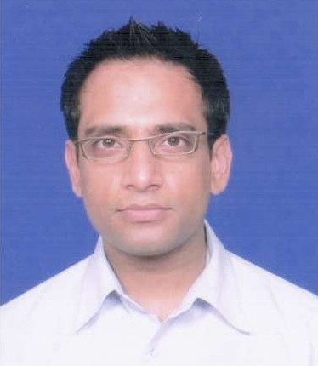
Tashmin Patel
A/501 Vishwa Residency, Gurukul Road, Ahmedabad-52.
E-mail: tashmin.patel@gmail.com
Mob: 0091 7567860935 / 9067230738

I would like to pursue a challenging career and be a part of a growing business organization that gives the scope to enhance my knowledge and reach the heights with strong determination and hard work. I am able to work as a part of a team as well as individually. Moreover, I can be a part of a changing business environment and always eager to learn new things. I believe that my self-discipline and the innovative ways of thinking give me a special edge over others.

EMPLOYMENT

- Executive, International Process
Vodafone PLC UK, Ahmedabad. Apr 2011 – Till Date
Executive at Back Office Vodafone UK PLC
Responsible for transcription of verbal feedbacks
Email and chat support to UK based clients
Work with functional managers and team sponsors to obtain necessary resources and eventually manage the team requirements
Provide status reporting
Keep a track of regular activities
Deliver the final work with an approx accuracy of 98%

- Business Development Manager
Libra Education, Mehsana. Oct 2009 – Jan 2011
Responsible for the smooth processing of the centre on a day to day basis
Securing business opportunities with current and potential business prospects
Setting up the marketing and merchandising agenda
Liasing the business report to the trustees every quarterly
Directly interacting with students to solve any problems
Assisting students in developing Reading, Writing, Listening & Speaking Skills
Running batches of Personality Development and Soft Skills for MBA
Assisting job placements

- Assistant Area Manager & Training Co-ordinator
Tote Sport, London. Feb 2004 – Sep 2009
Manager of a leading high street betting chain
Managed a staff of 25-30 people
Responsible for a cash flow of several thousand pounds per day
Full responsibility of accounting and reconciliation
Vigilance, security and compliance delivered at all times
Delivered a professional and friendly service
Helping area manager in the recruitment process
Training of Deputy Managers
Assessment of newly trained managers
Execute new marketing strategy

Assessment of trained new starters
Training of Deputy Managers
Assessment of newly trained managers
Responsible for liaison between Area Manager and Training Department

- Sales Advisor
Travel Pack Travel Agency, London. Sep 2002 – Feb 2004
Sales of holidays and flights in busy high street travel agency
Delivering an excellent customer service
Conducting outbound calls to chase clients
Attend continuous flow of inbound inquiries
Processing payments, accounting reconciliation and documentation

QUALITIES DEVELOPED
Articulate telephone manner
Up selling skills
Customer service skills to a vide background of customers

EDUCATION

Post Graduation Diploma in Business Management
Jupitar IT, London. (Oct 2003 – Oct 2005)

British Airways Airfare ticketing Certificate (2 Levels, IATA 10 points)
West London College, London (Oct 2001 – Oct 2003)

Bachelor of Science, M G Science College, Gujarat University, India.
June 1998 – Apr 2001

Higher Secondary (10+2) New Saurabh High School. Ahmedabad, India
June 1996 – May 1998

TRAINING COURSES
Business Awareness Course 20th Nov 2006 at Tote Sport
Conflict Management Course at Tote Sport in May 2006
Quality Management Programme from National Institute of Information Technology

ACHIEVEMENTS
Recognised as the best manager of the region in year 2008
Awarded best student of the year in my second year of graduation
Received a trophy for winning the Inter School Badminton competition

Personal Information
D O B/Marital Status : 28th Nov 1978 / Married
Languages Known : English, Gujarati, Hindi and French

REFRENCES
Available on Request.

