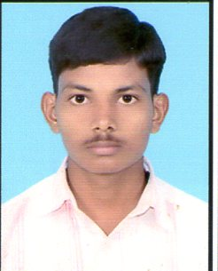
Curriculum-Vitae

Mobile no: 9712172406
Vaghelapravin011@gmail.com

Vaghela Pravin J.
Objective

To efficiently use my skills in a continuously learning environment culminating to my self development and substantial contribution to my organization.
Experience

- 1 Year experience in ITCT Computer Education at Becharaji as a Faculty.
- 1 Year experience in KVK (Kavshlay verdhan kendr) as a Faculty.
- 6 Month experience in Amazon Fc (Bhayla) as computer operator
Educational Qualification

- H.S.C Completed with 51.86% in academic year 2010
- B.C.A Completed with distraction in MS university academic year 2013
- I have other Computer Course Tally, Ms Office, DTP, and Fox pro, Hardware.
- CCC (Doeacc) Course completed in academic year 2011
- I have completed English speaking course in scope

Personal Details

Father Name : Vaghela Jivarajbhai
D.O.B : 31 March 1991
Address : At: Bavla (Shiv narayan society house no 14
Opp sukirtan flate Bavla )
: TA: Bavla
: Di: Ahmedabad-382220
Contact no : 9712172406, 7778858471
Gender : Male.
Languages known : English, Hindi, and Gujarati.
E-mail Id : vaghelapravin011@gmail.com
Marital Status : Married
Strength : Hard working, good communication skills,
Ambitious.

Place: Your’s faithfully
Date: Vaghela Pravin J.

