VIJAY ARVINDBHAI SHAH 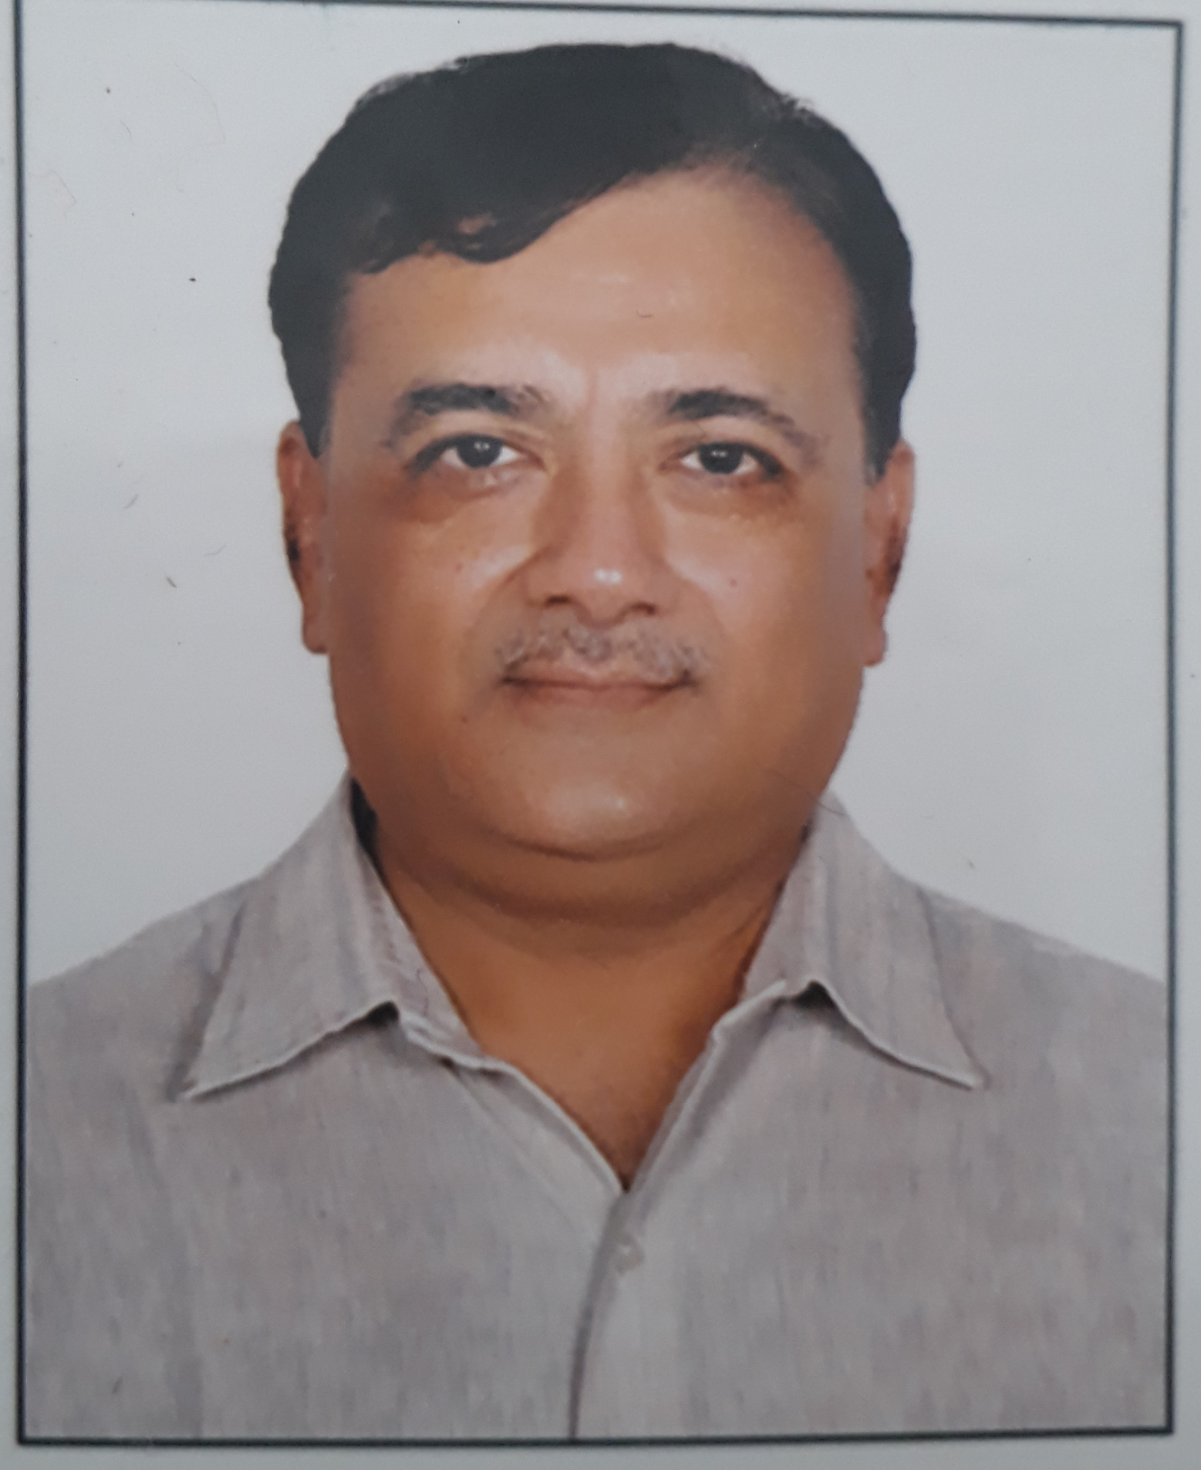
Mobile: +91-9428219850
Email: vijaysah62@yahoo.co.in

BRIEF OVERVIEW
- Over 30 years of experience in Plant Management, Plant Operations and Production Management & As a Quality Head. Presently working as GROUP VICE PRESIDENT Corporate – Operation responsible for developing product portfolios and export, tie up with company for contract manufacturing and Formulation Development aswell evaluation by QBD and Risk assessment
- A strategic conceptual planner& conflict management with experience in conducting & coordinating plant production activities, resource management with a flair for adopting modern methodologies in compliance to quality standards.
- Erection & commissioning of EU Level OSD & SVP Facility from layout Designing to operational stage as per regulatory norms and audited by many countries.it includes Ampoule/Liquid & powder vial Line
- Proficient in Contract Manufacturing/ Technology Transfer/P2P Business Development & PR capabilities
- An effective communicator with exceptional analytical, negotiation, relationship management and problem-solving skills with ability of resolving critical problem areas.
- Supply chain management (Purchasing skills, logistic management, inventory & procurement contracts, lag time calculations),Vendor development & qualifications
- HSE managements AS PER OHSAS 18001 REQUIREMENTS
- Lead Auditor & Trainer esp. For Regulatory Audits/contract mfg. Supervision/Quality,Technology Transfer to Manufacturing site
- Documentation/qualification/validation/Automation/Project erection & execution/Layout of facility designing/facility management/utility management as per international regulatory like soft gel/palletisation/Beta lactam/General Tablet/capsule/SVP - Ampoule /Liquid &Dry powder injectables etc.
- Oral solid/ lyophilisation/ parenteral/ soft gels/ prefilled dosage designing & developments/ costings/ inventory managements/ CAPA member
- Strong Appraisal skills by maintaining individual employee records on annual basis & discussion in group for their positives & negatives to improve Analytical skills
- Project of OSD Forms and Hormonal plant designing to meet WHO Geneva standards with bag in bag out filter HEPA AHU SYSTEM, Air breathing equipments, pressure suit & establishment of OEL for Personnel
- Formulation Development of RDT /MR /DR/BILAYER/CHEWABLE/EFFERVSCENT Tablets, Dry Powder Injectables/Hormonal injectables/Liquid injectables/Pellets/Syrups/suspensions/Emulsions/BCD complexations formulations ,Dosage form design - CMC and Design of Experiments
- Analytical Method developments , Comparative Dissolution study & stability Evaluations

Proficiency:

Plant Functions
- Strategic Planning policy, manufacturing schedules, along with resource allocation and machine loading for optimum scheduled output.
- Minimizing performance bottlenecks for high productivity by maximizing the men, material and machine.
- Appraising the prevalent manufacturing systems/ processes, identifying loop holes if any result-oriented measures for alleviating them and documenting the same.
- Annual budgeting design for sections, Discussing with HOD for monthly output & Targets, next six months production goals & boosting their motto by adopting incentives /awards by arranging annual functions which helps in tremendous quality output with inter department competition.

Production Management
- Planning production activities; implementing plans with a view to ensure smooth running of plants and timely accomplishment of production targets within the cost parameters.
- Ensuring execution of preventive maintenance schedules in order to ensure trouble free & seamless plant operations.
- Implementing effective techniques to bring efficiency in operations to improve quality standards & achieve maximum cost savings.

Contract Manufacturing
- Forecasting & tracking changes as per end-user demand against contract manufacturer's capabilities.
- Meeting requirements as per increased customer product demand quantities (billed-to / collected-on) by the contract manufacturer.
- Establishing & managing Productivity linked quality policy & lead to team for outsourced manufacturing with established quality agreement & cost part
- Audit, approvals, contracts as well establishing of AQL for Finish products release for Lifting from site
- Technology Transfer of Products to Manufacturing Site

Quality Management
- Troubleshooting all technical problems; conducting various tests & inspections to ensure that products developed are in compliance with pre-set quality specifications.
- QMS & LEAN Q systems, Risk Assessment
- Audit trail
- CAPA System Implementation based on Designed RCA & its outcome
- Documentation Authorisation & Control
- OOS, Market Complaints, Change Control, Deviation Control

Team Management
- Leading, training & monitoring the performance of team members to ensure efficiency in operations and meeting of individual & group targets.
- Managing administration of performance program including periodic performance reviews and appraisals for all employees.
- As a Management Committee Member in Core Team in CRPL, KNM as well RHC
- Worked with organisatins- Torrent Pharma, Helios Pharma,Brussels Labs, Corona Remedies
Knm Group and currently RHC group ( Div. Of Ratnamani Metals)

Regulatory & Audit & CAPA Designing
- Regulatory Audits/inspection prepared in view to cGMP PIC/s Guidelines for TGA & MCC
- Successfully executed Regulatory Audits WHO, ISO, KENYA, UGANDA, NIGERIA, RUSSIA YEMEN, LIBYA, MNC`s QA AUDIT, LIBYA, ETHOPIA & TANZANIA, PIC`s from MALAYSIA
- Preparation of Regulatory dossiers as per ICH guidelines CTD formats, BA/BE protocol approvals
- Inspection/Audit managements & co-ordinations with Admin & Technical officials to have successful audits/inspection & training to all levels & Designing CAPA and response letter
Fields Covered
- Supply chain managements, procurements, quality, Human Resource managers, projects, warehousing, accounts, commercials to align plants.
- Oversee Health & Safety executives (HSE)as per OHASA 18001 to reduce number of incidents.
- Providing back support to legal & statutory support to appointed legal advisor/regulatory advisors & advocates
- Providing Technical Dossier as per CTD/CMC following ICH guidelines for submission to global regulatory as well Indian regulatory, providing certificates/ Literatures to export division/ Institution/ Govt. Supplies.
- Formulation Development/pre-formulation study/Formulation evaluation as per Global standards applying Advanced stastistical Tool with QBD- QTPP, CQA, RA, DoE amd Design space,PAT & CS ,CI
Technologies Performed:
- Plans conversion to Targets as per Glantt chart
- Review & Implementation of plant specific mfg. policies & processes
- Communication to all concerns for achieving the perfection.
- Regular Reviews, Changes, Deviations & achievements reporting to Top management.
- Minimization of rejection ratios, Reducing cost of manufacturing & cost per unit with control of inputs, process and optimization of labour utilization as well energy controls,
- % capacity utilization, Improvements in capacities, installation of new capacities and statistical linking & generation of data, maintainance of ROCE of plant.
- Reduction & management of cycle time of manufacturing as well managing cycle time efficiently to have quality linked productivity.

Formulation Development : Quality by Design (QBD) with Advance Tools & Risk Assessment
QTPP , CQA`s ,CMA`s , CPP`s DoE, DS, PAT, CS and CI Tools
- Experience in Tablets, Parenteral & Oral Liquids/semisolids dosage, Vaginal Tablets, Sublingual Tablets, Sustain Release Formulations, Handling of Acid Labile Substance, Hygroscopic Material Enteric coated products, Palletizations etc.
- Polymer Science in sustain release & other Base materials as well Resin In pharma science & Fundamentals statistical process in product Developments.
- Orally disintegrating/rapid dissolving tablet formulations.
- Sustain/modified release/extended release & bilayer tablets. AMOXY POT CLAV STABLE FORMULATIONS LAUNCHED WITH SUCCESS
- Parenteral Formulation Development with its preformulation & stability studies in SVP as well LVP
- Parenterals molecule like Ranitidine,Diclofenac,Sodium chloride, Amikacin,Lincomycin ,Gentamycin
Heparin and approx 30 molecules developed
- Interaction with marketing & sales to provide strategic, Technical & innovative information ,back of literature support for promotion of product.
- Generic Formulation Development Experience for Tablets, Capsules & Oral Liquids
- Pre-formulation study of Excipients, API & New Chemical Entities, Evaluation study of developed Formulations.
- Pre-formulation study covered – Characteristic study, Safety Criteria’s, Toxicity, Stability, Compatibility & Acceptance criteria’s.
- API study covered- Organoleptic property, Hygroscopic, Acid / Base Compatibility, PH & solubility’s, Hydrophobic / Hydrophilic study Evaluation of finish covered stability study, In process of respective Dosage, Dissolution study and In vitro Bioequivalence study Process development & STP, Validation of process & STP and scale Up of validated pilot batch to commercial manufacturing (Care of Pilot Batch)
- Formulation Developments setting up dissolution criteria’s, bitter Less Medicines, Mouth dissolving tablets, Modified release, Chewable Acid Labile Tablets, Vaginal Tablets, palletization etc.
- Oral Liquids & Suspensions like sucralfate, Antacids, Liver Tonic, Enzymes New product developments with pre-formulation studies like Clarithromycin. Clindamycin, Azithromycin, Enzymes, Multivitamins & Micronutrients, Pantoprazole Sodium sesquihydrate, Rabeprazole sodium Omeprazole Chewable, Esomeprazole, Cefpodoxime Proxetil, Amoxicillin with potassium clavulanate Tablets & Dry powder etc Soft Gelatin capsules, Dry Syrups, Dry powder for Parenteral etc
- In depth knowledge in Medicated Soap and its testing parameters
- Evaluation of Designed formulation as per regulatory standards through outside Agency (In Vitro & Vivo) IVIVC with Cmax and AUC values
- Development of Aqueous polymer coating Technology for many molecules retaining their stability & efficacy with smooth finish
- Team Member for Development of product Free from side effects of hepatotoxicity during therapy and same is put for Process patent which is pending
- Technology Transfer of developed products to Trials Batch and Later on three successive Exhibit batches
- Containment facility for specialized molecules
- Trouble Shooting formulation development for production
- Nutraceuticals Formulations with Rules & Act of FSSAI its development and very First-time introduction of molecules in Indian Brands of Arginine as well RASVA

Utility, Machineries & Power plant
- Installation performance, Performance qualification as per URS, Design qualification approvals, Factory acceptance Tests & Site Acceptance Tests done.
- Area Qualification before installation carried out as per protocol for all machineries & Utilities like Water Systems, HVAC system, Air, Gases, Fire systems, Steam, Chilling, scrubbers Boilers, Dehumidifiers with Vapour absorption systems.
- ENVIROMENT PROTECTION CONTROL: Rules & Guidelines as well specifications related to maintenance of Air Quality, Water Quality & Waste Materials salvages as per GPCB norms, HSE norms as per OHSAS guidelines for OEL & OEB as well as Factory & Fire norms
- Handling of Biohazard Waste managements as well ETP & its operations

EDUCATION
- Master of pharmacy in pharmaceutical chemistry From L.M. College of pharmacy, Gujarat University, Ahmedabad, Gujarat (India)passed out 1st class , Year 1985
- Bachelor of pharmacy–from L.M. College of Pharmacy, Gujarat University, Ahmedabad, Gujarat(India) passed out 1st class year 1983

WORK PROFILE WITH ORGANISATIONS :

- Torrent Laboratories: Yr. 1985 - 1987 (3 yrs)
- Production chemist
(Psychiatric/Gastroenteritis/Cardio diabetics formulations Manufacturer & Process verification)

- Helios Pharmaceuticals: Yr. 1987 - 89 (3 yrs)
- Sr. Production chemist & Research chemist
(Antibiotics /General molecule formulations & Developed products biosimilar in vitro studies, Technology Transfer to Productions/ Quality Excellence in systems)

- Helios Pharmaceuticals: Yr. 1989 - 90 (1 yr)
- Asst. Production Manager
(Formulations Manufacturing/Engg. Utilities/Maintenance/Admin/Labour &
Technical personnel interviews/appointment & Allocation of activities/Productivity norms, CGMP system establishment)

- Brussels Laboratories : Yr. 1991 - 2003 (12 yrs)
- Ex. Director -Technical
(OSD Facility Layout designing as per WHO norms/Erection & project management,
Equipment for Mfg./QC/R&D selection and installations/Formulations Manufacturing/
Supply chain/costing/Technical operations & Regulatories)

- MAAN Pharmaceuticals Yr. 2003 - 04 (1 yr)
- Sr. Production & Formulation Manager
(OSD, SVP & ORS formulations Manager/Contract Manufacturing for Alembic/Cadila Pharma, Unichem Lab, Claris and PR activities/Audit compliance/Productivity targets/PPC/Supply chain), Engg/Product Management & Technology site transfer
NCPW Yr. 2004-05 as Plant Head - formulations)

- SBPL Yr. 2005 – 2008 (3 yrs)
- Vice president- operations & Quality
(Plant Erection at uttarakhand/ Product management/Contract Mfg/Agreements/costing)

- Corona Remedies P. ltd Yr. 2008 - 2012 (4 yrs)
-Vice president -operations
(Erection of OSD General/ Hormone facility/Beta lactam facility, Formulations manufacturing/Regulatories /export management/New prescription Managements/Audit compliances,
Strategic policy administrator for plant as well Ethical market operations/Patents/Brand
Trademark registration, FDA -cdsco communications & Legal matters
First 50th Rank Pharmaceuticals as per AIOCD in New Prescription Medicines)

- KNM PHARMA Group Yr 2013 - 16 (3 yrs)
- Group vice president
(Erection of nutraceuticals facility as per FSSAI norms/cosmetics/Ayurvedics
Beta lactam pot clav facility/Hormonal facility /General category medicine units
Formulations manufacturing/Technology Transfer of Micro Labs Bangalore products
Export managements/Costing/Supply chains & product management)

- Ratnamani Healthcare P ltd Yr. 2016 - till date
-Vice President-operation
(Establishment of OSD & Small Volume Parenteral facility as per EU cGMP norms
Complying to Eudralex Guidelines/formulations manufacturing/quality/Process
Verifications/MRM/Audit compliance to Regulatories -Uganda/Kenya/Ivory cost/
Ethiopia/Yemen/LIBYA/NAFDAC/SRILANKA etc)

PERSONAL DETAILS
Date of Birth 29TH JUNE 1962
Address: B/204, ROSEWOOD ESTATE, NR. PRERNATIRTH BUNGLOW -I , SATELLITE
AHMEDABAD-380015
Mobile: +919428219850

REFERENCES
- Dr. Hemant G. Koshiya, Commissioner FDCA, Gandhinagar
Mobile: 98250 29729
- Dr. K.L. Mehta, Chairman Corona Remedies p. ltd
Mobile: 98795 37944

