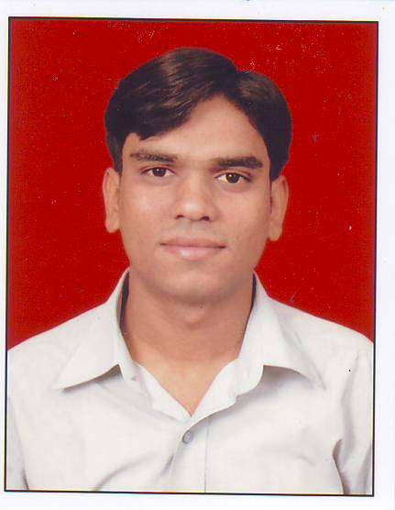
RATHOD RAVI
638, JAGRUTPOLE, VADVALO KHANCHO,
SN TEMPLE ROAD, KALUPUR,
AHMEDABAD- 380001. GUJARAT. INDIA.
E-mail: Ravirathod232@gmail.com
Contact: +91-8401880177

Sr. Cam Engineer
(Offering 5+ years’ experience in PCB manufacturing Field)
- Well qualified B.E. (Electronics & Communication) with 5+ Years’ experience in High Volume PCB manufacturing Industry.
- Motivated - Hard Working, Reliable and Productive.
- Proven ability to deliver high quality work and excellent customer satisfaction.
- Areas of strength includes:
- Expert in U-Cam& GENESIS software 7. Co-ordination with PPC
department
- Gerber data Analysis 8. Maintaining Healthy Work Environment
- Design Rule Check 9. Reverse Engineering
- Quotation Preparation 10. Analysis of Rejected Boards
- Optimized 2 to 14 layers PCBs CAM process 11. Cost Effective Panel Preparation
- knowledge of CAM 350 12. knowledge of GENESIS software
------------------------------------------------------------------------------------------------------------------------------------------
Work History
- Front End Engineer (Feb-2007 to june-2010)
At PCB Planet India Ltd., Gandhinagar, Gujarat.

- Sr. Engineer (July-2010 to may -2012)
At Cipsa-Tec India Ltd., Tumkur, Karnataka.

- Sr. Engineer (may-2012 to Till date)
At Meena circuit india pvt ltd.baroda,gujrat.
Educational Qualification
- B.E. (Electronics and Communication), 2nd class, Dec 2006.
From Sardar Patel University, Vallabh Vidyanagar, Anand.
- H.S.C. Examination with 2nd Class, March 2002.
From Gujarat Higher Secondary Education Board, Gandhinagar.
- S.S.C. Examination with 1st Class, March 2000.
From Gujarat Secondary Education Board, Gandhinagar.
------------------------------------------------------------------------------------------
Compensation Summary
- Current: 3.00 LPA (CTC)
With Accommodation and Transportation Facilities.

- Expected: With your rules and regulations.

------------------------------------------------------------------------------------------
Computer Proficiency
- Programming Languages
Technically - C, C++,
Programming language of 8085, 8086 (microprocessor), 8051(microcontroller)

- Operating Systems
DOS, Windows (98, 2000, NT, XP, vista)
------------------------------------------------------------------------------------------
Industrial Visits
- Kepraj Electronics at Gandhinagar of power Electronics.
- Gujarat Poly AVX at Gandhinagar of ceramic capacitors.
- BSNL exchange at new v.v nagar
------------------------------------------------------------------------------------------
------------------------------------------------------------------------------------------
Achievements
  - SEMINAR

- I have given a seminar on
- OTDR (Optical Time Domain Reflectometry)
- VSAT (Very Small Aperture Terminal )

  - PROJECT DEVELOPMENT

- I have made differential amp using op-amp in 2nd year.
- I have made UJT trigger ckt in 3rd year.
- I have made R/2R ladder ckt analog to digital converter in 3rd year.
- I have made traffic signal on 8051 in 6th sem in 3rd year.

Personal Profile
- Father’s name: Harshad bhai Rathod
- Occupation: Tailor
- Nationality: Indian.
- Languages known: English, Hindi, Gujarati.
- Interests: Listening music, cricket.

Declaration

- I declare here that the information given above is correct to the best of my knowledge.
Signature
RAVI RATHOD

