Curriculum Vitae

Arjun M. Prajapati

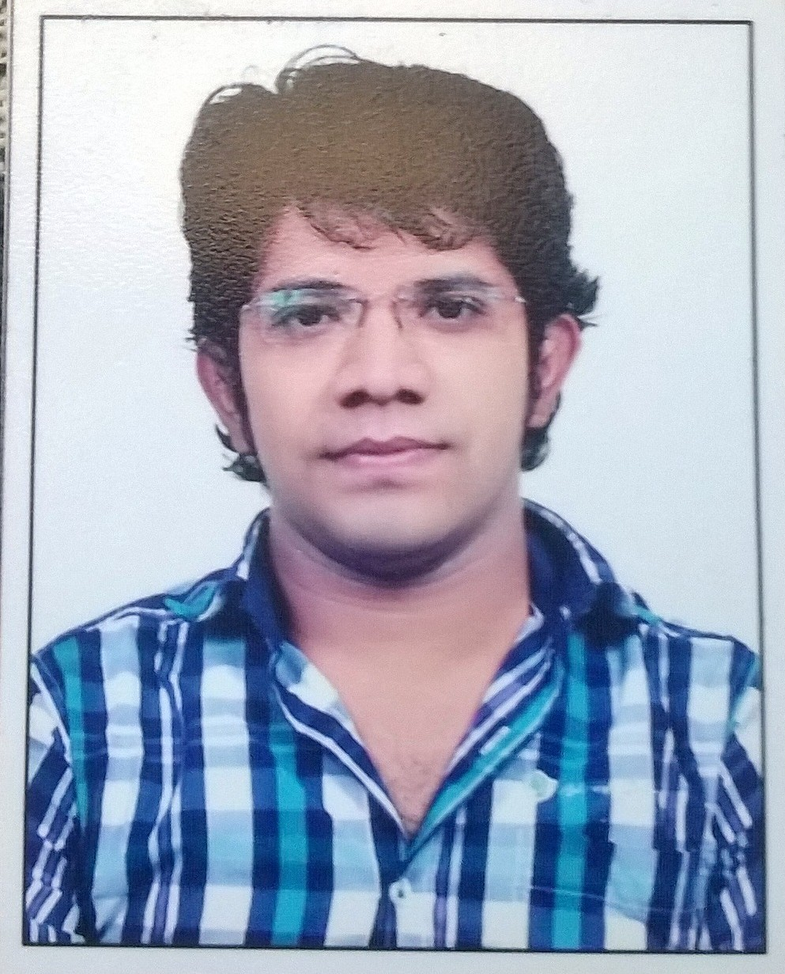  Mobile No.  +91- 9714674364  Email ID arjunca89@gmail.com  Residential Address  B/11, Suhash Residency.  Jantanagar road,  Ghatlodiya,  Ahmedabad-380061  Gujarat | Objective  To secure a position with a well established organization with a stable environment that will lead to a lasting relationship in the field of Accounts, Auditing, Taxation and Project finance & Management work. To obtain a position that will enable me to use my strong organizational skills, educational background, and ability to work well with people.  Education Qualifications  - D.T.P (Diploma In Taxation Practice from Gujarat university in 2016 (58 %)  - CS Executive Second Group Cleared from ICSI In 2016.  - PGDFA (Post Graduation Diploma in Finance & Account) + SAP ( System Application Programme) from Times Pro. In 2016 (70%)  - M.com. from Gujarat University in 2015 (50 %)  - B.com. from Aroma college of Comm., Gujarat University in 2010 (57%)  - H.S.C. from New Saurabh High school, . Board GSHEB in 2007 (62%)  - S.S.C. from Pratap Hindi High school, . Board GSHEB in 2005 (61%)  Technical Skills & Achievements  Office Tools:  - Ms-office 2007 & 2010  - Tally 9 & Tally ERP 9 & QuickBooks , Xero , Bill.com, & Atlas Weblink  - Income Tax Software (Genius, etc..)  Achievements:  - Bill.om Certified  - Six Sigma white belt Certified  - Recently get Employee of the month award for June 2021.  Contd...

Technical Training  INFORMATION TECHNOLOGY  100 hours IT Training from Ahmedabad Branch of WIRC of ICAI  ORIENTATION PROGRAMME  General Management and Communication Skill Training from Ahmedabad Branch of WIRC of ICAI  AREA OF INTEREST:  - Project Finance  - Direct Tax  - VAT & Service Tax  - Auditing  - Accounting  - Management Work | Articleship Training & Other Experience  - I have completed my Articleship Training for 3 years with M/s Amrish J. Patel & Co., Chartered Accountants,  - I have 6 month experience in Planets Aviation Pvt. Ltd. ( Airlines field) As a Aountant for manage the proper record of billing and Checking financial report and billing generating.  - I have 2 years and 6 month experience in Siddhivinayak Realty.( Building and Construction Line ( Buglow Project ) over here I have handle the work of Acounting & Other work below mentioned.  - Site-Management Work - Coordination with Project Manager.  - Legal & documentation Work- Dealing with Advocate for preparation of Agreement to sale and Saledeed.  - Finance Management- Dealing with bank for APF ( Approved project Finance) Approval and Loan Sanction for Customer .  - Currently I'm working in Analytix Business Solution ( US Accounting KPO) as a Senior Accountant from last 2 year and 3 month. over here I handle below work.  - AP Processing- Vendor bill recods & Reconciliation,  - AR Processing- Prepare customer Invoice & Reconcialiation,  - Bank Activity  Bank Entry & Reconcilation  - CreditCard Activity  Credit card Entry & Reonciliation  - MIS Report Preparation  Flash Report & Executive Summary Re  - Payroll Proessing- Payroll Working & Submit , 401k Payment  - Finanial Processing  Preparation Financial Workpaper , Review of workpaer & Send financial after review to client  - Client Management  Communication with client with email  Strengths and skills  - Quick adaptability to new set ups  - Always desire to learn new things  - Professional dedication, sincerity, & positive approach  - Accepting new challenges  Personal information  - Date of Birth : 04/07/1989  - Nationality : Indian.  - Marital Status : Married  - Language known : English, Hindi, Gujarati  - Hobbies : Playing Cricket, Listening Music

