_{CURRICULUM VITAE} 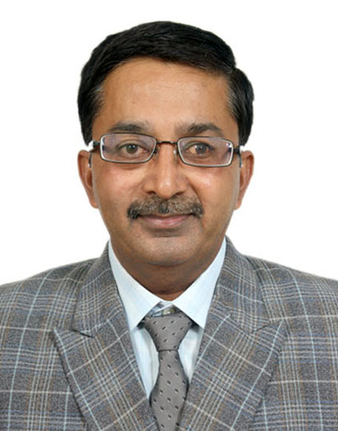
_{Experience& Exposure :} _{28- 1/2 Years.}
- Presently Working with: M/s. Tera Cables India Pvt. Ltd. Charodi –Farm, Sanand. Ahmedabad, as Asst. Manager Project & Marketing, SINCE 1ST September 2007, as Asst. Manager Project & Marketing. Assigned activities of Local & Export Marketing of Cables and other activities pertaining to Lision work with Govt. Departments. And as Controlling ISO 9001: 2008 Implementation work.
- M/s. Arun Arora & Company Ltd. : from 01. 9. 2006 up to 30.9.2007 as Asst. Manager. Assigned to Survey and assess the Industrial losses and report to the Insurance Companies.
- M/s. Progressive Consultants: A Bhopal based company, providing services for international Certifications like ISO 9001-2000, HACCP, CE Mark Certifications, as Associate Consultant at Ahmedabad. giving consultancy for Planning ISO 9001, Implementation along with Internal Audits, Trainings etc. for various organizations like Tiles Manufacturing Industry, Rubber Industries, Pharmaceutical laboratory, Ice- Cream Manufacturing Machines, Guar Gum Industry, Electrical Accessories Manufacturing Unit, Electrical Motor Manufacturers etc. for a period from Nov. 2005 to
- M/s. Shivam Water Treaters (P) Ltd. as Project Executive assigned as overall In-charge for Execution of water treatment solutions for Industrial plants.
- M/s. Vivace Consultants P. Ltd., A consultancy firm providing services for International Certifications like ISO 9001-2000, HACCP, CE Mark Certifications, for 8-9 months as Sr. Staff Consultant from May 2004 to Jan. 2005.
- M/s. Hindustan Gum & chemicals Ltd. Viramgam. This is a unit producing Food Grade Quality Guar Gum Products, for 12-13 years with the Project Planning, E&C. of Process plants, Utilities, ET Plant and Production of Guar Gum products.
- M/s. Amar Dye-Chem. Ltd. As Forman Projects, for Modifications, E&C. and the O&M of Dyes, Dye-Intermediate manufacturing facilities. Etc.
- M/s. Janardhana Chemicals Pvt. Ltd. As Production Supervisor for the Production of Phenol- Formaldehyde Resins & PF Molding compounds for 2 Years.
- M/s. B.M.Thakkar & Co. Pvt. Ltd. As Production Supervisor for the Production of Phenol- Formaldehyde Resins & PF Molding compounds, for 1 Year.
- M/s. Atash Industries (I) Ltd. As Trainee Chemical Engineer for Production of Ammonium Nitrate (Crystals & Pills), & months since 1987.
_{Educational Qualification:}
Diploma Chemical Engineering in 1987, from Board of Technical Examinations, MUMBAI..
_{XIIth (HSC)} from M.S. Board of Sec. & H. S. C. Board, Mumbai with 58% (1983)
Xth (SSC) from M. S. Board of Sec. & H. S. C. Board, Mumbai with 63% (1980).
_{Knowledge Area:} Windows 98, Windows XP. received training on CE Mark Certification from CETE, Pune.
_{Interest/Hobbies:} Working on New Projects, travel around, making new contacts.
_{Personal details:}
_{Nationality:} _{Indian.}
_{Date of Birth:} _{01/ 04 /1964}
_{Father’s Name} Shri . Anand Mohan Mathur. - Govt Servant. (retd.)
_{Gender:} _{Male.}
_{Marital Status:} _{Married}
_{Res. Address :} B/ 4, Kadamb Flats, Ambli-Bopal Road,
Bopal, Ahmedabad. -380058. (Gujarat).
: (02717)230701(M) + 91- 9428735754
E Mail: ashishmathur63@gmail.com

_{Ashish Mathur}

