RESUME

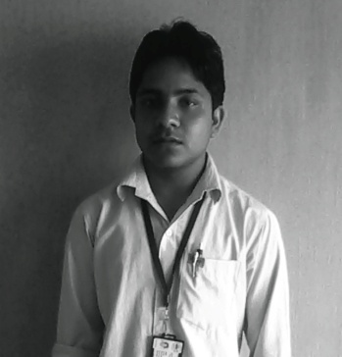
ASHUTOSH MAURYA
Address- Yusuf Pur Baghwan,
Behind-Mohrdwaj Sandal Meal of Perfumes (Near SBI),
Makrandra Nagar,
Kannauj,
Uttar Pradesh,
Pin-209726

E-mail- ashumaurya63@gmail.com
Mobile Number- 07800141026, 08474037564
______________________________________________________________________

CARRIER OBJECTIVE:

- To join with a progressive organization that provides me environment to apply my knowledge and technical skills in the areas of developments.
- A part of the team that dynamically work towards growth of organization.

Sl. No. | Qualification | Institution | Year of study | % of Marks
1 | Post Graduate Diploma in Plastics Processing & Testing | CIPET,  GUWAHATI. | 2013-2015 | Complete
TECHNICAL QUALIFICATION:

1 | B.Sc. | R.P.(P.G.) College,Kamalganj,  Farrukhabad. | 2013 | 44.59%
2 | Intermediate | K.K.Int. College,  Kannauj | 2009 | 57.40%
3 | High school | K.K.Int. College,  Kannauj. | 2007 | 63.66%
EDUCATIONAL QUALIFICATION:

WORK EXPERIENCE (if any):

- Working as a Process Engineer in DEEP POLYMERS PVT.LTD. Kalol, Gandhinagar, Gujarat. (In Plant Training)

SOFTWARE KNOWLEDGE:

- Operating Window XP,7 & 8
- Ms Office 2003, 2007& 2010.
- Other useful software like Tally 9, Adobe Photoshop 7.0 etc.

MACHINE EXPOSER:

- Injection Molding Machine.
- Plastics Testing Machines.
- Extrusion Process
- Blow Molding

FIELD OF INTEREST:

- Production / Quality Control / Marketing.

GEOGRAPHICAL LOCATION PREFERRED:

- Any Where in India.

STRENGTH:

- A self-motivated team player with excellent communication, analytical skill.
- Bears and ordered & logical approach towards work.
EXTRA CURRICULAR ACTIVITIES:

- Diploma in Computer Applications (DCA).
- Certificate in Computer Applications (CCA).

PROFICIENCY IN SPORTS:

- Cricket, Chess.

PERSONAL DETAILS:

1. Father’s Name : Mr. Gautam Singh

2. Date of Birth & Age : 06-08-1993

3. Sex : Male

4. Nationality : Indian

5. Marital Status : Unmarried

6. Permanent Address : Yusuf Pur Baghwan,
Behind-Mohrdwaj Sandal Meal of Perfumes (Near SBI), Makrandra Nagar, Kannauj, Uttar Pradesh,
Pin- 209726.
DECLERATION:

The above information given is true to the best of my knowledge and belief.

Date: Signature
Place:

