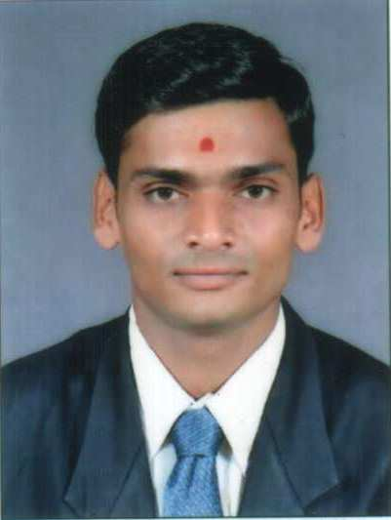

JANAK RAMANI
24, Ghanshyamnagar society, Viratnagar Road, Odhav , Ahmedabad-382415
09327050869. jnkdrmn@gmail.com

PROFILE SUMMARY

- A result oriented professional having inclination towards Finance as a career.
- An adaptive professional with the ability to act according to the circumstances and to derive desired performance.
- Great facilitator, motivator, counselor & coach, have good interpersonal skills to gel among team players and to guide them to the right path, eventually turns out to be a good leader.

CAREER OBJECTIVE
I would like to obtain a job with long term prospects. To secure a position where my qualities of a fast learner and the ability to take on new challenges can be used. And also to secure a position where my ability to communicate and liaise effectively with a diverse client group in a friendly and diplomatic manner can be put to good us

ACADEMIC QUALIFICATION

Degree | Year Of Passing | College/University | Specialization | %Age/Division
Master Of Commerce | 2011 | Gujarat University | Advanced Accounting and Statistics | 50
Diploma in Banking | 2010 | Gujarat University | Finance | 72
Bachelors in Commerce | 2009 | Gujarat University | Advanced Accounting and Statistics | 48
HSC | 2006 | GSEB | - | 57

SUMMER INTERNSHIP PROGRAM
Gujarat University 1 Nov 2010– 26 April 2011
Assistance Accountant

Finance Department, Accounting Department.

PROFFESSIONAL EXPERIENCE:

Organization: SALES INDIA
Tenure: 1st July to 31 January 2012
Designation: Marketing

PROJECTS UNDERTAKEN
Gujarat University in Banking: Financial Structure and Accounting Department

Master of Commerce: FDI in Indian Economy

OTHER PROFESSIONAL SKILLS
- Technical Skills - I have a good knowledge of MS Office (Word, Excel and Power Point), internet and html.

I have good knowledge of Tally 6.3 & 5.4.

HOBBIES AND EXTRA ACTIVITIES
Enjoy Socializing and meeting new people and Travelling,

LANGUAGE PROFICIENCY
English, Gujarati, Hindi and French
PERSONAL DETAILS
- Date of Birth 11 November 1988
- Marital Status Single
- Father's Name Mr. Dhirubhai Ramani
- Gender Male

