RESUME
PATEL JAYDIPKUMAR BHARATBHAI
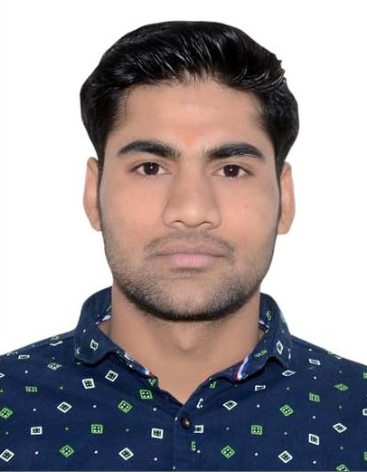

Permanent Address :
Near radha krishna temple,
Post-Devda, Ta-Vijapur,
Dist-Mehsana
Pincode:-382830
Phone: (M) +91 9898381226
Email: pjaydip111@gmail.com

career OBJECTIVE:
I want to serve the Organization at my level best effort and want to become it’s essential part by enhancing it’s overall effectiveness and undertaking challenging responsibilities.

personal PROFILE:
Date of Birth | 29 nov, 1992.
Gender | Male
Nationality | Indian
Religion/Cast | Hindu
Marital status | Un-married
Known languages | English, Hindi, Gujarati.
Hobbies | Reading, Know something new in Mechanical, Playing

EDUCATION:

EXAMINATION | BOARD/UNIV. | PERCENTAGE | YEAR OF PASSING
S.S.C. | G.S & H.S.E.B.Gandhinagar | 65.54% | March- 2008

EXAMINATION | BOARD/UNIV. | PERCENTAGE | YEAR OF PASSING
H.S.C. | G.S & H.S.E.B.Gandhinagar | 59.80% | March- 2010

EXAMINATION | BOARD/UNIV. | C.G.P.A | YEAR OF PASSING
DEGREE IN MECHANICAL | G.T.U. | 7.06% | June 2014

ACADAMIC TRAINING :
- Visited Hydro & Thermal Power Plant.
- Visited Amman Apollo.

technical SKILL:

- Software knowledge: Solidworks 2014,2015,2016.Autodesk AutoCAD 2015 basic
: MS-Office, Window 7.Window 8 & 8.1

EXPERIENCE:

Sr no. | Name of organization | Designation | Period
1. | KESAR ROAD EQUIPMENT (INDIA)PVT.LTD.  81/Nirmal Industrial Park,  G.I.D.C.,  At.Gozariya-382 825,  Dist. Mehsana.(Guj.)India. | Mechanical Design Engineer  & Production Engineer | 1 july 2014  to  14 March 2016
2. | UNITED INDUSTRIES.  20/1 Shayona industrial Estate ,Near Panchratna Estate,Phase 4 Near Ramol Bridge GIDC vatva,Ahmedabad. | Mechanical Design Engineer | 15 March 2016  To  Still Working

DECLARATION:

I hereby declare that the above mentioned information is true to the best of my knowledge.

Date: / / Yours sincerely,
Patel Jaydip B.

Signature___________

