RESUME

SOLANKI KARAN MANSUKHBHAI
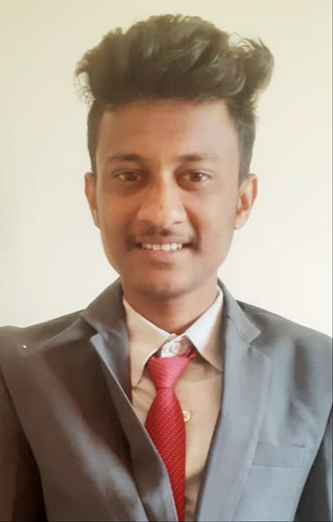
Haveli Chowk
Junagadh Gujarat
Chorwad:-362250

Contact No:

7698375767

E–mail Address:
Karansolanki642@gmail.com

Career Objective
Looking for a Professional Career to be Successful in Aviation Industry
Academic Credentials
Degree | University / Board | Year | Discipline
B.C.A | Saurashtra University. Rajkot, Gujarat | 2017 | Successfully Completed
HSC | Gujarat Board | 2015 | Successfully Completed
SSC | Gujarat Board | 2013 | Successfully Completed

Professional Certification
Successfully Professional Certification Aviation, Hospitality, Tours and Travel from Sky9 Aviation Academy (2018-2019)
IT Skills
Computer Basic skills
Personal Dossier
Date of Birth | 11 Jan 1998
Marital Status | Single
Gender | Male
Nationality | Indian
Languages Known | English, Hindi, Gujarati
Father’s Name | Mansukh Bhai
Passport No. | S 2555967
Aadhar Card No. | 232426382169
Pan No. | HJKPS9430J

Declaration
I hereby declare that the above mentioned information is true to the best of my Knowledge

Date: Sign:

