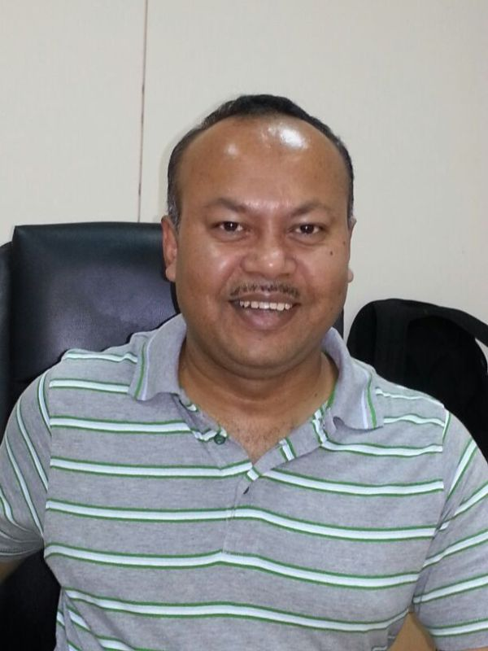PRANAB KARMAKAR
------------------------------------------------------------------------------------------------------------
Father’s Name : Mr. Binode Karmakar

Permanent address : 73, Vraj Homes
200 ft Sardar Patel Ring Road,
Gam : Shella, Taluka : Sanand,
Ahmedabad – 380 058, India

Correspondence address @ India :
C/O Mr. Binode Karmakar
P.O. Radhakishorepur,
West bank of Jagannath Dighi,
Geet Bharati Para,
Gomoti , India – 799 120
Mobile : +91 8794295626

Correspondence address @ Bangladesh :

C1, House No. 538
Lane No. 11, DOHS, Baridhara,
Dhaka, Bangladesh

Phone : (Residence) +880 1765569087 (Office ) +880 1755516576

E- Mail Pranab.Karmakar@envoytextiles.com
paridhikarmakar@gmail.com

Passport No. Z2320266
Date of Issue 29/05/2012
Date of Expiry 28/05/2022

Academic Qualifications

M.Tech(Textile Engineering) : Passed in the year 1997 from IIT, Delhi with first class

B.Sc.Tech. : Passed in the year 1995 from Calcutta University with

(Textile Technology) first class

Contd……

Professional Qualification
- Certified Lead Auditor for ISO 9001,2000 from BIS
- Developing Leadership Potential Certificate from IIM, Ahmedabad, India

Professional Experience

1) June,2011 Onwards : with Envoy Textiles Limited, Bangladesh, as GM, Quality Assurance, IQC, Process Control.

Job Description : Heading Quality function of Denim business – prime functions includes managing Physical Testing Lab, Chemical Lab, Color Lab, Clearance of material, Customer Service, Process Audit & Inspection.

2) May,2004 to May,2011 : with Arvind Limited, India, as Head, Quality Assurance & Standardization.

Job Description : Heading Quality function of Denim business – prime functions includes managing Cotton Lab, Physical Testing Lab, Chemical Lab, Calibration Lab, Color Lab, Clearance of material, Customer Service, Process Control, Sampling and Collection.

3) April,2003 to April,2004 : with The Abhishek Industries Limited, India, as Deputy
Manager, Quality Assurance

Job Description : Heading the Terry Towel Division for Quality,
Process Control & TQM projects implementation. Special
Projects on (a) Yarn dyed towels in improving the fresh
Packing (b) Reducing the length variations in dyed yarns
& thus reducing dyed yarn remnants. (c ) Improvement
in patchy dyeing by altering the size recipe.

4) March,2001 to March,2003: with Auro Weaving Mills, a unit of Vardhman
Group, India, as Assistant Manager.

Job Description : Heading the Preparatory & Weaving unit for Quality,
Process Control. Special trials with cotton mixings
Yarn parameters & Sizing recipe and ultimately achieving
92.5% installed loom efficiency with 99% fresh greige
packing. Later on Greige Inspection was included as an
added responsibility.

5) January,1998 to Feb,2001 : with Ashima Limited, India, as Assistant Manager.

Job Description : Testing of cotton, yarn & fabric – projects on different
Mixing trials, Lowering of hairiness in 40’s yarn etc.

6) July,1995 to June,1996 : with Mahavir Spinning Mills, India, a unit of Vardhman Group as Textile Graduate Trainee.

Job Description : Shift supervision from Blow Room to Ring frame for a
26,400-spindle unit. Special project on improving
Imperfection for combed varieties.
Machines/Equipments
Worked on : Lakshmi Rieter make Blow Room, Carding, Drawframe, Sliver Lap, Ribbon Lap, Combing, Speed frame & Ring
Frames, UT-5, UTR, UTJ, CSP Tester, Elmendorf Tear
Strength Tester, AATCC Crock Meter, Grab/Strip Test
for fabric tensile strength, Color fastness tester, Stiffness
Tester, Stretch/Growth testing, Mettler Toledo Auto
Titrator for %age Indigo, Ozone fastness testing,
Hunterlab with Shelin Software (Version 3.0) for shade
sorting etc.

Additional Information’s : Achieved North Eastern Council Scholarship during
Undergraduate studies.

Scored 93.5 percentile in GATE 95 & acquired UGC
Scholarship.

Won Gold medal in the North India TQM project
Competition held in Chandigarh in the year 2000

Personal Details :

Nationality : Indian
Date of Birth : 9th September, 1972
Marital Status : Married
Languages known : Bengali, English, Hindi, Gujarati

Current CTC : USD 5700 per Month
Contract completing on : June,2015

Date : 26th July ,2014

Venue : Dhaka, Bangladesh
Signature
(Pranab Karmakar)

